 

INVESTIGATION REPORT

**Queuing Website for Asia Pacific University Cafeteria**

**By**

GOAUTHAAM A/L ARUMUGAM

TP02084

UC3F2108IT (BIS)

A report submitted in partial fulfillment of the requirements of Asia Pacific University of Technology and Innovation for the Degree of

B.Sc. (Hons) in Information Technology

Supervised by Dr. Intan Farahana Kamsin

2nd Marker: Ts. Dr. Siti Sarah Maidin

22 November - 2021

**Acknowledgement**

Firstly, I would like to convey gratitude and special thanks to my supervisor Dr. Intan Masim as she was there from the beginning stage of this project when I personally requested her to be my mentor and she accepted. Miss Intan has been very helpful in guiding and supporting me through the phase of this IR in improving this investigation report. I am grateful to Miss Intan for accepting to be my mentor. Besides that, I would like to also show my gratitude to Miss Siti Sarah for accepting the request to be my second marker.

Furthermore, I feel thankful to Mr. Dhason Padmakumar for guiding and motivating us by reminding us to work on our FYP and IR in each and every briefing class. Mr. Dhason Padmakumar also has provided many important documents in order to successfully complete the IR. In addition, most of the time whenever I have doubts about the report, I would email Mr. Dhason and he will surely reply quickly which really helps me to not waste time and focus on the document.

Lastly, I would like to show my gratitude to my friends and acquaintances for helping and motivating me through this IR. Most importantly, I would like to thank my parents for giving me an opportunity to do the written report in return for a promising future. Words are not enough to express the gratitude I have for my family. The support and love which they show me is a very big strength for me that helps me stay motivated in order to give my best in order to reach my goals in life.

Thank you.

Table of Contents

Chapter 1: Introduction to the study 5

1.1 Project Background 5

1.2 Problem Context 6

1.3 Rationale 7

1.4 Potential Benefits 8

1.4.1 Tangible benefits 8

1.4.2 Intangible benefits 8

1.5 Target Users 8

1.6 Scope and Objectives 9

1.6.1 Aim 9

1.6.2 Objectives 9

1.6.3 Deliverables 10

1.6.4 Nature of challenges 11

1.7 Overview of Report 12

1.8 Project Plan 13

Chapter 2 Company Background 16

Asia Pacific University 16

Background overview 16

Chapter 3: literature Review 17

3.1 Introduction 17

3.2 Domain Research 17

3.2.1 Queuing website for Asia Pacific University 18

3.2.2 Upgrade of a new system in cafeteria 20

3.2.3 University students and staff 20

3.2.4 Implementation of the cafeteria website specially made for APU cafeteria 21

3.3 Similar system 21

3.3.1 Skiplino 22

3.3.2 Q less system 22

3.3.3 Wave Tec system 22

3.3.4 Comparison of similar system 24

3.4 Summary 25

Chapter 4: Technical Research 25

4.1 Programming language: PHP 26

4.2 Notepad ++ 27

4.4 Database Management system 27

4.5 Operating System 28

4.8 summary 28

Chapter 5 business Care 29

5.1 SWOT analysis 29

5.2 SWOT analysis (Asia Pacific University) 29

Chapter 6: system development methodology 31

6.1 introduction 31

6.2 methodology comparison 31

6.2.1 Waterfall model 31

6.2.2 Rapid application development model 33

6.3 justification on chosen methodology 36

6.3.1 Difference between waterfall and RAD model 36

6.3.2 Methodology justification 38

6.4 Brief overview of implementing on the chosen methodology 38

Chapter 7: Research methods 40

7.1 Introduction 40

7.2 Questionnaires 40

7.2.1 Design of questionnaire 41

7.3 Summary 47

Chapter 8: Requirement validation 47

8.1 introduction 47

8.2 Analysis based on questionnaire data collection 47

8.2.1 Questionnaire 47

8.3 summary 54

Chapter 9: conclusion and reflections 55

References 56

Appendices 59

# Chapter 1: Introduction to the study

## 1.1 Project Background

In this 21st century, there are a lot of systems and applications invented to solve problems which have been encountered. People are finding ways to come up with solutions for all problems nowadays. One of the biggest problem universities have faced is managing the queue in the cafeteria. Queuing theory is really important and shall be adapted in all places because it helps the features of queue. Being in a queue is fair as it respects people’s space and it sets order for students in university, customers in restaurants and in other places. Many of us have faced the queuing issue due to heavy crowd while waiting and it can be maddening at times as most of us are busy in our daily routine schedule. According to Francesc Solsona and John Vilaplana, both of them have come out with a theory which helps to solve the problem in queuing system which has been really time consuming for users. The queuing system is defined in two important elements which is the service system and the population of the source of its customers. In this research investigation, the queuing website suits well on overcoming the problem faced by the Asia pacific university’s cafeteria. It is very common that most students and staffs are likely to face problems like waiting in the queue for a very long period of time to place their orders because the cafeteria workers have to collect multiple orders at the same time and prepare their orders. This can affect students and staffs study/work schedule (Goauthaam, 2020). As a method to overcome this problem, the research idea here is to create a queuing website for Asia pacific university cafeteria. This queuing website is created to overcome the major problem experienced by Asia pacific university’s cafeteria whereby the old queuing system seems to be not applicable as it consumes long time. The APU cafeteria queuing website serves many functions which has many types of service facilities and proper proficiency of server (SHARMA, 2020). Besides, this website will be designed with proper security features in order to ensure the confidentiality, availability of information and integrity. Moreover, it allows students to receive their orders through this website and collect their meals once the system notifies them. It also enables students or staff to pay online by using this website. (Jordi Vilaplana, 2021)

## 1.2 Problem Context

Queuing system is known to face issues, especially in universities. Most of the time, students make a long way of queue to place their orders in the cafeteria. Asia pacific university has also encountered the same queuing problem as well. In this case, this new queuing website is suggested to be implement to solve all this issue. Based on few surveys done by the researcher through questionnaire, a number of percentage of students agrees that it is time consuming for them to queue up and receive their meals as it does affect them from attending classes on time (Jones, 2005). In conjunction to it, universities are now open after the pandemic, and it is also said to be not safe for students to create a crowd in the cafeteria and not following the SOP’s like practicing social distancing that has been implemented by the government (Goauthaam, 2020).

Besides that, many students are afraid to be in crowded places due to the Coronavirus. This negatively impacts the businesses in the cafeteria. Another problem that has been identified is missing orders since they do not have a proper record system of the food ordered. Other than that, some orders have been given to the wrong person which is not fair to students who have been waiting for a long time. This happens commonly because the cafeteria will be crowded and there are high chances of missing orders and misplacing orders. (EDWIN LUTHER BRADLEY, 2000).

Furthermore, APU cafeteria is not computerized and it’s mostly done manually by the workers. APU is using the top up system which does not satisfy students. For example, there are blogs that posted where students and staffs complained about APU’s cafeteria management. Moreover, due to handling the cafeteria manually by staff, there will be higher risk for human errors. (M.Atieh, 2015)

## 1.3 Rationale

Based on the issue stated in the problem context, the proposed solution will help students and staff of Asia pacific university to overcome the issue of wasting their time in queues and being exposing themselves in crowded places when ordering their meals. Implementation of this new queuing website can help students and brings benefit for them. Surely, students would prefer this queuing website which makes it easier for them to use as compared to the previous cafeteria system. This is because the previous cafeteria system was handled manually by human force and there is also a student TP top up machine which has its cons too. The main idea here is to develop an effective queuing website for APU cafeteria and implement this website for APU students and staff which will be easily accessible, saves time, quicken the process of ordering food and beverages at APU cafeteria without any crowd. The main goal of this idea is to avoid the long queue and to make orders in sufficient for students and staff of APU. This queuing website is created to make the student life easier by ordering their daily meals via the website using cashless method. This queuing will be able to reduce the massive crowds that pile up in the cafeteria. (Goauthaam, 2020)

## 1.4 Potential Benefits

By doing this project, there are few benefits which will be achieved by the different parties especially the targeted users. The categories in two different group which is tangible and intangible. In the following, the tangible and intangible benefits of this project will be given detail.

1.4.1 Tangible benefits**:**

* Students can use this website anytime and anywhere
* This queuing website can be used by students and lecturers
* System will be upgraded and maintained well
* The queuing website can be used for ordering food
* The food item and drinks will be updated daily with new items

1.4.2 Intangible benefits**:**

* It will be safer rather than queuing and creating crowds in the cafeteria
* Time saving
* Bring cashless system by paying online
* More convenience for students compared to the TP system of buying food and queuing in cafeteria

## 1.5 Target Users

The target user of this particular projects are all the adults between ages 18-50

The researcher and developer of this project does recognize the important of specific targeted user that will be utilizing the proposed system. The users are:

* Asia pacific university students
* Asia pacific university lectures
* Asia pacific university cafeteria admin management

## 1.6 Scope and Objectives

## 1.6.1 Aim

To develop an effective APU cafeteria website for APU students. This website will be used to reduce the problem of queuing and reduce the problem that faced by APU students.

## 1.6.2 Objectives

1. To implement Queuing website for Asia Pacific university cafeteria

2. To maximize this system’s reach and bring efficiency for APU students by implementing cafeteria queuing system

3. To determine how the system bring awareness of social distancing during queuing for food at this COVID-19 pandemic in APU cafeteria

4. To make sure student are not in close contact in cafeteria while ordering the food

5. To save time by purchasing the meals through the website

6. To implement the online paying system

## 1.6.3 Deliverables

According to the problem statement, the main aim of this research is to develop an APU cafeteria website which will reduce the problems and be really helpful for the students to access. The students are able to use this system maximum which bring benefit for each student. Every detail of the students will be store safety in the back end of website. The features and functions of the proposed system will be user friendly for APU students, lecturers and admin.

**Queuing website allows students,**

1. To login the queuing website

2. To Sign up the queuing website with the student’s details

3. To update the students’ profile

4. To do the selection of the food menu

5. To do the Ordering upon the menu

6. To Edit students’ order

**Queuing website allows lectures,**

1. To login the queuing website

2. To Sign up the queuing website with the lecturer’s details

3. To Update the lecture profile

4. To do the selection of the food menu

5. To do the Ordering upon the menu

6. To Edit lecturer order

**Queuing website allows admin,**

1. To Upload the Food Menu

2. To update the pricing for each food and drinks

3. To check the order

4. To send notification for the serving

5. To Delete the serving order

## 1.6.4 Nature of challenges

To develop a web-based system does encryption for all the student information and websites which are critical as should be secure well and avoid the breaches and information that will be stolen. It’s quite challenging to introduce this queuing system because Apu students are already used to the TP card paying system. The TP card paying system has been used in APU for almost 3 years now. Some students may be a little reluctant to use the new system. This queuing system should have a simple design which can assure a user-friendly program. This should attract students to use and adapt to this system. Furthermore, in regard to the security, only APU students will be able to use this website. The developer will be facing problem in selection of programing language. The knowledge on (HCI) human computer interface, HTML, C# programing language should be more focused for the designing phase in order to make sure it turns out a useful website. Furthermore, there is a lot studying, research and understanding on the requirement of this project in order to make a successful system by the developer. (Goauthaam, 2020)

## 1.7 Overview of Report

The (IR) investigation report is divided into 9 different chapters with few important components. Each and every chapters have their own scope which is targeted on the research on specific topics.

**Chapter 1**, contains the introduction of the whole project and research documents and the purpose and also the objective of this investigation research. There is project background which explains the solution of the project and the idea behind this project. Besides that, the problem context states all the main problems which relates to the project. Rationale is the reason, justification and the benefits of project. It will be explained with two benefits which are tangible and intangible benefits. Target users explains the target user for the proposed system. Alongside the scope of the objective which contains the aims, objective, deliverables and nature of challenges which will meet during the investigation of the subject which is important in order to develop the queuing website.

**Chapter 2,** has the background details of the company which will be proposing the system. This chapter does contains the details of the Asia pacific university and their vision and mission.

**Chapter 3,** here is the most important and dept. research of the subject which relates to the project aim and title. The literature review has a good investigation through the project into each topic. This chapter is important because all the details which will be found shows a significance of the proposed project and all the requirement which makes the project successful. There will also be a section analyzing and comparing similar websites.

**Chapter 4,** in this chapter there will be research regarding the technical which will done to make sure which interactive development environment (IDE) will be selected for the proposed system to be developed. There will be also a clear explanation provided on the preferred (OS) operating system that works on during the development of the project.

**Chapter 5,** there is a good and important discussion on the business case regarding the selected university will be conducted. There will be explanation and discussion on the SWOT analysis.

**Chapter 6,** here there will be two website development methodology presented. The selection and comparison on their differences and similarities of the development of project will be done. There will be justification given on the selected development of methodology for the project. The selected system development methodology model will be implemented and will shed light on the explanation of the project.

**Chapter 7,** is the research method which should be select and explain on how it applies on research project and it benefits. There will also be justification of the selected method which will be included and all the objective questions will be given with proper reasons.

**Chapter 8,** this chapter does need the chapter 7 to be completed in order to proceed with the chapter 8 because this chapter need all the data and information collected during the research method phase and then will be doing the analyze and also gives the proper explanation which does justify on each research finding.

**Chapter 9,** here in this section which it will shows a reflection on the whole project by the researcher and the upcoming website which is proposed and the benefits on working on the investigation report. There will be also details on the future situation improvement in order to avoid mistakes.

## 1.8 Project Plan

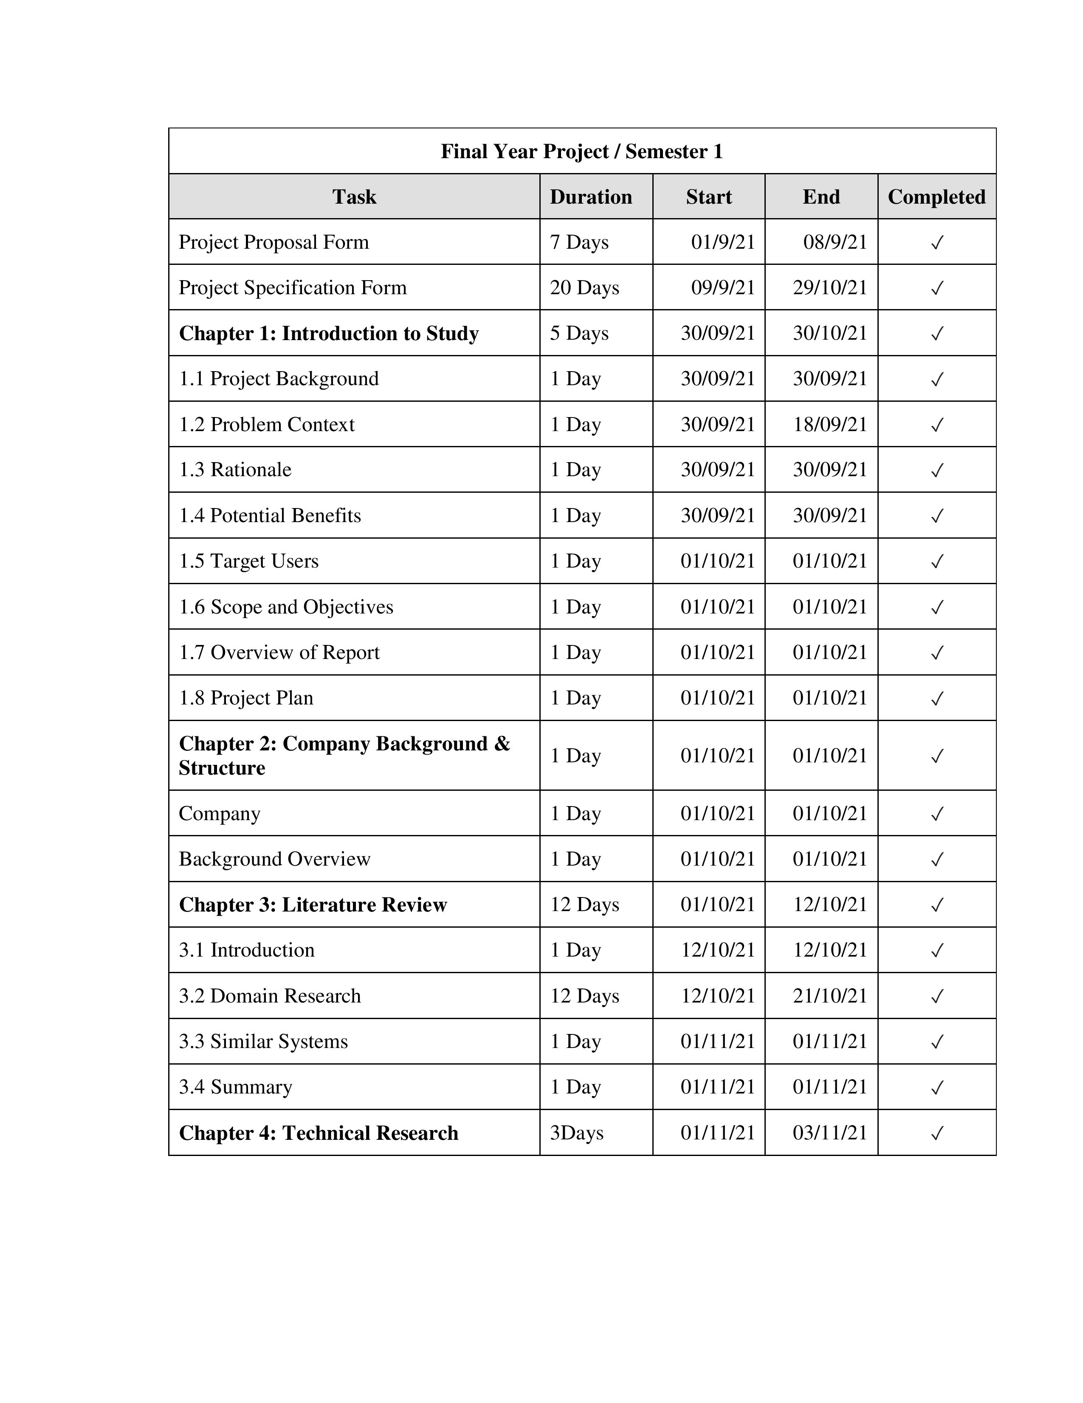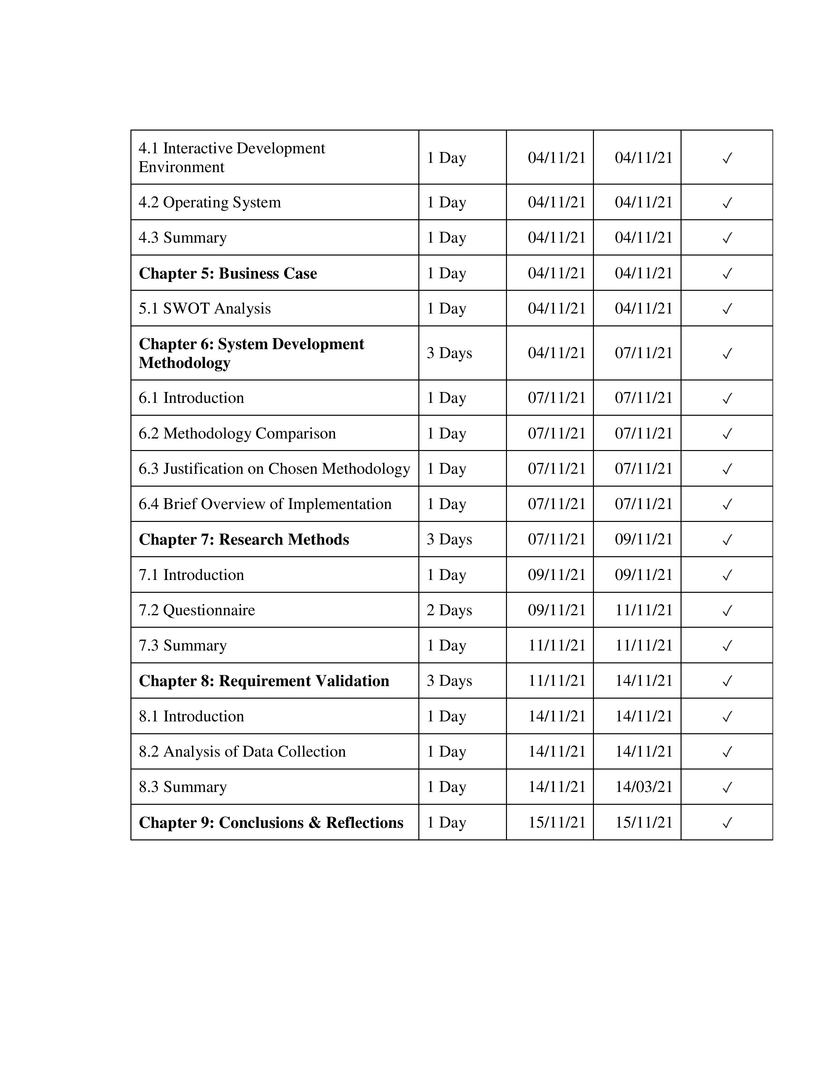

# Chapter 2 Company Background

## Asia Pacific University

## Background overview

Asia pacific university of technology and innovation (APU) is one of the premier universities compare to the private universities in Malaysia. This university is very unique on the technology and innovation and also does a great job on being creativity towards transforming the students into effective competent, employable and also future proof of professionals. Asia pacific university does actually have every good reputation as around 200 prestigious award winning from the local and international level. Asia pacific university was actually establish in year 1993 (topuniversities, 2021). Besides that, based on the latest update on the annual graduate tracer study by the ministry of higher education, there is 100% success rate in APU which were graduate and were employed. Among the top 10 university in Malaysia, Asia pacific university is among the top 10 private universities. Asia pacific university does give a good experience on learning and great studying atmosphere and the campus is really big with many facilities for students which will be really useful and bring a great environment and experience for the students. In term of business, APU does provide a very good education service to all the students and the lectures in APU are truly great and very educated and great in teaching and providing education services to the student (studymalaysia, 2021). APU have actually been rated the number 1 on having a great multicultural learning experience which includes the local students and international students around the world. Future more there are around, 12000 students and from 130 countries studying in APU which is a campus that is in Malaysia. APU has a great iconic campus which is design in metropolitan style for the interactivity and the campus is located in Jalan Teknolgi 5, Taman Teknologi Malaysia, 57000 Kuala Lumpur wilayah Persekutan Kuala Lumpur. APU provides various course for learning. There are many services provided which helps and advices students on their needs on academics. Asia pacific university provides dual degree programing which will be a great advantage for the students. (apu, 2021)

Asia pacific university vision is to be a leading university of technology and innovation transforming students into highly employable, competent and future – proof professionals. .The mission of the Asia pacific university is to provide a good quality, affordable pricing, innovative and international benchmarked education and a good research in a professional, ethical and student centered with manners by designing and delivering a range on enhancing and extraordinary learning experiences. (apu, 2021)

# Chapter 3: literature Review

## 3.1 Introduction

This chapter will review the literature and past research in the area of queuing website which helps to support the issue that has been encountered in the past method of queuing. Past research has been included to support the literature review. With the determination of making this research better, successful and precise, the new domains are:

* Domain research
* APU cafeteria website
* Upgrade of a new cafeteria system
* University students and staff
* Implementation of the cafeteria website specially made for APU cafeteria

## 3.2 Domain Research

In domain research, there is research based on the component performance which is not proper on waiting on one queue website. The performance attributes are determined for many different types of queuing website. Based on the explanation of decision made by managerial, there is conclude which is able to relate to the design and performance of the queuing website (Gabriel, 2001). For an instance, famous fast-food restaurants use queuing websites on a short-term basis. Most of the time, there will be long queues at fast-food drive through during peak hours where many people come to get their meals. There will be a transient rush of pressure which will be difficult to manage based on the capacity of the working staff. In order to put effort to accelerate the process of delivery, some restaurants use a method to make faster paying process by having three windows. The first window is for ordering, the second window is for paying and the third window which will be at the exit is for picking up the food (Akter, 2019). At the other times of the day, restaurants use the single window which may not have the waiting line to queue at the drive through of the window. There is a challenge on designing the service for this system which is suitable but not on immoderate amount of capacity. For example, fast food restaurants experience inconstant service and demand. Most of the restaurants find it incomprehensible on knowing the customer demand (Ilamsyah, 2019). They don’t know the accurate number of each order placed by the customers. The challenge is when the orders made by customers are different and unique. It is important to know the different elements of a queuing website. According to Sylvia Monalisa, implementation of the queuing website was very helpful and useful for ASheni University for ordering the foods and drinks. It was easy for making orders because there were options for paying method which makes it easy to make payment and not waste time at the cafeteria. These were the few components which accommodate to the population of customers, service of the website, design of service and also based on the choice used for the queuing website. (Engmann, 2017) This theory of Sylvia Monalisa is useful on applying in the research on creating the queuing website for the university’s cafeteria.

## 3.2.1 Queuing website for Asia Pacific University

Based on E.I. Esedimy, it was declared that the customer population can be considered to finite or infinite. If there were new prospective customers for the waiting line system can be affected by many of the customers in the system, which the population of customers will be finite. For example, if a class room has 15 students, the overall population of customers for the meeting with lecturer will also be the 15 students. (Esedimy, 2014) Besides that, if there is an increase of students during the process of waiting to meet the lecturer, there will be a chance of new customer to decrease. There is a limit of finite based on how long the waiting line can ever be. The amount of customers queuing in line does not greatly affect the rate on which the population bring new customers. The population of customer is considered infinite (MARZUKHI, 2020).

This cafeteria queuing website for Asia pacific university also works in a similar way and it will be convenient for all the users from APU. This is basically a website which allows students, lectures and APU staff to login to the website with their ID card number and then the website will give access to the user to view the menu pages for ordering the meals (Mnyanga, 2020). It has the features of purchasing it online. It also gives the token number for collection in the queue and it will also provide notification once the meal is ready to collect from the cafeteria. This queuing website is able to pay online which can save a lot of time. (Haoa, 2011). All of the APU students, lecturers and staff need to access this queuing website as it will help them save time rather than wasting time on waiting in long queue.

Students, lecturers and staff are able to pay online and don’t have to queue. Once the order is complete, the website will notify the users to collect the orders. Furthermore, when it comes to the comparison between the old queuing method and this new queuing website, there are many benefits using this queuing website. This queuing website will have features like online payment which the previous system uses student ID card (TP card) to pay at cafeteria. The notification on this queuing website will be helpful and easier for students, lectures and staff because they are able to make orders through the website no matter the location within APU campus (Tykal, 2020). According to the research of Professor Vipul Upadhayay and yogesh p. Ladhe, implementing the queuing website makes it easier and useful for customers to manage the orders. The main concept of this idea is to be develop a queuing website for APU cafeteria and it should be implemented for all users of APU such as, students, lectures and staff which will find it accessible. Surely this queuing website will provide satisfaction to its APU users (Professor Vipul Upadhaya, 2019).

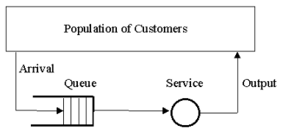

**Figure 1: theory of queuing website**

## 3.2.2 Upgrade of a new system in cafeteria

The older version of APU cafeteria uses TP card paying system which does not work well because there were many complaints from the students in APU confession page such as missed placed food orders, student waiting for almost 35 minutes in queue, missing orders and the most common complaint in the confession page is the students and staff are required to use only the ID card (TP card) to pay for their meals in cafeteria. Most students are unable to top up their TP card. Even if they have cash, they can’t purchase their meals because they don’t have the card with them. This makes the cafeteria queue longer when most students come to order and it takes a long period of time as the whole cafeteria will be crowded with students most of time during lunch break (Samarawickrama, 2019). Based on Bezarede mekonnen, there will be a huge impact to the cafeteria if it’s not properly organized. This is where the queuing website comes in because it is going to be very unique and something new for all the users in APU whereby everyone can surely adapt easily. APU users will be able to access their orders and collect it fast from the cafeteria because this website will be something new for students and staff of APU. This website will surely be very useful for APU and also for the upcoming students in future who will be coming to APU**.** (Bezarede Mekonnen, 2020)

## 3.2.3 University students and staff

Based on the Ojo Ayodele Oluwasuen, the queuing website was helpful for their research purpose when they implemented it in their university. The queuing website helps on saving the order time of students and staff by using the website. APU students or staff can use that time for doing something more valuable rather than wasting time for waiting in the long queue. (Oluwaseun, 2018) According to the research of Siti Azfanizam Ahmad, people will eventually adapt to the new queuing website since it’s easily applicable. The students, lecturers and staff can access to the Apu cafeteria queuing website in their laptop or mobile by entering to the website page. The APU users should just input their own student ID and staff ID for the lecture and staffs which it will be accessible once the account been registered. (Ahmad, 2018)

## 3.2.4 Implementation of the cafeteria website specially made for APU cafeteria

All students and staff should register their account in this queuing website with their ID card. The website is only applicable for APU students and staff and is only usable at the APU cafeteria. This website can be used to order meals in cafeteria from any distance. It is necessary that users are in APU campus area only (Kurniawan, 2020). Furthermore, this website will bring a positive impact and a difference in APU cafeteria when the students and staff start to adapt it. Outsiders who are not from APU won’t be able to use this website and make orders because this website has been designed especially for APU students, lecturers and staff only. According to Mourad Ouzzani, the theory of queuing will be more systematic and faster, which it has a lot of benefit for his research for applying for a mobile application. (Ouzzani, 2016)

## 3.3 Similar system

## 3.3.1 Skiplino

Skiplino is a good queue management system which allows customers to utilize easily and intelligently for the business purpose. The Skiplino website is similar to cloud-based system that collects and handles all the data of customers and the details of queuing correctly. Skiplino is based on cloud software that is very strong to access the data with great and fast performance. The data of customers will be stored safely and securely since this queuing website is more to cloud-based software. Skiplino also has a mobile application that is free to download for customers. Furthermore, with this app, customers are able to book their spot for queuing which attains the tickets in the location based on different services being offered. Skiplino queue management system records the service the customer has decided to use. There are three features in Skiplino which are, management and tracking, instant feedback and web booking. This queuing management is mostly applicable in banks.(skiplino.com, 2021)

## 3.3.2 Q less system

Q less system is mainly created for social distancing and it’s a great application which serves to customers. Q Less system helps customers properly organize situations to avoid long queues and lines. Besides that, Q less have instant paying methods. There are three types of systems being used for this q less which is virtual call- back queues, flex appointment and remote system. Qless system collaborates with many industries. The main vision of this system is to do scheduling appointment and proper queen managing platform. (qless, 2021)

## 3.3.3 Wave Tec system

Wave Tec is a queuing management system which is mainly created to reduce the time of queue. It provides a great service for customers and makes better staff efficiencies. Besides that, Wave Tec has good philosophy and vision that can be a good target in order to engage, organize and measure. Wave Tec is a queuing management system that has 27 years of experience serving around the world. It provides many types of system that can make better customer flow such as queuing app, linear queuing, queue display and also queuing management software. (wavetec, 2021)

## 3.3.4 Comparison of similar system

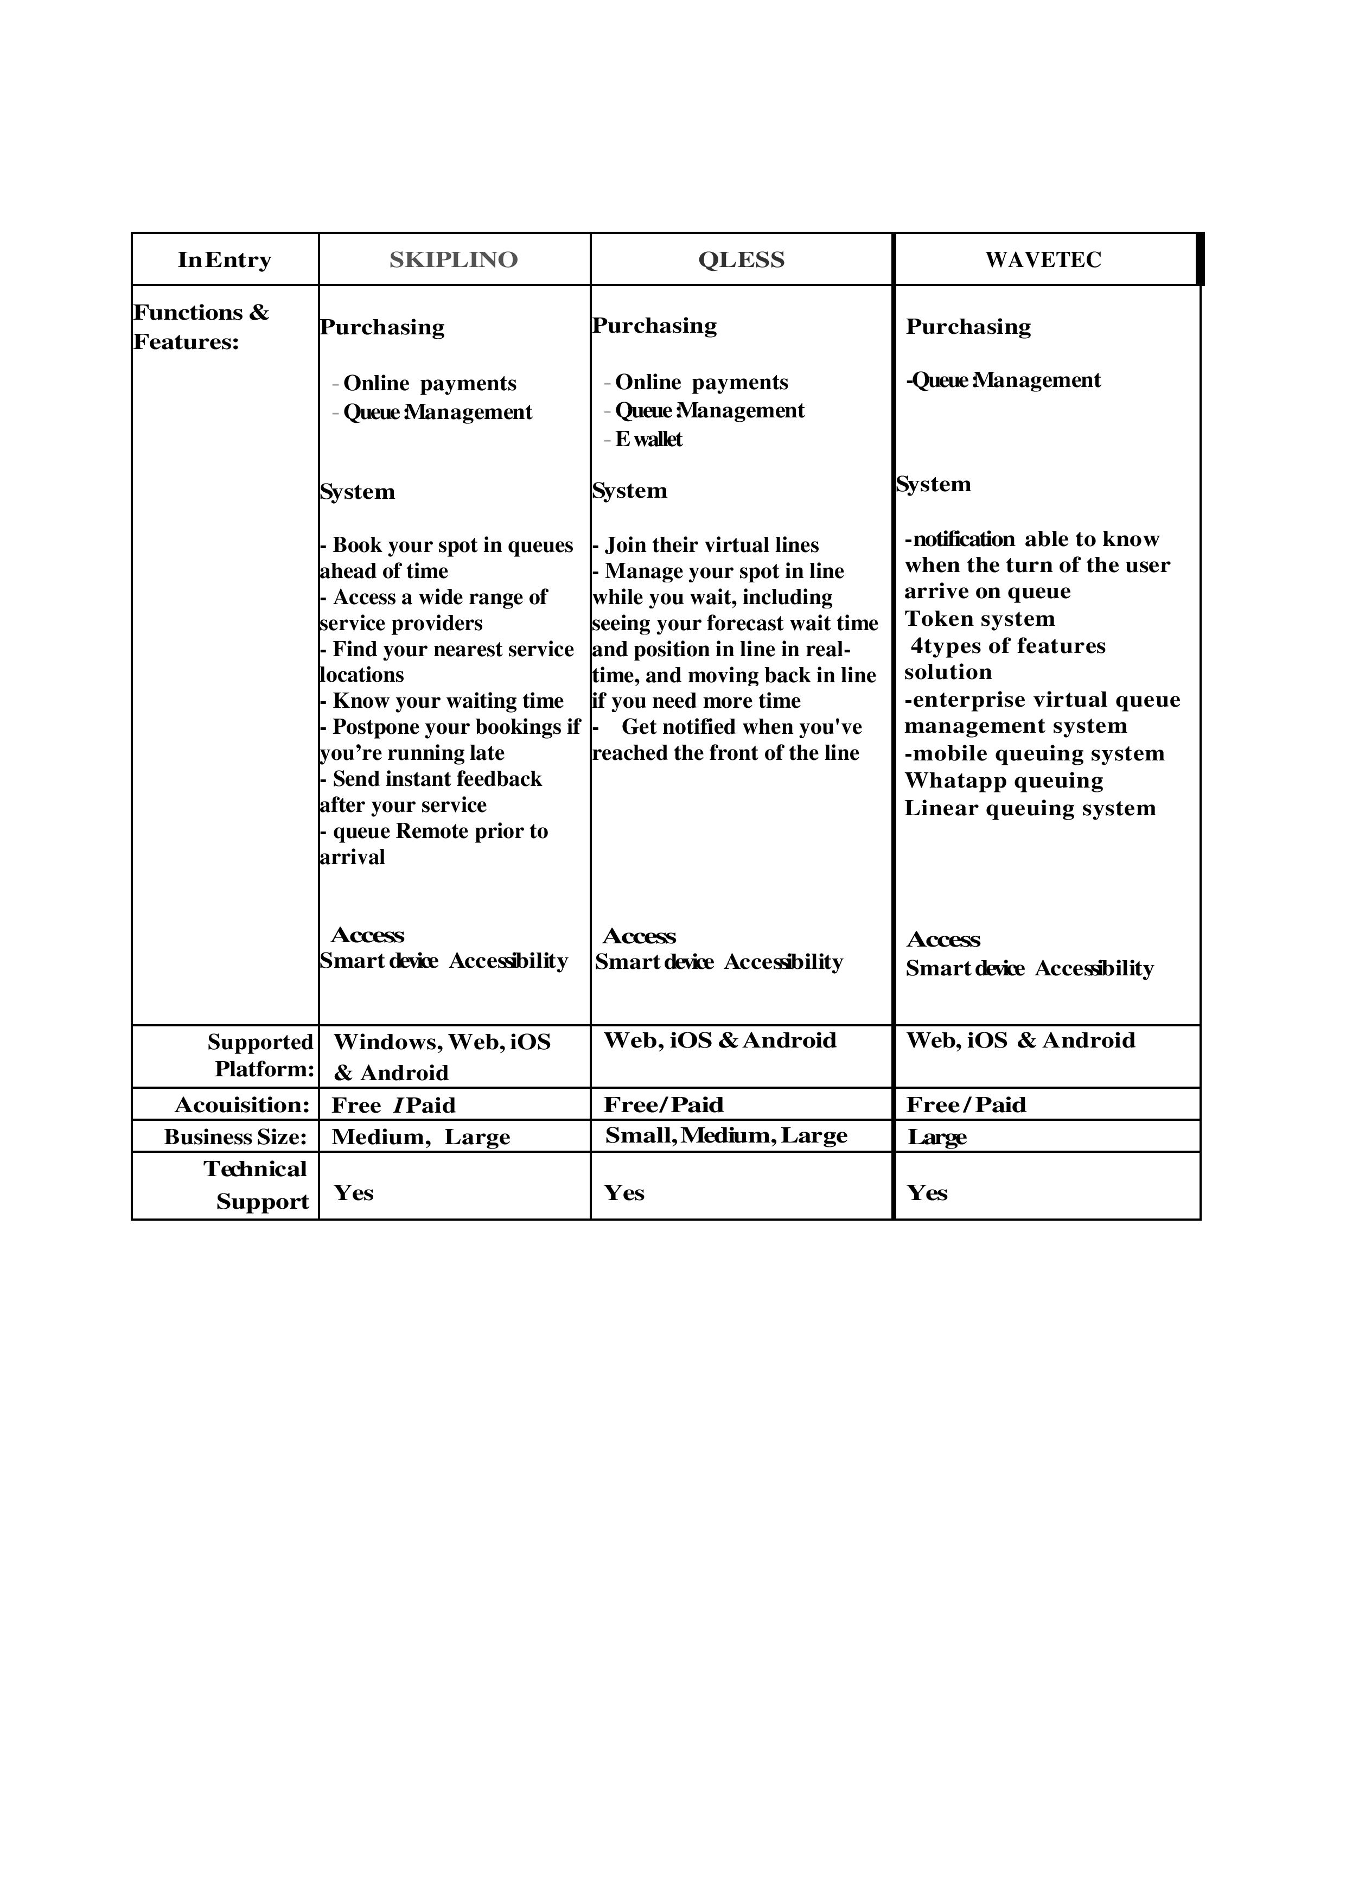

Based on the table above, there are three types of similar systems. Skiplino is only able to satisfy the criteria of website and application whereby same goes to the three of the similar system but Skiplino mainly concerns on booking. On the other hand, Q less attends more to the online paying system with various supporting paying methods which are similar to wave Tec. Wave Tec and q less have similar types of notification ability. Skiplino uses the other method which is remote system. Based on this comparison, this research will surely take into consideration on developing and designing a better version of queuing website for the APU cafeteria.

## 3.4 Summary

In conclusion, the importance of domain research in literature review has make a dept research within the topic manner and it manages to find the reason and importance of the reach topic which should be a concern on during the development of the APU cafeteria queuing website. The domain research has touched on APU cafeteria website, Upgrade of a new cafeteria system, University students and staff, Implementation of the cafeteria website specially made for APU cafeteria and on the similar system which been compared in the research domain. The system comparison provides an advantage on having a basic understanding of the system which will be helpful in knowing the functions during developing the APU cafeteria queuing website (Swami, 2020).

# Chapter 4: Technical Research

## 4.1 Programming language: PHP

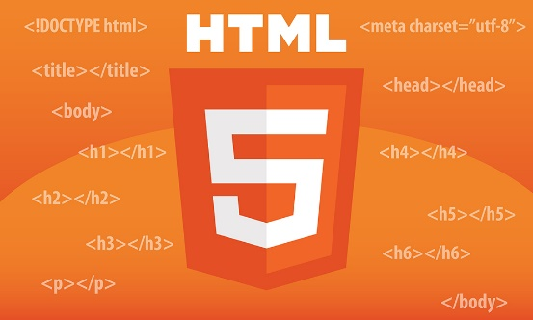

The programming language which is selected for this proposed website is using PHP. PHP is actually used for managing, the content, and dynamic, database and does help on building website. It should be integrated together for the database which is MYSQL which be really helpful. Another name of PHP is called as hypertext preprocessor. (tutorialspoint, 2021) . PHP language will be really great because it have a great system function and can handle all the files correctly. Besides that, in PHP, the developer also able to delete, add and modify the elements inside the database thought the PHP and it also can encrypt the data. (tutorialspoint, 2021) HTML will be also using to develop this website. HTML will help on structuring the web pages with the proper contents such as inserting pictures.

## 4.2 Notepad ++

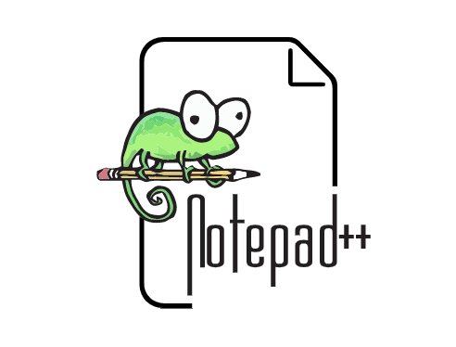

The selected interactive development environment (IDE) for the development proposed for this website will be Note pad ++, in order to the text editing with a lot of great features in it. Notepad++ is a great integrated development environment for Linux and Microsoft windows. This notepad ++ is actually specially design for editing the source codes and its easy whenever to do changes on the text file. This IDE is a really helpful for the developer to build the website and design. (Hope, 2021)

## 4.4 Database Management system



MySQL is actually a proper SQL rational database management system. It does a proper structuring the query language. This MySQL, will benefit during the process of the queuing website because it will give a good support on developing phase on the data management. (mysql, 2021)

## 4.5 Operating System



Microsoft window 10 is the operating system which will be used for the developing this website. Windows operation system is great because it helps on developing the website with many types of software which can be create and design the website for all type of target users. The user interface of window is really easy to use and it has great features in I t. there are many windows users which does make beneficial on developing the propose website with windows. Windows is a great operating system which will be really suitable and great choice to develop the website. (Rehman, 2021)

## 4.8 summary

Finally, the decision-making and research on to interactive development environment was done in order to make sure which language and platform is really suitable for the propose website in the future. Notepad ++ will be the most suitable IDE throughout this development phase of this project and the selected framework on this proposed website will be done in PHP and HTML which are a great programing language which was learn on course. In the final stage, the operation system which is used by laptop is window 10 as most of the user platform are window user. The IDE platform was actually build based on Linux webhosting because it’s easy to integrate with the notepad++.

# Chapter 5 business Care

## 5.1 SWOT analysis

SWOT analysis stands for strength, weakness, opportunities and threat which is a great technique for evaluating based on the four aspects of business. (mindtools, 2021) This tool is able to analyze in order to make the business more successful for the future. SWOT analysis will be a great strategy to grow the business and reduce mistakes in the business and have more understanding on company threats and way to create opportunity which will be a great advantage for Asia pacific university. (Parsons, 2021)

## 5.2 SWOT analysis (Asia Pacific University)

**Strength**

Asia pacific university is premiere compare to the private universities in Malaysia. APU has receives almost 200 prestigious award local and internally which does portray the excellence of APU as being a great university and education provider. APU does offer dual degree programing which is associated with Staffordshire University. APU provides almost 30 facilities which can bring a great experience and learning atmosphere for the students. Apu does provides scholarship for most of students and APU does offers almost 70+ degree which is specialized programmers. APU does have a great new metropolitan modern design campus which will attract the students and upcoming high school graduates. Most of the universities in Malaysia does have more occupy of local students but APU is one of the universities which have been rated number 1 in Asia for having a great multicultural learning experience. This can be a great advantage which all students able to have a good strength among the multi ethic in this multi culture education. APU have a very strong marketing strategy around the world which able to bring many students from the different country to study in APU. (apu, 2021)

**Weakness**

There is also some weakness in Asia pacific university. Apu applies basic education system when it compares to all universities which most of the universities does have similar kind of education system. The student fee for student is very high compared to some other private universities in Malaysia. (apu, 2021)Besides that, the web portal which is design for student to login is quite poor which the server will take time to upload assignments or folder in it. APU have an own mobile application which does not have a great function. there were some complains from the student from the APU confession page regarding the facilities which should be improve and some of the facilities such as accommodation, parking and recreational are not free to use and its chargeable, for example the cafeteria system is not clean and kind slow which make the cafeteria crowded by students and the prices of the food and drink is really expensive**.** (Elankovan, 2021)

**Opportunities**

Asia pacific university should come up with the idea on compulsory implementing the internship program because some course doesn’t need internship program and by having this implementation, the student will have greater opportunity on working experiences and gain knowledge on work ethics. Besides that, the curricular activities and program should be concerned well because it’s really important for student on participating all the curriculum activities which had in university. In order to avoid competitors of universities, Apu should concentrate on the cost and should provide cheaper cost for the students and should not change on the facilities. (APU, 2021)

**Threats**

Asia pacific university should concentrate on the pricing because when it compares to other universities, the facilities are mostly all free for those students and the course fee is little cheaper compare to APU. Other universities does offer cheaper price for their program and course. There is also a minor threat which the international students from APU are restricted from working here in Malaysia. The cost of living as a APU student have been increasing has every year comes which could be a threat and other university has a moderate and simple living cost as a student. (APU, 2021)

# Chapter 6: system development methodology

## 6.1 introduction

In order to develop a good software, software development meets should be really important in developing as it is a framework which structure, control and plan on the developing process of the information system (queuing website) which does fulfill the expectation of the users .the purpose of the developer to apply software development methodology is because it provide a stable system, and gives a clear understanding on the task for the project. (Technologies, 2021) Besides that, this methodology development actually doesn’t need any technical feature but there should be a proper planning on the life cycle of the system development. Furthermore, for this propose system development, there are two methodology model which was selected to compare in order to find which is really helpful to do the decision phase and assisting on the development of the system. The two selected methodology force comparison is rapid application development model and water fall model. (Team, 2021)

# 6.2 methodology comparison

## 6.2.1 Waterfall model

Waterfall methodology is the process model which been introduced firstly in the system development life cycle (SDLC) and it also name as waterfall model which is a sequential process which use for developing like a waterfall thought from the process of project. This waterfall method be really helpful on making a good effective project and this model been divided separately in different phase, which named as waterfall as each process phase does go downwards from each process correctly. Furthermore, each phase should complete fully in order to go the next phase in correct sequence and can’t skip or go overlap on any of phase. (tutorialspoint, 2021)

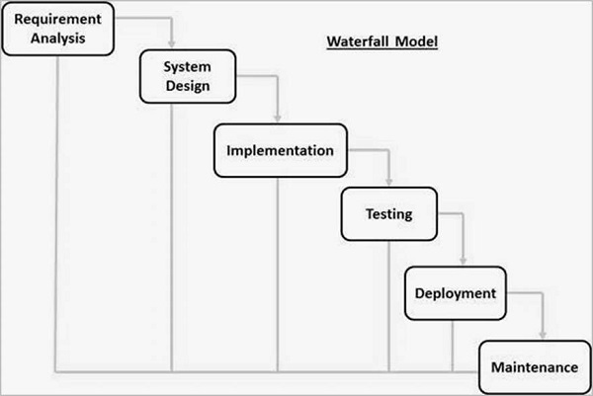

Figure: water fall model diagram (tutorialspoint, 2021)

Waterfall methodology does actually have 6 stages which is requirement gathering and analysis, system design, implementation, integration and testing, system development and maintenance. The first stage is the requirement gathering, it helps to collect document specification and details based on the requirement understanding before starting a project. (tutorialspoint, 2021) The second phase is design phase which will do the designing based from the first phase of requirement specification. This design phase does on the whole architecture of the system. Then, implementation phase does integration with the small input from the system design and do the integration with the following phase. moreover , after all unit have done the development in the implantation phase , it will bring it into the testing phase to check if there is any problem occur or error detect in order to run the system correctly without any issue . Next is, the deployment phase where once the testing phase is done correctly to find the system function correctly, it will be ready to deploy for the customer in the market. the final phase is , maintenance phase where the system maintenance will occur and does the regular maintenance like , updating , upgrading and doing the modification of the system in order to make the system perfume better . (Sharma, 2021)

**Advantage of the waterfall methodology** (Martin, 2021)

* It is suitable for small projects
* Each phase should complete before going to the next phase
* This model is easy to understand and easy to be applicable for the user
* This model does help on save a lot of time on each process
* The waterfall model is easier to handle for the project because rigidness of the model.

**Disadvantage of the waterfall methodology** (Martin, 2021)

* If ever there is error or problem, only able to solve it in that particular phase
* The testing process arrive late on the waterfall model
* This waterfall model can’t able to add the feedbacks of client during the development phase
* Can’t do any modify on the software once the testing phase have begin
* Waterfall methodology does not suit well for the project which need a long term of maintenance.

## 6.2.2 Rapid application development model

Rapid application development is known as RAD model which focus on the development of the model which have rapid prototyping and fast feedback on the testing cycle and development process. RAD model helps the developer to make few repetition and updates on the software quickly without requiring any schedule of development on each time. Besides that, RAD model does give a very fast result on developing compare to any other software development methodology. this RAD model does need iterative model and incremental when there is a team which in smaller group of developer, expert of domain, representative customers and all other IT resource does need to work on their prototype in order to make the prototype successful. The main concept of this RAD model is to ensure the prototype is able to use repeat and successfully. (kissflow, 2021)

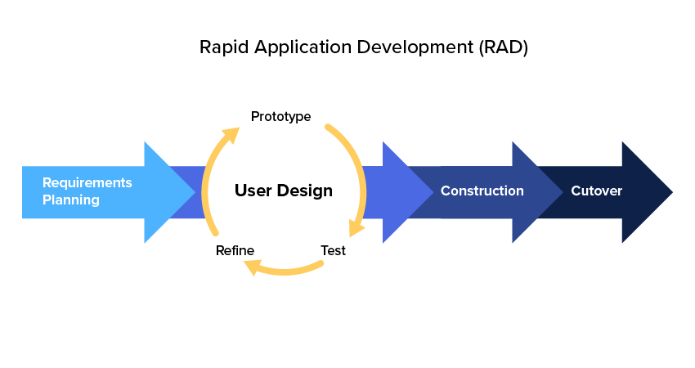

Figure: Rapid application development model diagram (kissflow, 2021)

Rapid application development methodology have four phases which is requirements planning, user design, and rapid construction and then cut over phase. The phase user designing and rapid construction will be going throughout rill this project meet it requirement correctly based on the expectation. The first stage is requirement planning which the developer, member of team and client will build expectation on the project and the objective will also be discuss in order to prepare ahead from potential issue which may occur during the development process. Second phase is user design which the target users does work together along the development process of system to make sure the important of project on each steps on user design phase. The developer will actually allow to user to test and use the prototype on this phase in order to make sure, if the developer does satisfy and make the prototype as the user expectation. Furthermore, in the rapid construction stage, the prototype which is done from design stage will be change into the working model because most problems will come during the design phase, which it let the developer to construct the final working model as fast as possible. Here is the phase where, the system testing, the coding and integration applied. The whole team of project should work together in order to make sure the system works well and smoothly without any issue and does satisfy the target user expectation and objective. The final stage of this phase is, cutover stage is the stage where implementation will occur which the complete product will be launch to the target user in order to use. (Team L. C., 2021)

**Advantage of the Rapid application development**

* It’s easy to adapt and flexible
* It’s easy on moving the deliverables
* With the less amount of people, productivity can be increase in the minimum time given
* It able to make more reusability on the development component
* This model allows the user to check and review during the development phase of project

**Disadvantage of the Rapid application development**

* It need user to involve thought the development process o
* RAD model will suit for project with bigger budget
* It more complex on the managing process
* It’s not suitable for small project

# 6.3 justification on chosen methodology

6.3.1 Difference between waterfall and RAD model (Puzhevich, 2021)

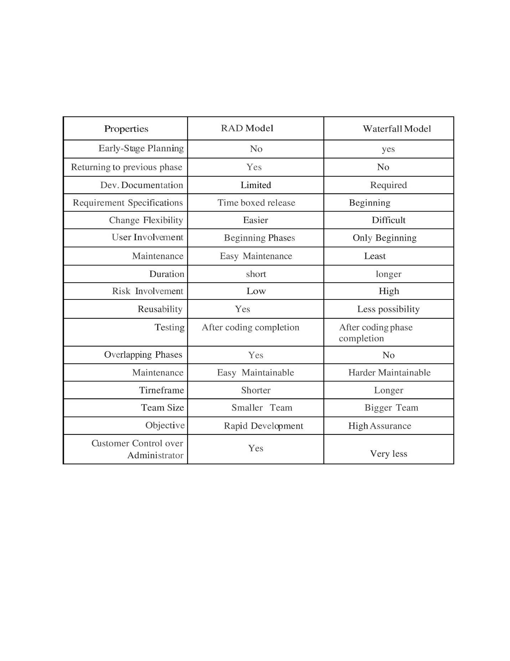

## 6.3.2 Methodology justification

According to the comparison between waterfall and rapid application development, waterfall methodology will be the suitable methodology which should be applied and developed on the proposed system project. This waterfall methodology is a great option because it’s much better because it’s easy to utilize and much more safe based on the time constraint for the project which not that long. Besides, in this methodology the coding will be flexible on the development changes which easy to implement on previous stage if ever it needed and it is really suitable for creating website. Waterfall model give a great benefit because I able to do changes during the testing phase easily and can able to change according to user expectation if have required and able to add more features on it based on more ideas during the building process of the website. Waterfall model has a great method which includes requirement, design, implementation, testing, deployment and maintenance stages which will be really helpful for the developer to go on order smoothly on the progress of developing the proposed website. Finally, by implementing waterfall model, the risk of problems will be lesser and can be able to do it without any problem by splitting in to dew segments , which make easier when the developer do it step by step . (Mochal, 2021)

## 6.4 Brief overview of implementing on the chosen methodology

Waterfall model is the selected methodology which it contains six phases that will be implement for the proposed project during the development which is requirements, system design, implementation, integration and testing, deployment and the maintenance.

**Requirement**

This is the first stage where the developer could collect all the information about the requirement of project before starting. Developer able to collect many types of information in many ways. Before this phase end, the requirement of project should be clear for the developer and should have a requirement document as well. (lucidchart, 2021)

**System design**

By applying the requirement from the first stage, the developer able to start designing the website. There should not need any codes during this phase but able to decide on what hardware is require and programing language is suitable for the website. (lucidchart, 2021)

**Implementation**

This is the phase where coding involves, the developer able to get information from the previous stage and to implement on the proposed website. (lucidchart, 2021)

**Testing**

After the coding is complete, the testing stage will occur in order to do find out if there are any problems occur. If there is any problem on the project, it can be fix and edit in the codes in this phase or may have to start from phase 1 for better outcome of proposed website. (lucidchart, 2021)

**Deployment**

This phase, there will be a proper complete outcome of the proposed website which will be ready to deploy (lucidchart, 2021)

**Maintenance**

The proposed website have delivered well to the user and it’s been using and mean time, if there is any issue occur, the developer able to do update and do some patches to solve the issue by returning to the required phase. (lucidchart, 2021)

# Chapter 7: Research methods

# 

## 7.1 Introduction

Data analysis is a very important part in any research or studies. By applying data analysis, it provides a good understanding on the data, trend, information which will determine the reason for the analytical. The two categories of research method include quantitative and qualitative method. Choosing the right research method for this investigation depends on the various kinds of questions that are asked and what type of responses the researcher receives from the respondents. As a result, quantitative data gathering method has been selected for this particular research and the tool selected in order to conduct the research will be the research survey questionnaire. (skillsyouneed, 2021)

## 7.2 Questionnaires

Questionaries’ is a tool used for doing research that has a list of questions needing response with the purpose of collecting information. Questionnaire is a method of data collection that is beneficial for collecting data from large number of respondents. It is able to collect various information from different respondents that would be helpful on analyzing data. (McLeod, 2021) Besides that, questionnaires are a great choice when doing data gathering as it saves time from and is able to get fast response from the respondents. The questionnaires are designed using Google form which is accessible to everyone since its free. Furthermore, Google form is great for doing questionaries’ because it has a function generates graphs and charts automatically. This will be helpful for the developer to analyze data. The main objective of this survey is to collect information on the importance of applying Queuing website for Asia pacific university and gathering opinions from the students of APU on this queuing website. The target respondents for this questionnaire are Asia pacific university students, staff and lecturers. The survey is expected survey to have 25 – 35 respondents in order to make a great data analysis.

## 7.2.1 Design of questionnaire

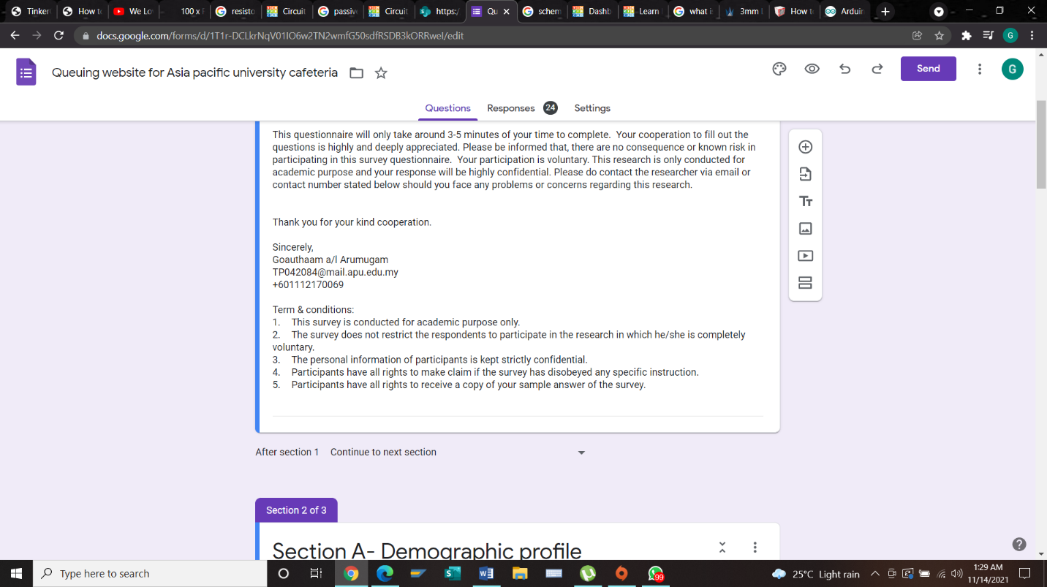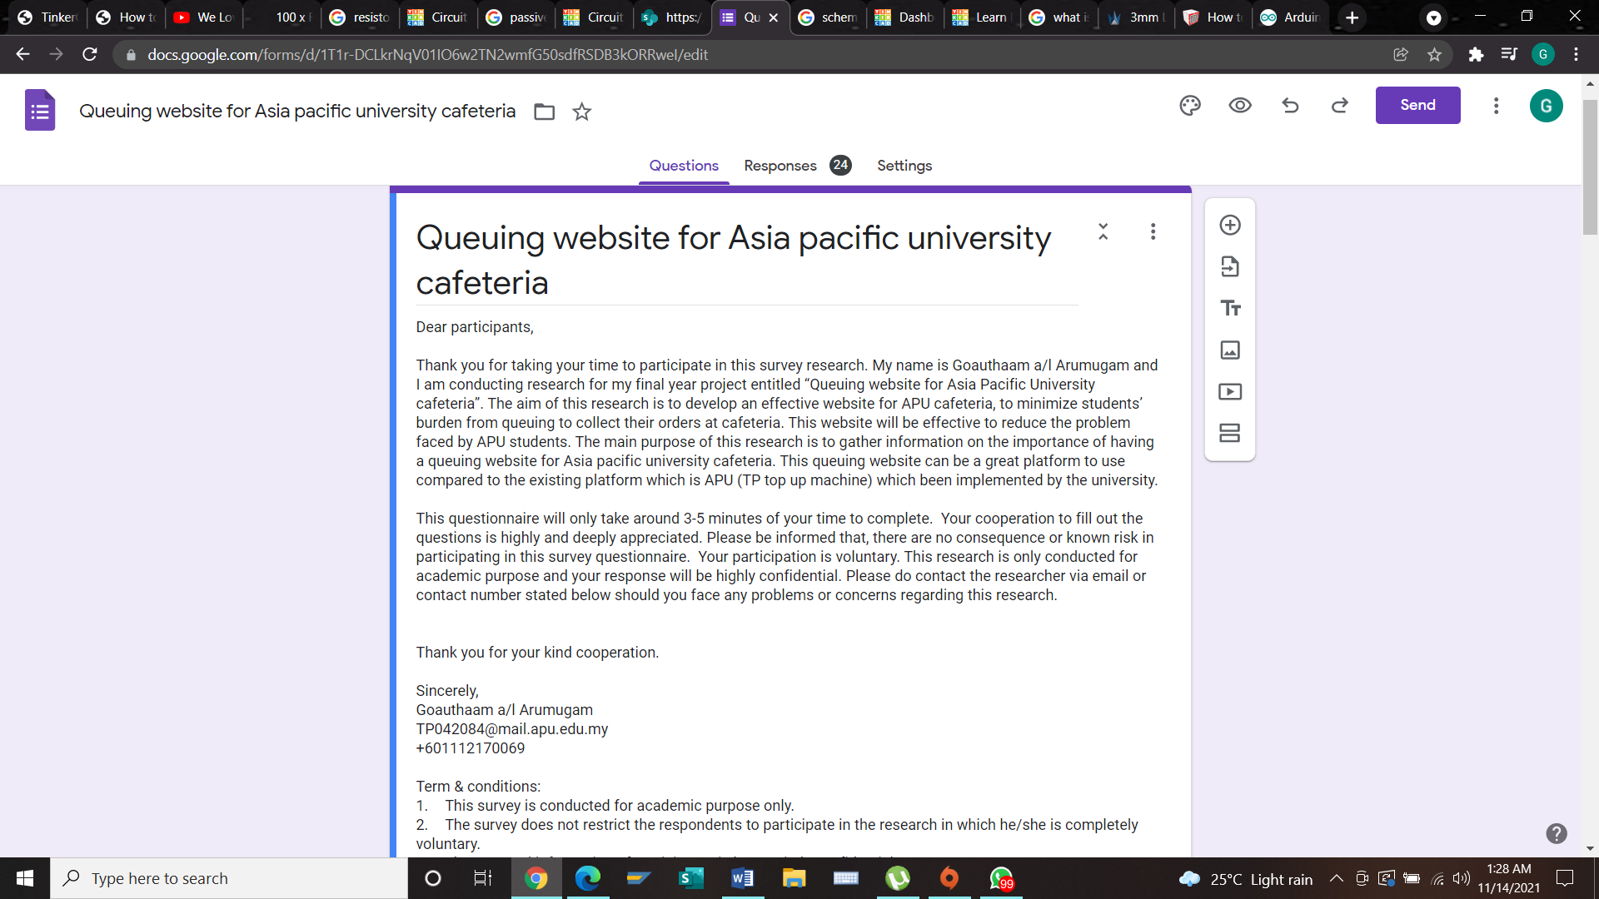

**Section A**

This section collects the demographic details of the participants.

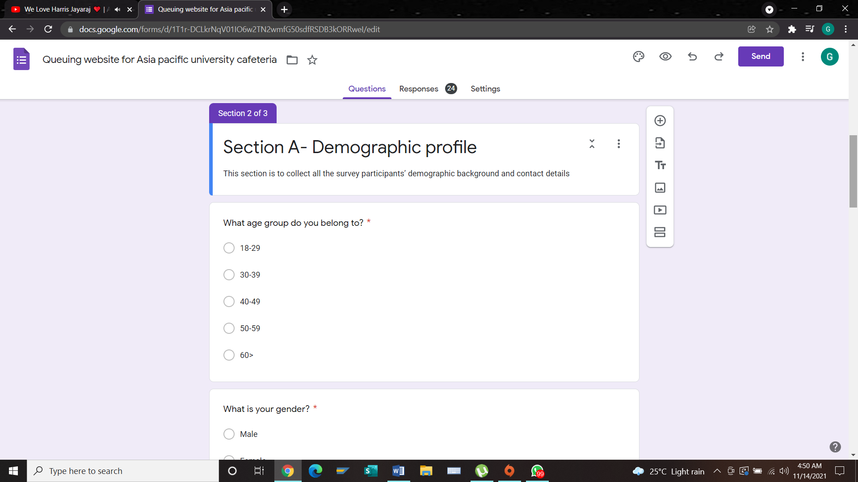

**Objective:** to find out the age group of every participant

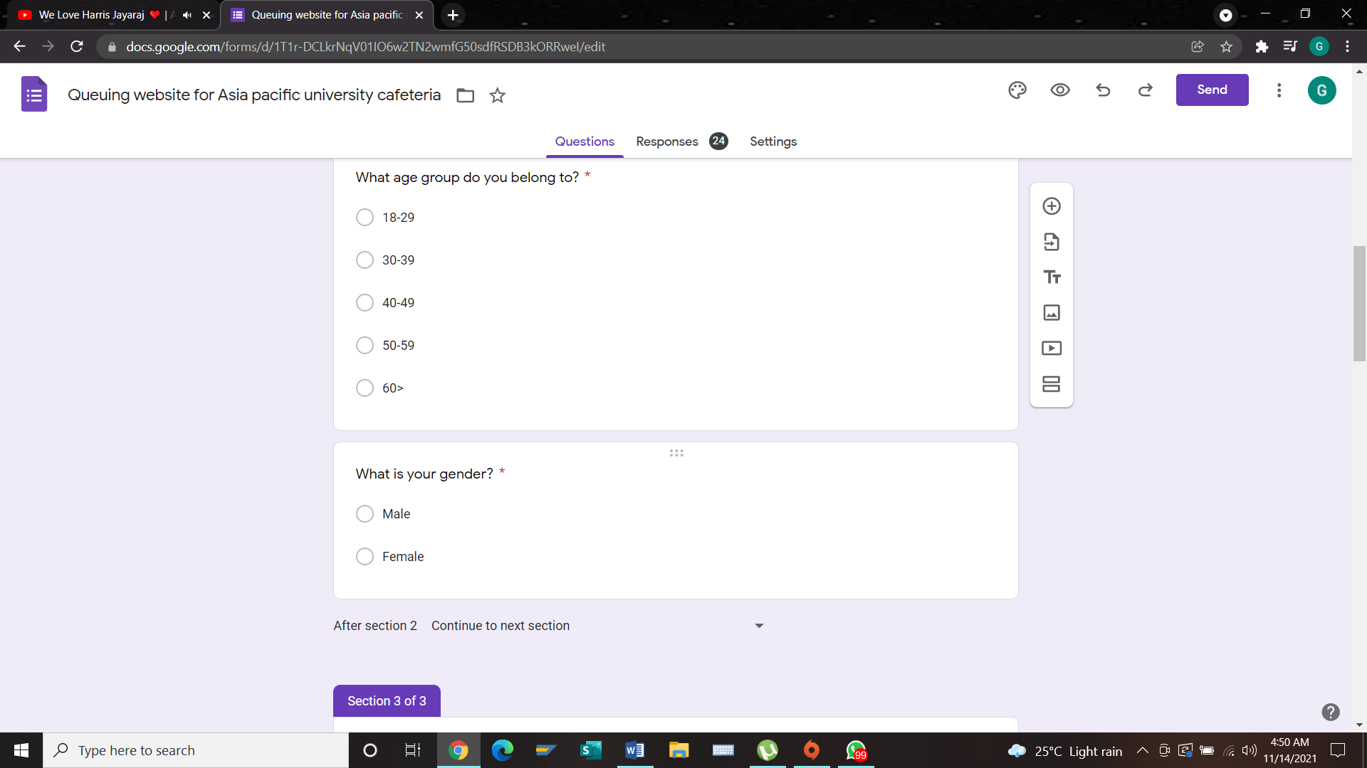

**Objective:** identify the percentage between two genders

**Section B**

This section aims to recognize the opinions of participants on the queuing website and their preferences on a queuing website.

**1)**

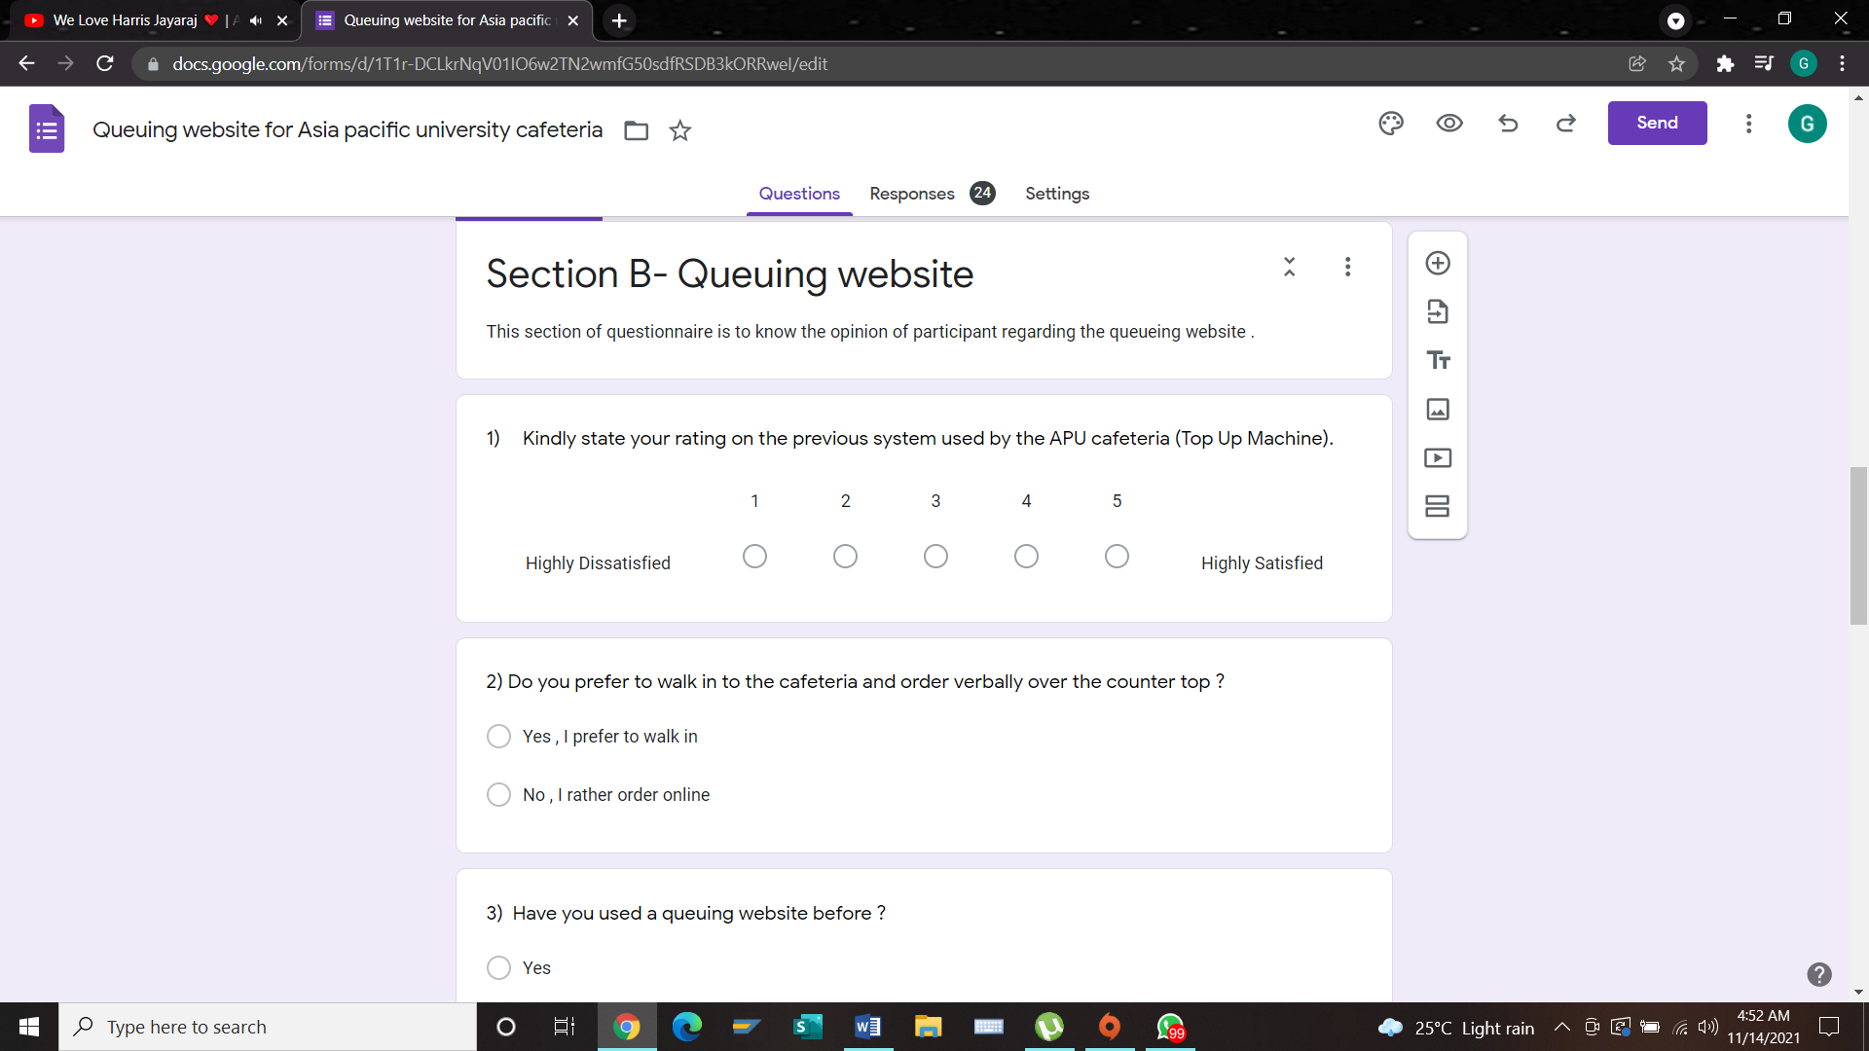

**Objective:** to find out the perception of participants on the previous system (Top up Machine) and the satisfaction level.

**2)**

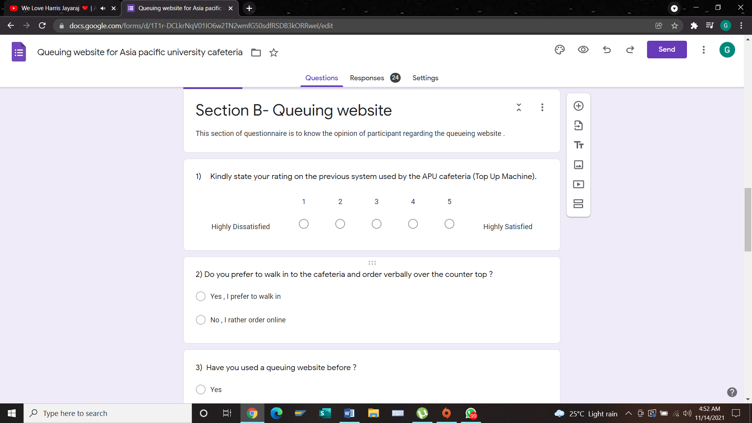

**Objective:** to find out if the participant prefers walking in to purchase their meals at cafeteria or purchasing it online.

**3)**

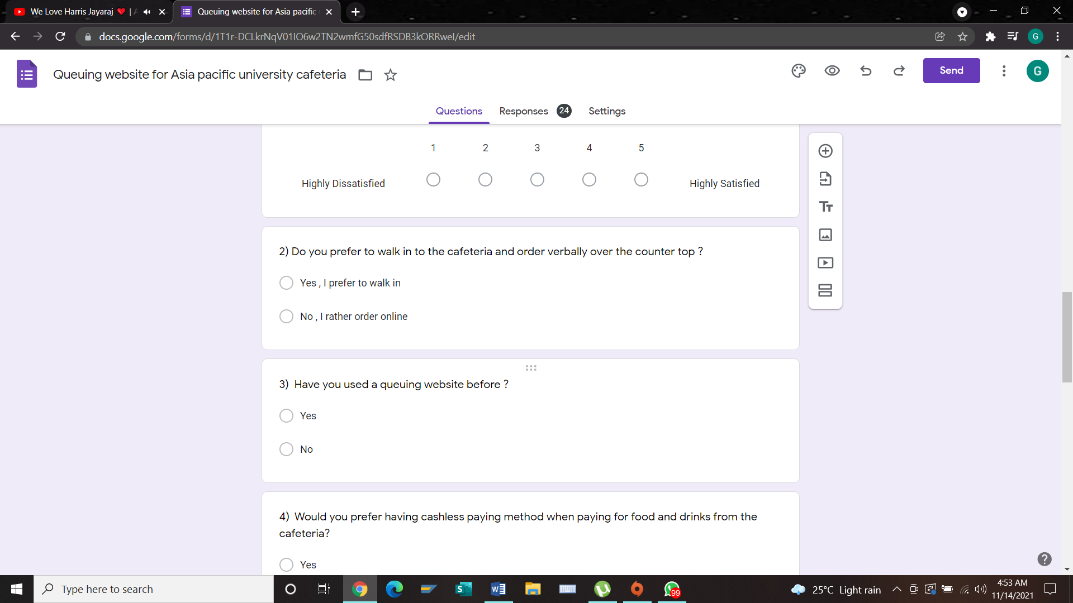

**Objective:** to find if the participant has used a queuing website before

**4)**

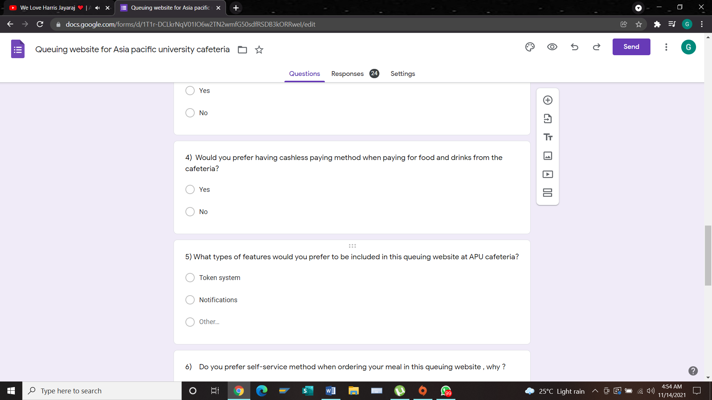

**Objective:** to identify if the participant prefers cashless paying method which should be applied at the APU cafeteria.

**5)**

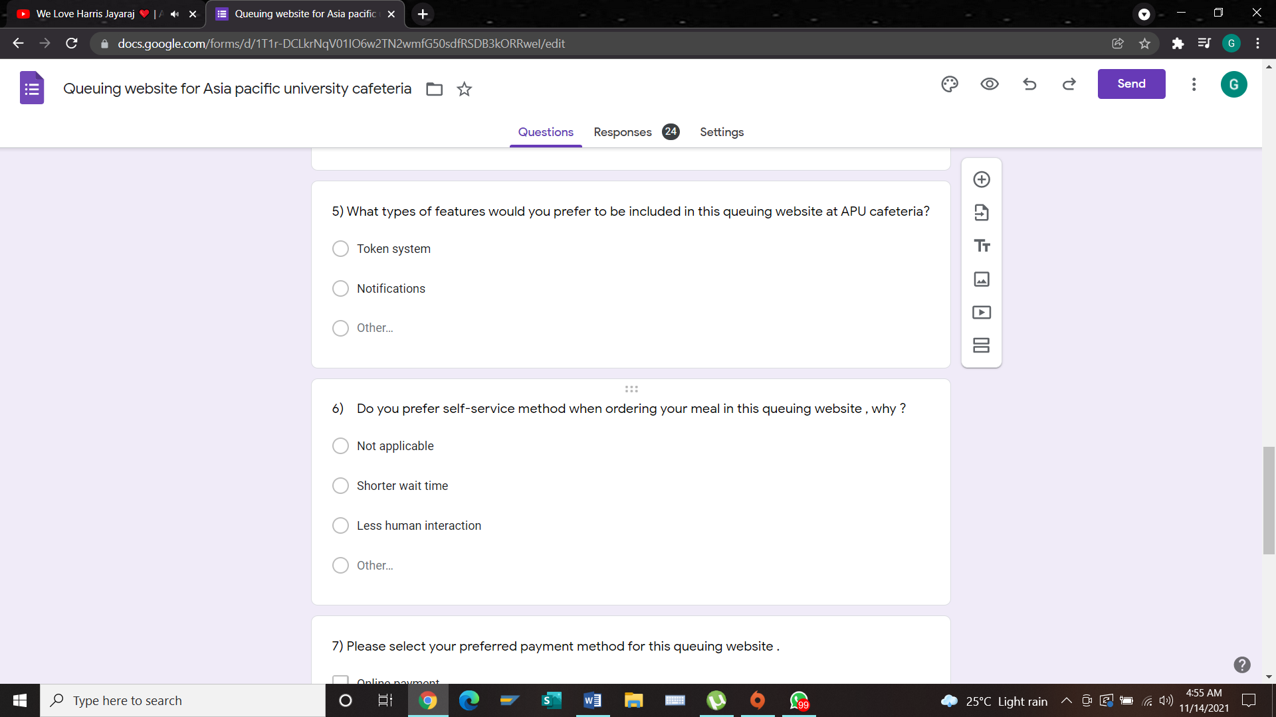

**Objective:** to find which features participants prefer and which should be applied on the APU cafeteria queuing website.

**6)**

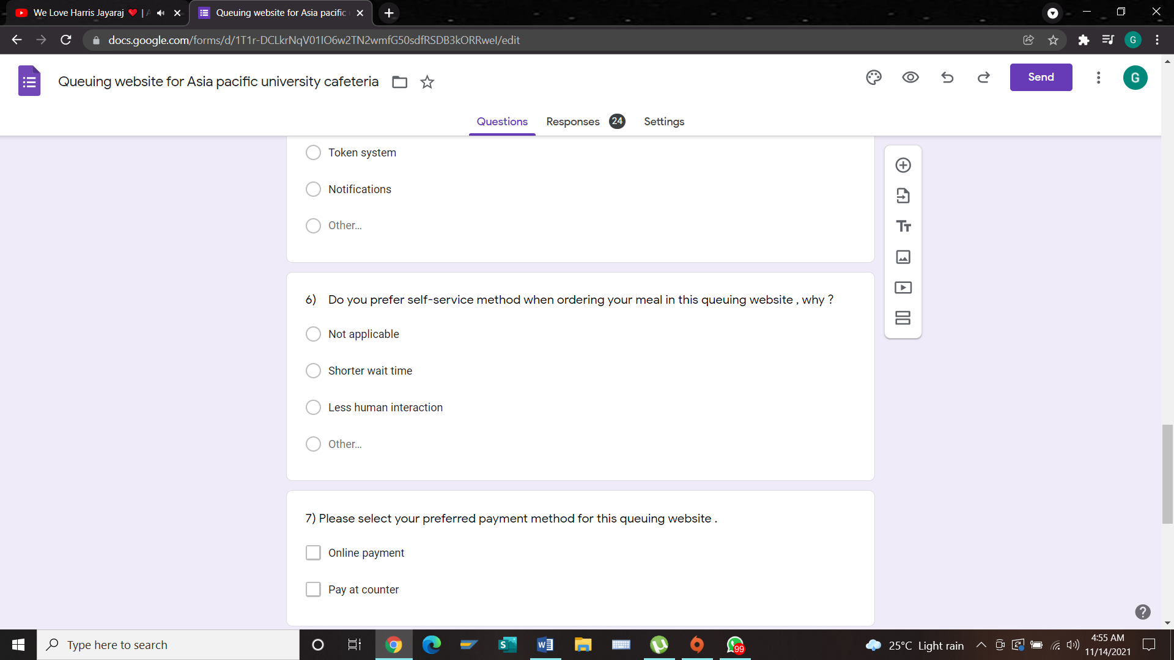

**Objective:** to know if the participant prefers self-service method which will be applied in the queuing website and what are their preference based on choosing this queuing website.

**7)**

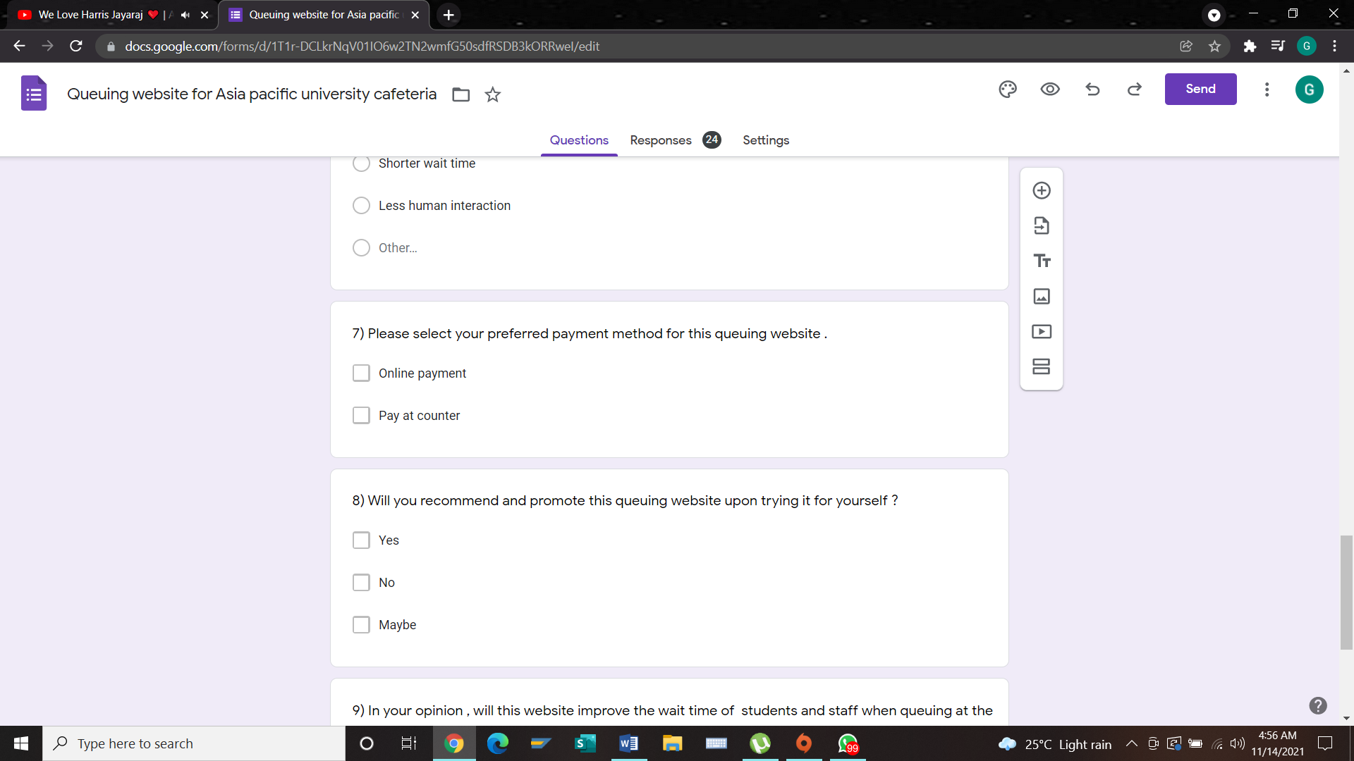

**Objective:** to find out what are the preferable payment method of the participant.

**8)**

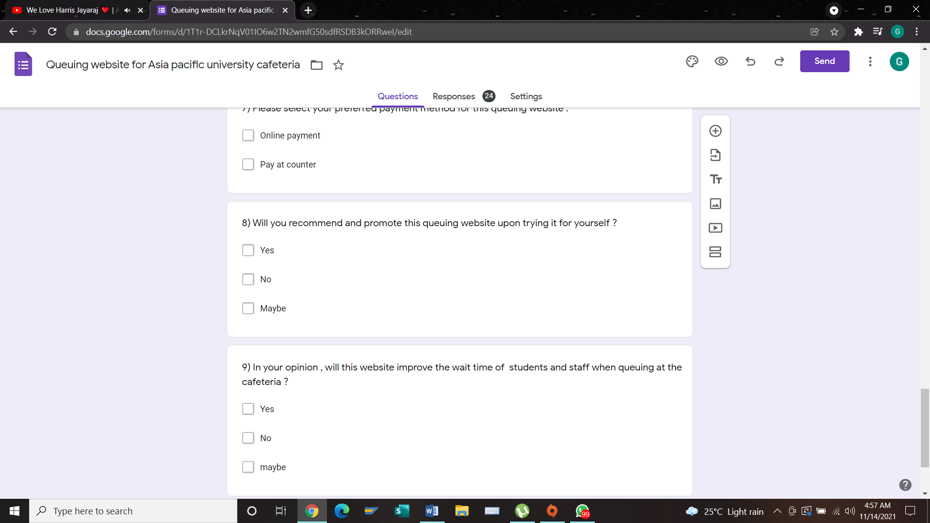

**Objective:** to know if ever the participant will promote and recommend this queuing website for APU cafeteria upon trying it by themselves.

**9)**

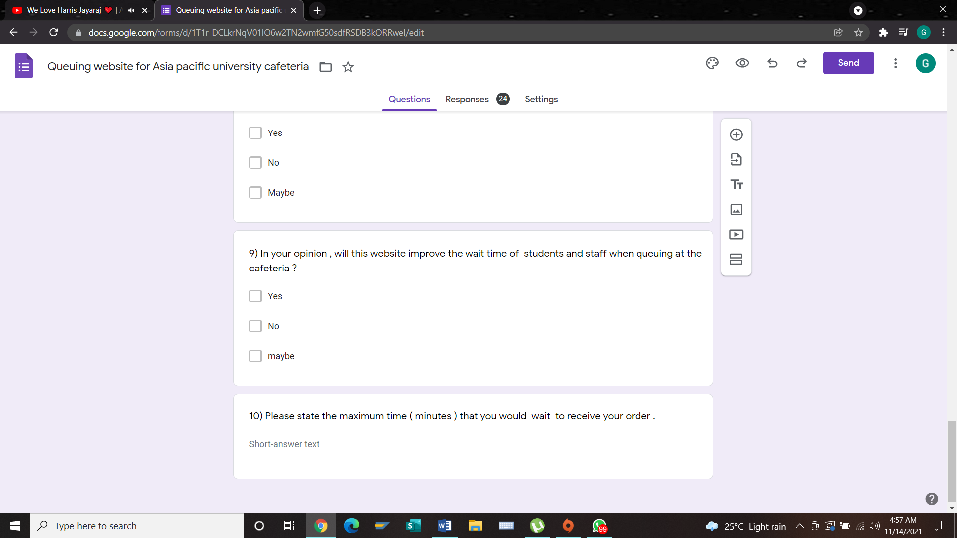

**Objective:** to find out the opinion and perception of participants on knowing if this queuing website will benefit them by improving their wait time for orders.

**10)**

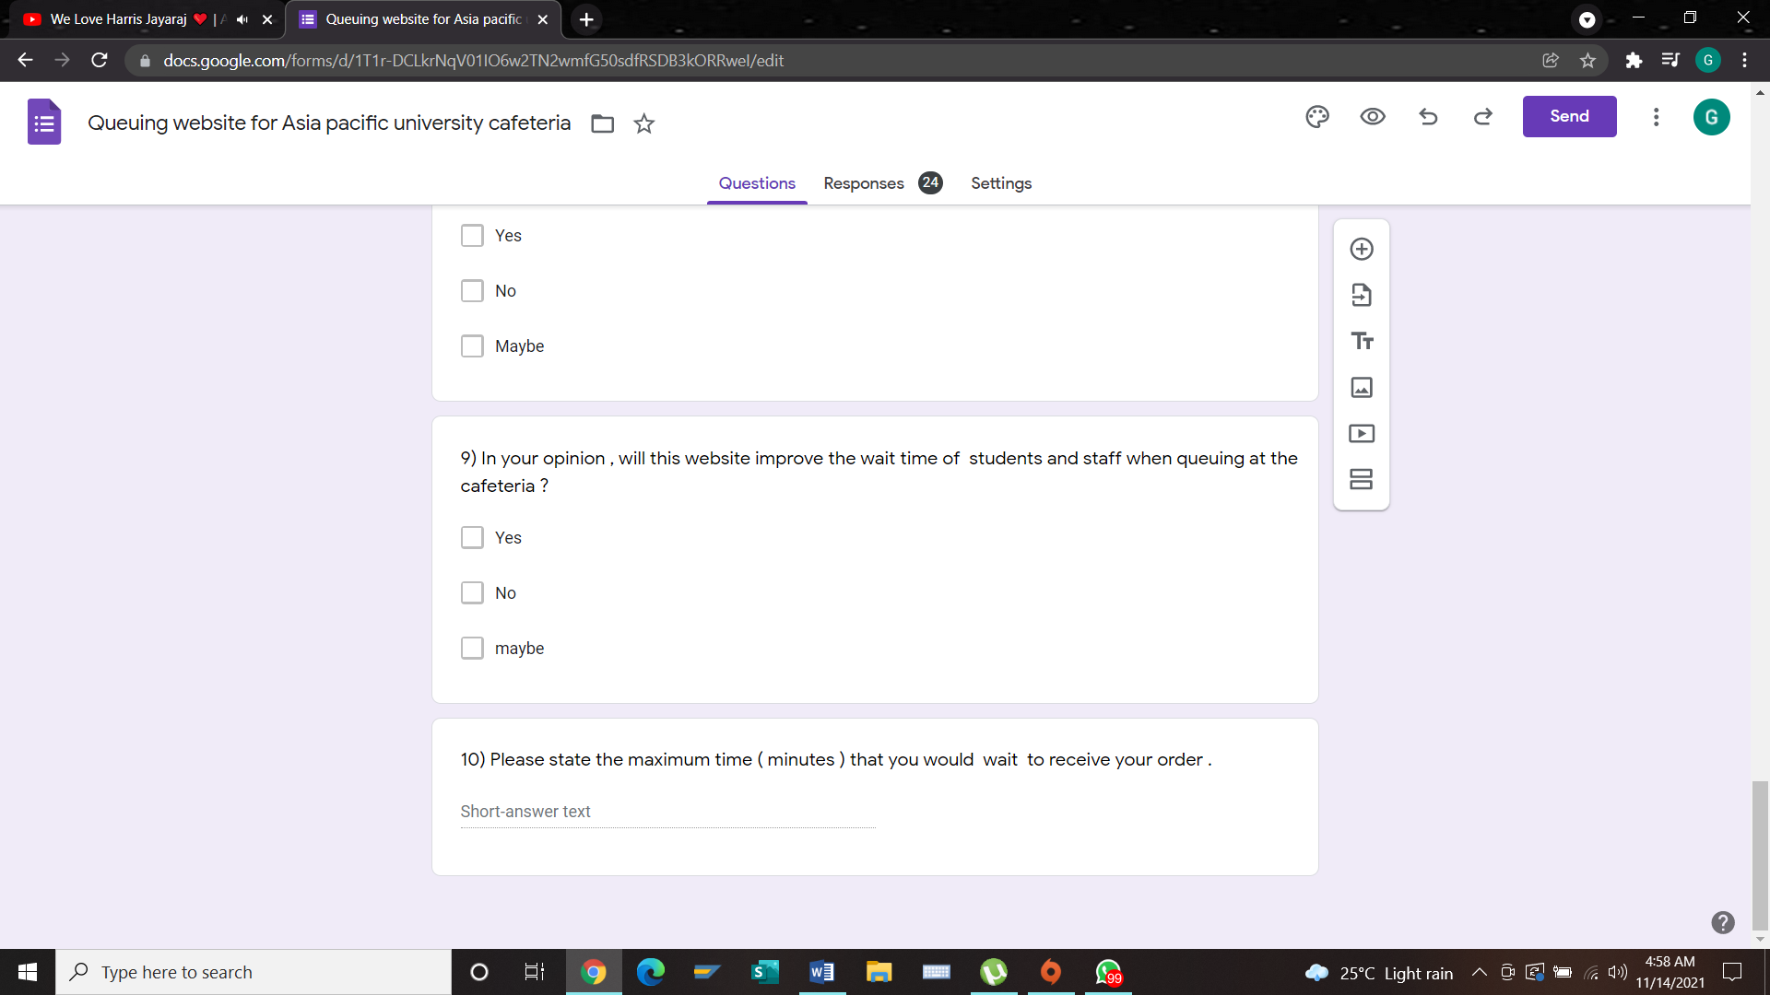

**Objective:** to find out how long approximately the participants will wait for their order.

## 7.3 Summary

From the beginning till the end of process on making and developing the questionnaire form, the question asked to the participants should be general and not technically because not many participants understand the subject or topic. Besides that, it’s important to give accurate instruction to the participants when selecting their answers. There are objective and subjective form of questions to broaden the types of responses.

# Chapter 8: Requirement validation

## 8.1 introduction

The form of Questionaries was widely distributed by using the proper sampling method to collect information from respondents. The target participants for this questionnaire are APU students, lecturers and also staff. The analysis below has been divided accordingly in order to avoid confusion.

## 8.2 Analysis based on questionnaire data collection

## 8.2.1 Questionnaire

**Section A – Demographic Profile**

**1)**

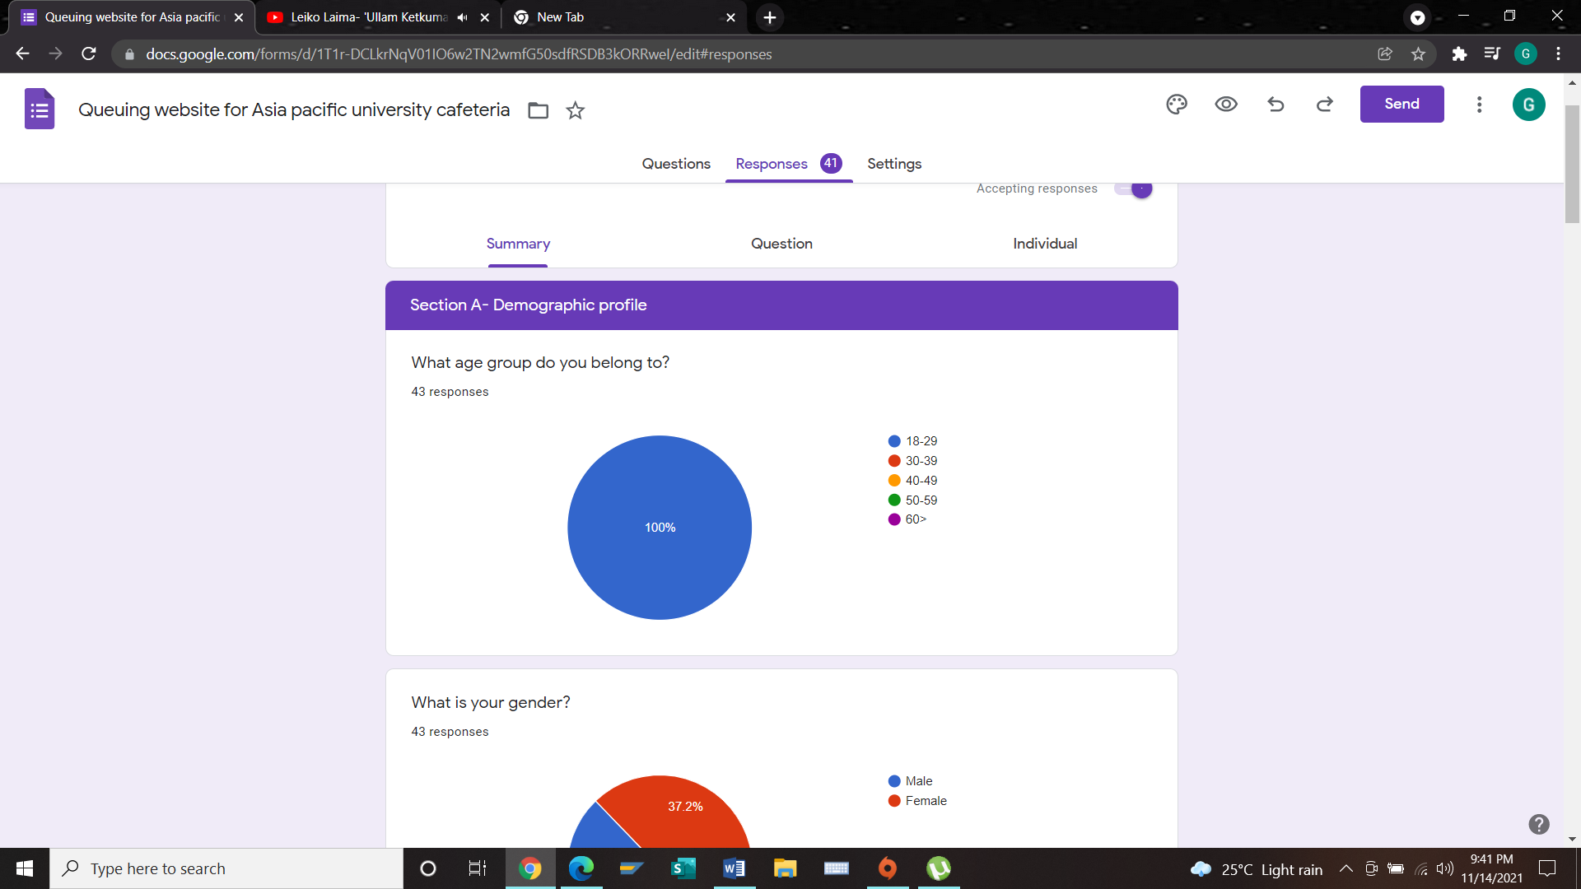

Based on this chart, 100% of participants who completed the survey are from the age group of 18-29. This analysis shows that all participants from this age group have shown interest on this survey.

**2)**

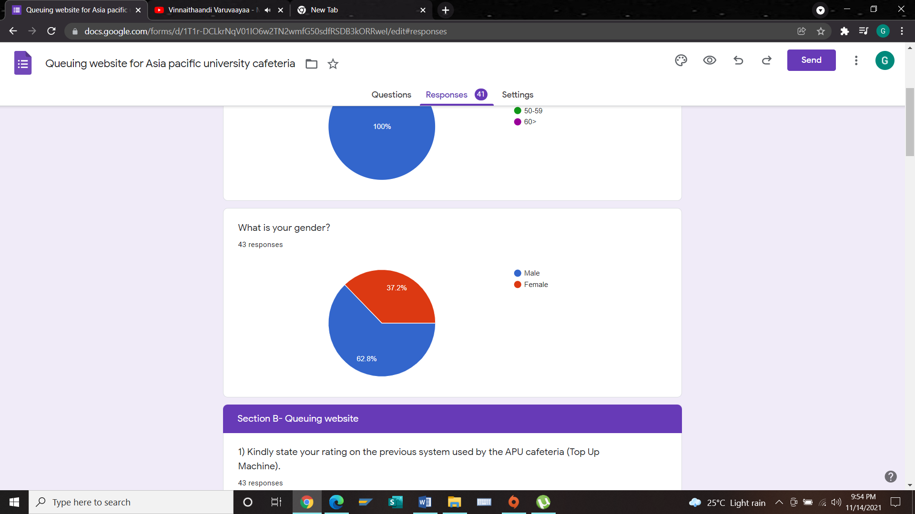

Based on this chart, 43 responses have been collected. Out of which 62.8% of them are male respondents and 37.2% are female respondents. There are more male participants compared to female participants.

**Section B**

**1)**

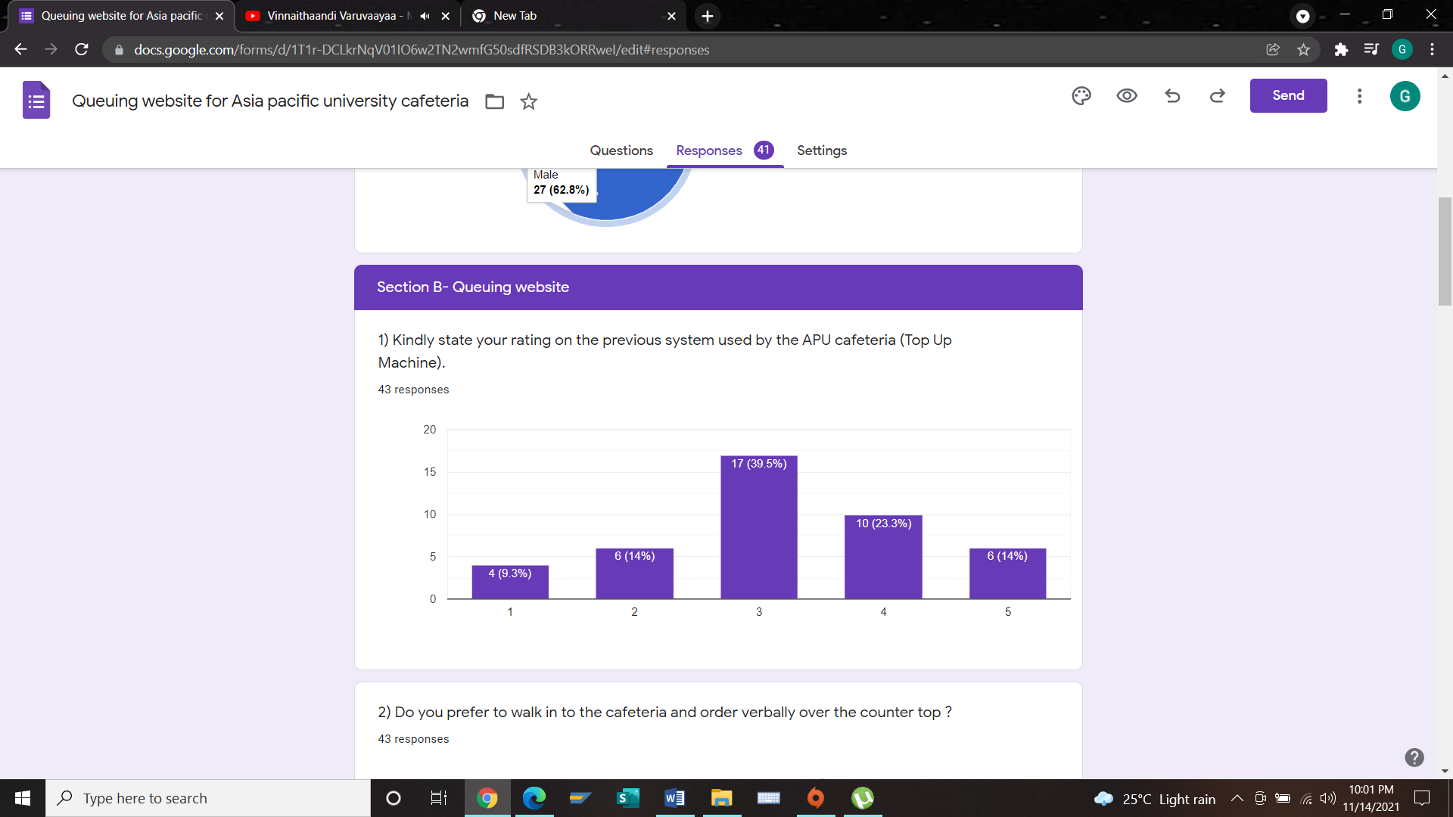

Based on the chart above, 39.5% of the participants have rated to have a neutral feeling on the previous system used by APU cafeteria. This shows that participants are not fully satisfied with the TP top machine. 23.3% of participants find the previous system (TP top machine) to be satisfying while 14% of participants are highly satisfied on the previous system. Besides that, there are also 14% of respondents who don’t like the previous system and there are 9.3% of participant who are highly dissatisfied. The analysis clearly shows that the majority of participants have a neutral feeling.

**2)**

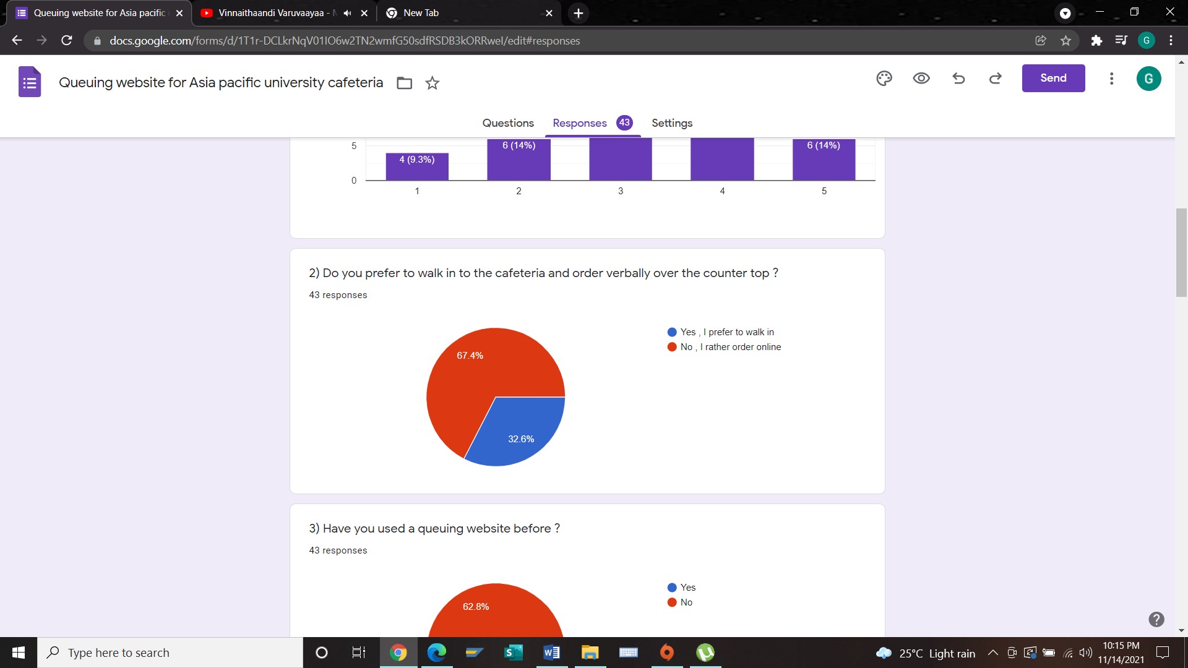

Based on this chart, majority of the participant prefer to order online compared to walking in. There are 67.4% of participants who prefer to order online and 32.6% who prefer to walk in to APU cafeteria and make their orders. This analysis shows that majority prefer to order their meal online than walk in to the counter. The APU cafeteria queuing website will make sure there will be online ordering system which will satisfy them.

**3)**

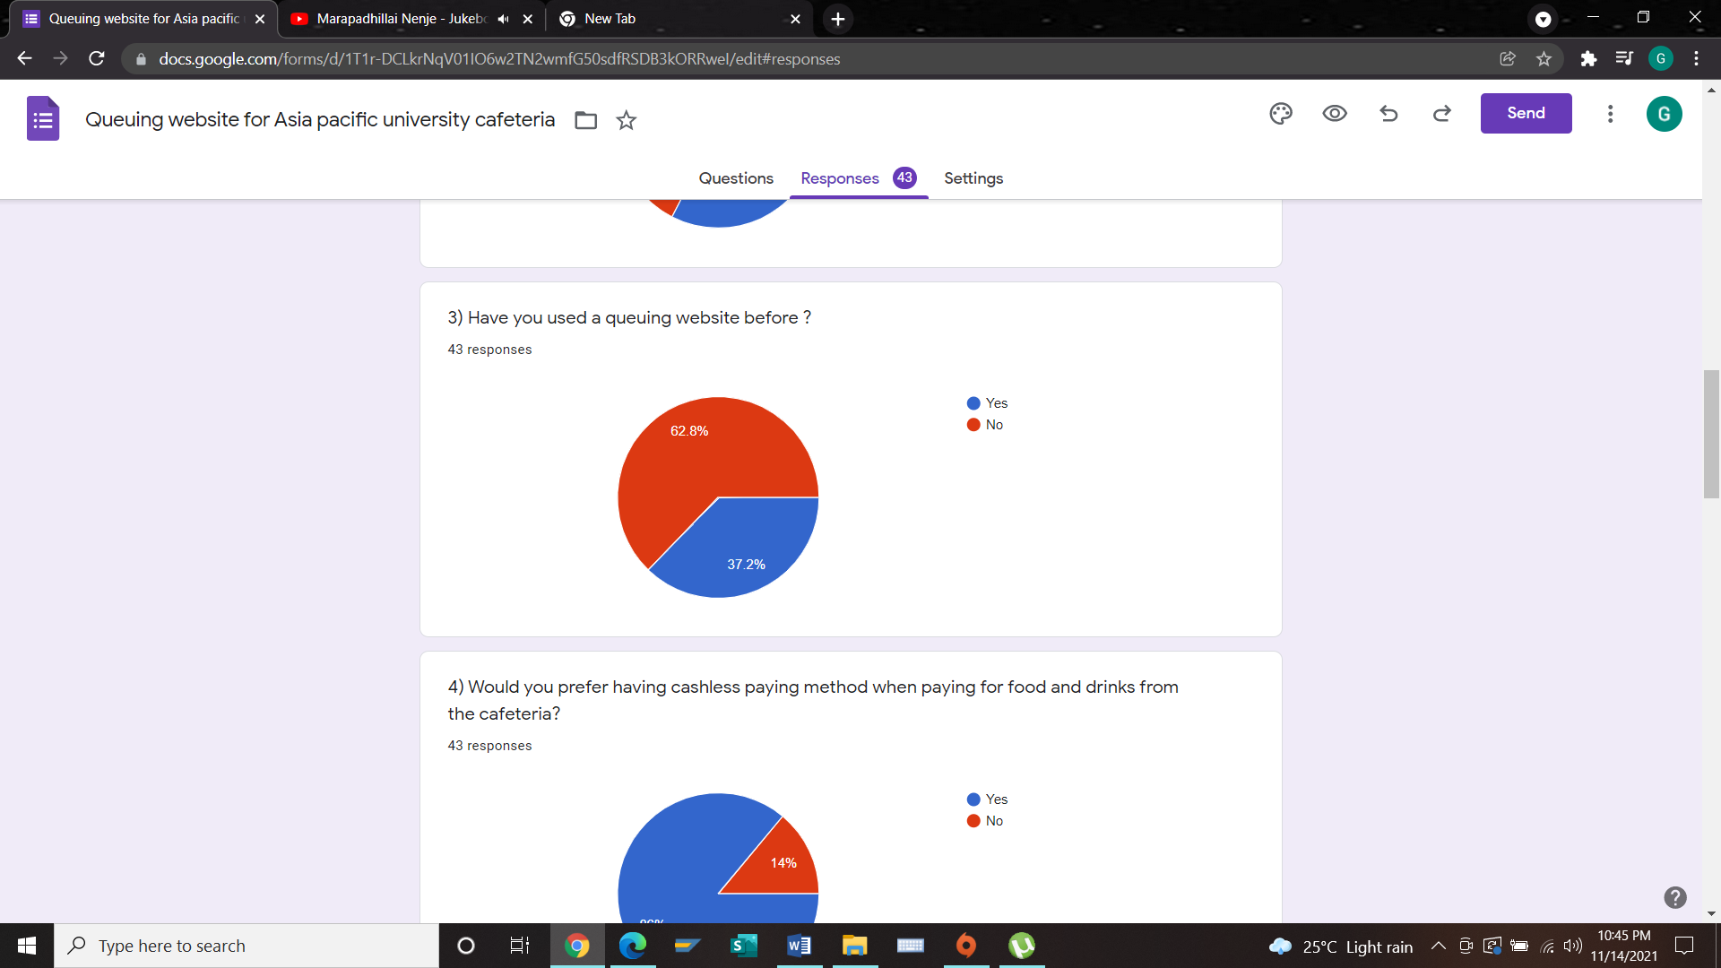

The chart above shows the percentage of participants who are familiar with a queuing website and those who are not familiar with a queuing website. 62.8% of participants are not familiar with a queuing website while 37.2% are familiar with a queuing website. This analysis shows that participants are not familiar with queuing websites. This can be a great experience and opportunity to use this in APU cafeteria queuing website because it will be a new exposure to them.

**4)**

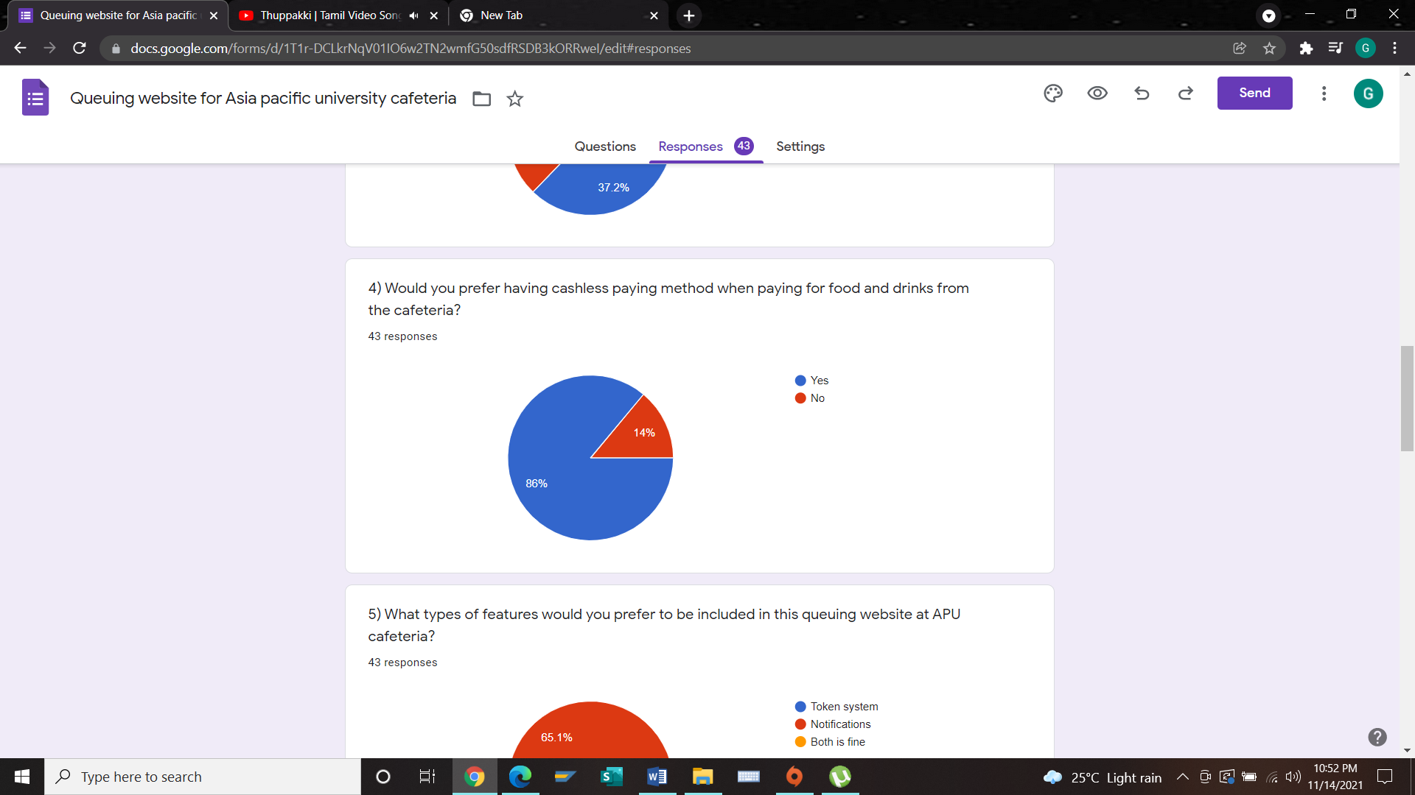

Based on the result gathered, 86% of participants prefer using cashless paying method and there are only 14% of participants who don’t prefer cashless paying method. It is clear and obvious that majority of the participants would like to have cashless paying method and this cashless paying method will be applied in APU cafeteria queuing website.

**5)**

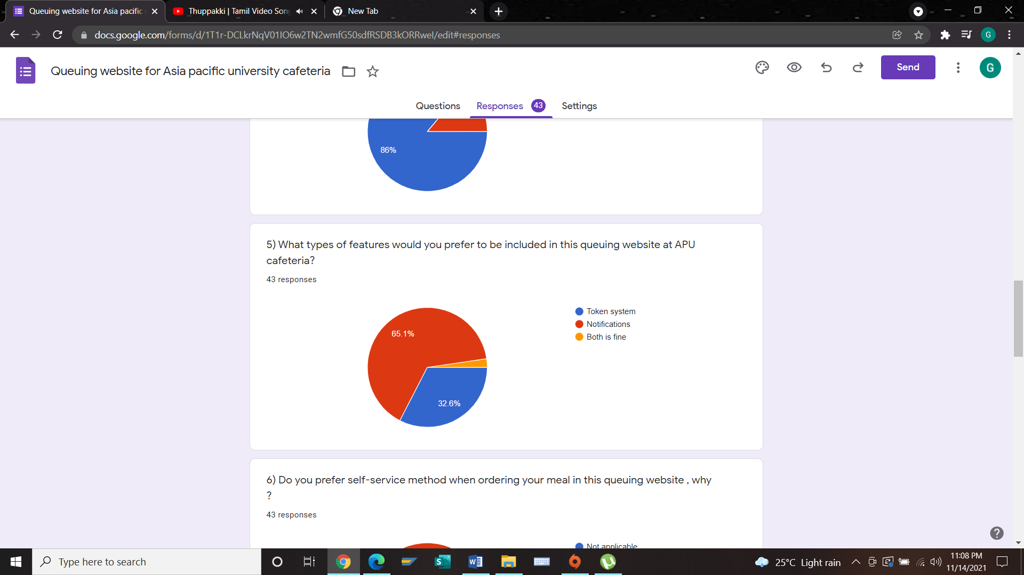

According to this chart, 65.1% who are the majority prefer and expect the notification feature to be installed in the queuing website while 32.6% of participants prefer having the token system for the queuing website for APU cafeteria. 2.3% of participants prefer having both features. The developer will be sure to include these features in order satisfy users.

**6)**

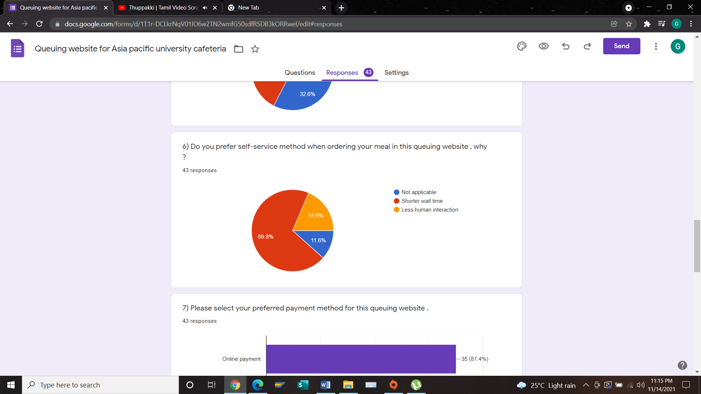

Based on this chart, 69.8% of participants prefer self-service method because there will be shorter wait time and there are 18.6% of them who prefer this method because there is less human interaction. The minority of 11.6% participants do not prefer to have self-service method.

**7)**

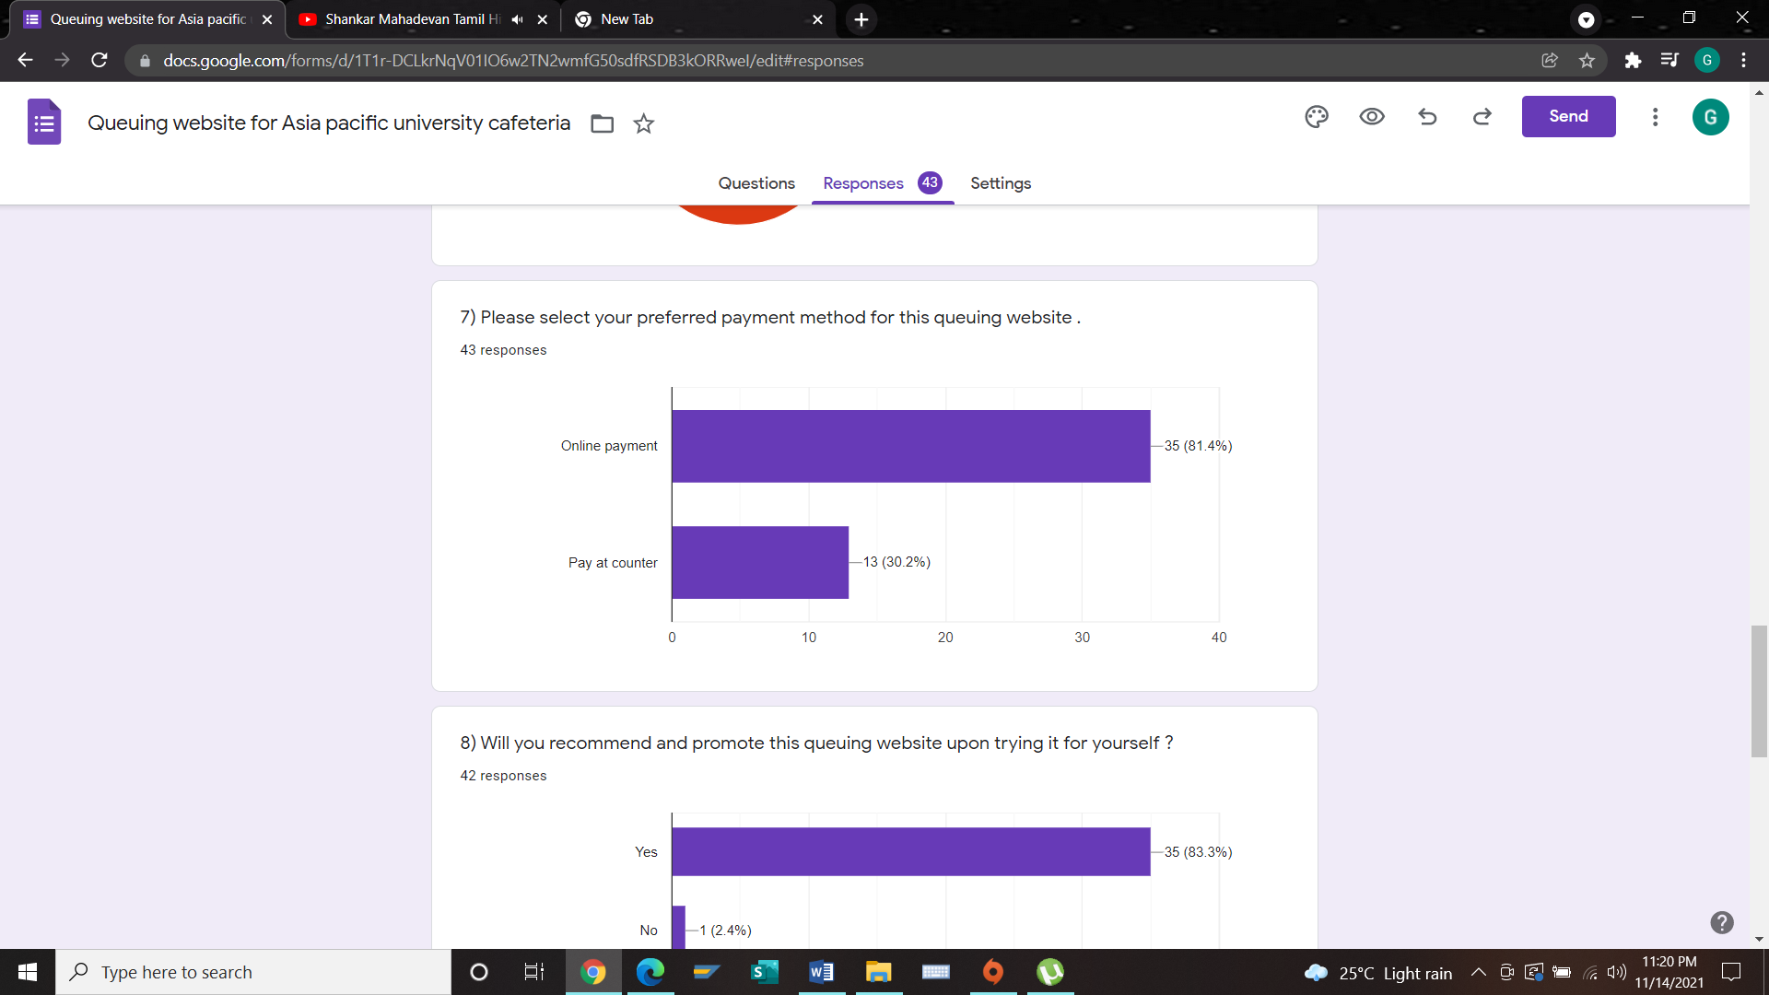

Based on this chart, majority of the participants responded prefer having online payment for APU cafeteria which overall has high percentage of 81.4%. There are 30.2% of participant who prefer paying at counter which is the least in the chart. Most of the participants prefer online payment in order to pay for their meals and drinks at the APU cafeteria by using the queuing website. This queuing website will be developed by having the online payment method.

**8)**

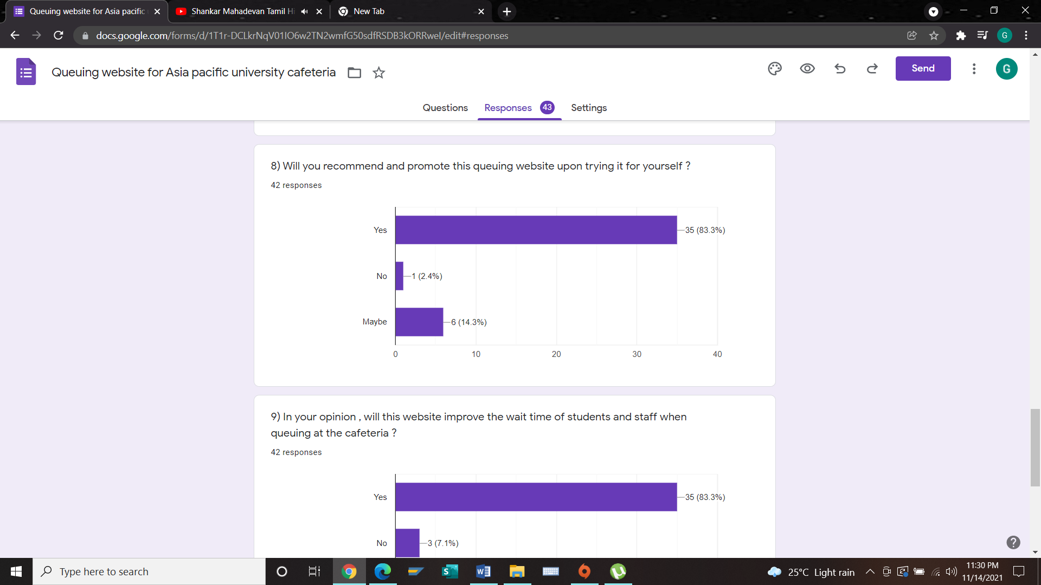

According to this chart, 83.3% of participant will recommend and promote this queuing website of APU cafeteria after they try it while 14.3% may recommend based on their satisfaction level. 2.4 % have chosen to not recommend and promote this queuing website for APU cafeteria after trying it for themselves.

**9)**

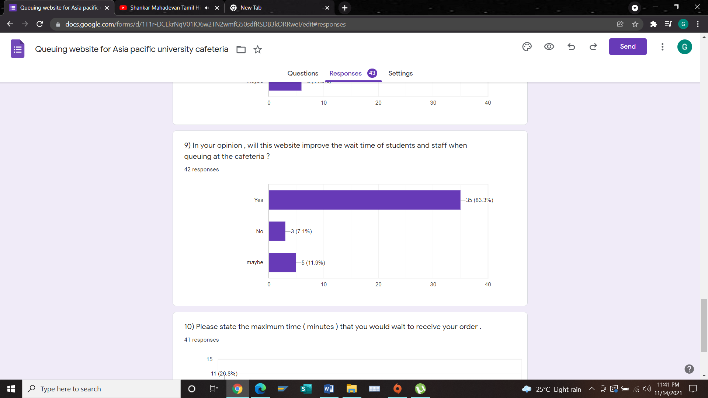

Based on this chart, majority of the participants believe that the queuing website of APU cafeteria will improve their wait time in cafeteria after ordering the meals. There are 11.9% of participants who think it may improve on their wait time while 7.1% don’t believe this can improve their wait time.

**10)**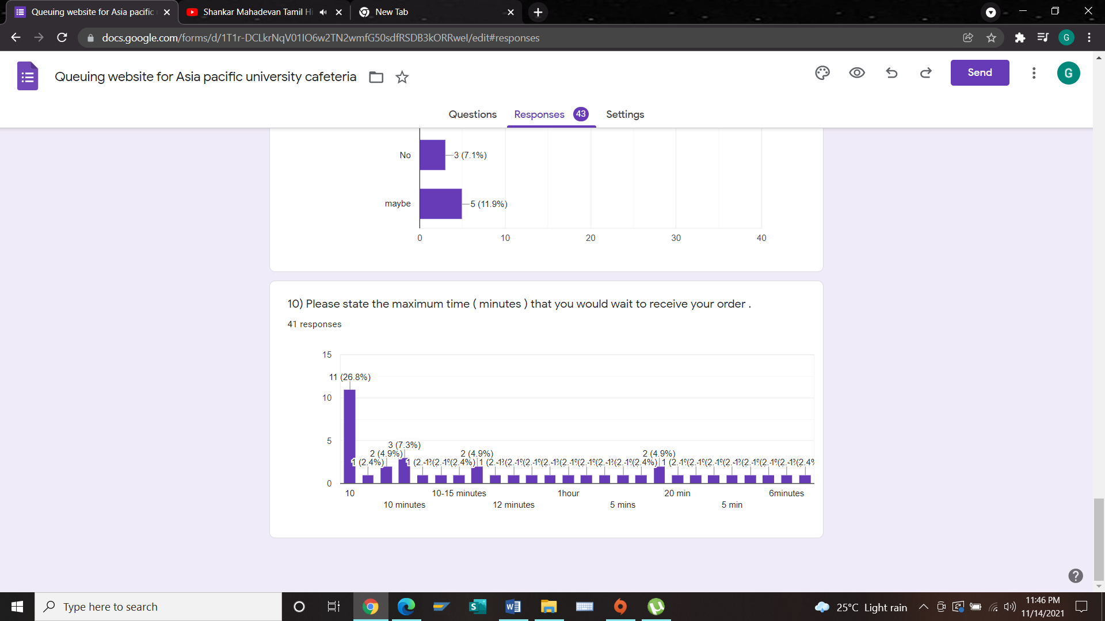

According to the result, majority of the participants expect to wait approximately only 10-15 min for their order to be ready. There are very high percentage of 26.8% who prefer on having the order within 10 minutes.

## 8.3 summary

From the beginning to the end of this survey questionnaires, most of the response are very favorable on the proposed queuing website for Asia pacific university cafeteria and the participant really would like to apply this queuing website in APU. There is also some question which is semi –ended and also there is some optional answer which the participant can type their answer based on participant perspective. There are responses on why the participant prefer this specific queuing website for Apu cafeteria which will really helpful in future on developing the project. Based on the result of this survey, the developer have a lot of idea on how to improvise and build this queuing website based on the preferences of APU students, lecture and staffs.

# Chapter 9: conclusion and reflections

In all respect by conducting this research, the outcome of this investigation research have come really well by achieving the most of the requirement for this individual research which should be given to the supervisor. Actually, there could be more parts of the research which can be complete but due to the lack of motivation due to the pandemic and time constraint, which was not able to achieve as the highest standard but this research was overall done with good satisfactory. The investigation and technical part of research was done correctly according to the temple given. Furthermore, all over the process the developer have actually really learned and grow a lot of knowledge and have a great understand on research. there was the struggling phase where it was hard to find information for certain chapter ad topics but however could able to handle and get through and give the best on executing on the task accordingly that been struggling. The whole research was achieved and all the UN clear doubts and topics which were not clear was latterly mange to understand and clear throughout the research. Besides that, there was also some minor issue such as time constraint during this research. Initially, the developer would really like to do more research on the chapter 3 but however I have done. Overall this research does prove that the queuing website for Asia pacific university is really helpful and give solution to the problems.

Actually there were a lot of factors and areas which I could have improve and done more better by doing more research on some of the topics which will be really supportive for the topics. Time management could have surely improved because the developer could have done more better on the researching, which in the future development research and project, I will surely invest more effort and tie on working and manage my time well on doing research and also ask for proper guidance for help which were required from the correct parties.

# References

Ahmad, S. A. (2018). Improving Queuing System. *Improving Queuing System with Limited Resources Using TRIZ and Arena Simulation*, 17.

Akter, S. (2019). DESIGN AND IMPLEMENTATION OF AN ONLINE RESTAURANT SYSTEM. *MPLEMENTATION OF AN ONLINE RESTAURANT SYSTEM*, 40.

apu. (2021, november 1). *www.apu.edu.my*. Retrieved from apu.edu.my: https://www.apu.edu.my/explore-apu/university

APU. (2021, november 2). *www.apu.edu.my*. Retrieved from www.apu.edu.my: https://www.apu.edu.my/life-apu/campus-facilities

Bezarede Mekonnen, T. A. (2020). Assessing the Impact of Cafeteria Food Related Problems. *Assessing the Impact of Cafeteria Food Related Problems*, 6.

Bradley, E. L. (2020). QUEUES WITH BALKING AND THEIR APPLICATION TO AN INVENTORY PROBLEM. *QUEUES WITH BALKING AND THEIR APPLICATION*, 51.

bradley, s. (2021, november 6). *vanseodesign.com*. Retrieved from vanseodesign: https://vanseodesign.com/css/benefits-of-cascading-style-sheets/

Contributor, T. (2021, november 5). *whatis.techtarget.com*. Retrieved from techtarget: https://whatis.techtarget.com/definition/bootstrap

EDWIN LUTHER BRADLEY, J. (2000). QUEUES WITH BALKING AND THEIR APPLICATION. *queues with balking, 2*(queuing), 108.

Elankovan, V. (2021, november 2). *worldofbuzz.com*. Retrieved from worldofbuzz.com: https://worldofbuzz.com/angry-students-expose-msian-uni-for-having-dirty-cafeteria-infested-by-disgusting-pests/

Engmann, S. M. (2017). E-COMMERCE FOR CANTEEN SERVICES. *ASHESI UNIVERSITY COLLEGE* , 30.

Esedimy, E. I. (2014). Enhancing Cloud Computing Scheduling based on. *Queuing Models*, 7.

Gabriel, S. (2001). THE FEASIBILITY STUDY OF INTERNET CAFE BY QUEUING MODEL . *NTERNET CAFE BY QUEUING MODEL*, 93.

Goauthaam. (2020). Greatwiz Website Queuing System in Asia Pacific University’s Cafeteria. *Greatwiz Website Queuing System in Asia Pacific University’s Cafeteria*, 10.

Haoa, T. (2011). Study on Queuing System Optimization. *Queuing System Optimization*, 7.

Hope, C. (2021, november 4). *www.computerhope.com*. Retrieved from computerhope: https://www.computerhope.com/jargon/n/notepad-plus-plus.htm

Ilamsyah. (2019). The Web-based Raharja Internet Cafe (RIC) Ordering . *Internet Cafe (RIC) Ordering*, 8.

javatpoint. (2021, november 8). *www.javatpoint.com*. Retrieved from javatpoint: https://www.javatpoint.com/advantages-of-linux

Jones, P. P. (2005). Perceptions of waiting time in different service queues. *Perceptions of waiting time in different service queues*, 16.

Jordi Vilaplana, F. S. (2021, october 31). A queuing theory model for cloud computing. *queuing theory model for cloud computing*, 22. Retrieved from Jordi Vilaplana, Francesc Solsona , Ivan Teixidó, Jordi Mateo, Francesc Abella & Josep Rius

kissflow. (2021, november 5). *kissflow.com*. Retrieved from kissflow: https://kissflow.com/low-code/rad/rapid-application-development/

Kurniawan, R. (2020). information System Ordering Online Restaurant Menu At Hover Cafe. *Ordering Online Restaurant Menu At Hover Cafe*, 9.

linux. (2021, november 5). *www.linux.com*. Retrieved from www.linux.com: https://www.linux.com/what-is-linux/

lucidchart. (2021, november 10). *www.lucidchart.com*. Retrieved from lucidchart: https://www.lucidchart.com/blog/waterfall-project-management-methodology

M.Atieh, A. (2015). Performance Improvement of Inventory Management System Processes by an Automated Warehouse Management System. *Performance Improvement* , 41.

Martin, M. (2021, november 7). *www.guru99.com*. Retrieved from guru99: https://www.guru99.com/what-is-sdlc-or-waterfall-model.html

MARZUKHI, N. B. (2020). FOOD ORDERING SYSTEM USING QR CODE. *FOOD ORDERING SYSTEM* , 36.

McLeod, S. (2021, november 3). *www.simplypsychology.org*. Retrieved from simplypsychology: https://www.simplypsychology.org/questionnaires.html

mindtools. (2021, november 2). *www.mindtools.com*. Retrieved from mindtools: https://www.mindtools.com/pages/article/newTMC_05.htm

Mnyanga, E. A. (2020). Queueing systems in the cafeterias at the University of Dodoma in Dodoma. *Queueing systems in the cafeterias*, 122.

Mochal, T. (2021, october 21). *www.techrepublic.com*. Retrieved from techrepublic: https://www.techrepublic.com/article/waterfall-vs-rad-how-to-pick-the-right-method-for-your-project/

Oluwaseun, O. A. (2018). Queuing in the University System. *Queuing website in the University* , 3.

Ouzzani, M. (2016). Rayyan—a web and mobile app for systematic reviews. *a web and mobile app*, 5.

Parsons, N. (2021, november 2). *www.liveplan.com*. Retrieved from liveplan: https://www.liveplan.com/blog/what-is-a-swot-analysis-and-how-to-do-it-right-with-examples/

Professor Vipul Upadhaya, Y. P. (2019). Review on Implementation of Queuing Theory. *Queuing Theory*, 4.

Puzhevich, V. (2021, november 15). *scand.com*. Retrieved from scand: https://scand.com/company/blog/waterfall-vs-rad/

qless. (2021, november 7). *qless.com*. Retrieved from qless: https://qless.com/get-in-line-app/

Rehman, J. (2021, november 7). *www.itrelease.com*. Retrieved from itrelease: https://www.itrelease.com/2019/07/advantages-and-disadvantages-of-windows-operating-system/

Samarawickrama, D. W. (2019). A simulation on performance improvement at a university cafeteria. *performance improvement at a university cafeteria*, 10.

SHARMA, A. (2020). Online Cafeteria Management System. *Online Cafeteria Management System*, 26.

Sharma, L. (2021, november 5). *www.toolsqa.com*. Retrieved from toolsqa: https://www.toolsqa.com/software-testing/waterfall-model/

skillsyouneed. (2021, november 3). *skillsyouneed.com*. Retrieved from skillsyouneed: https://www.skillsyouneed.com/

*skiplino.com*. (2021, november 4). Retrieved from skiplino: https://skiplino.com/queue-management-system/

studymalaysia. (2021, november 1). *studymalaysia.com*. Retrieved from studymalaysia.com: https://studymalaysia.com/where/profile.php?code=apu

Swami. (2020). A Smart Approach to Facilitate Cafeteria. *A Smart Approach to Facilitate Cafeteria*, 11.

Team, L. C. (2021, november 5). *www.lucidchart.com*. Retrieved from lucidchart: https://www.lucidchart.com/blog/rapid-application-development-methodology

Team, S. E. (2021, november 3). *www.synopsys.com*. Retrieved from www.synopsys.com: https://www.synopsys.com/blogs/software-security/top-4-software-development-methodologies/

Technologies, S. (2021, november 3). *www.seguetech.com*. Retrieved from www.seguetech.com: https://www.seguetech.com/benefits-adhering-software-development-methodology-concepts/

topuniversities. (2021, november 2). *www.topuniversities.com*. Retrieved from QZtopuniversities: https://www.topuniversities.com/universities/asia-pacific-university-technology-innovation-apu

tutorialspoint. (2021, november 5). *www.tutorialspoint.com*. Retrieved from www.tutorialspoint.com: https://www.tutorialspoint.com/sdlc/sdlc_waterfall_model.htm

tutorialspoint. (2021, november 4). *www.tutorialspoint.com*. Retrieved from www.tutorialspoint.com: https://www.tutorialspoint.com/php/php_introduction.htm

Tykal, P. (2020). CREATING A FOOD MENU APPLICATION FOR MENDEL UNIVERSITY IN BRNO. *CREATING A FOOD MENU APPLICATION*, 8.

wavetec. (2021, november 4). *www.wavetec.com*. Retrieved from wavetec: https://www.wavetec.com/

# Appendices

# 

PPF

**Section A**

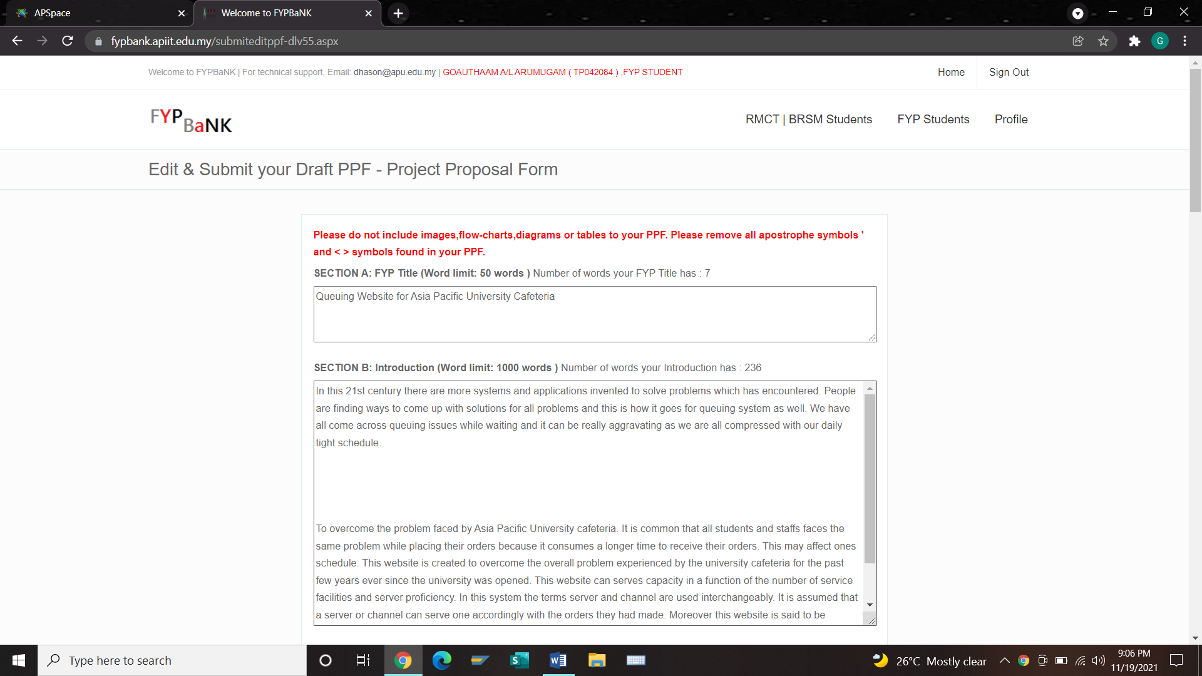

**Section B**

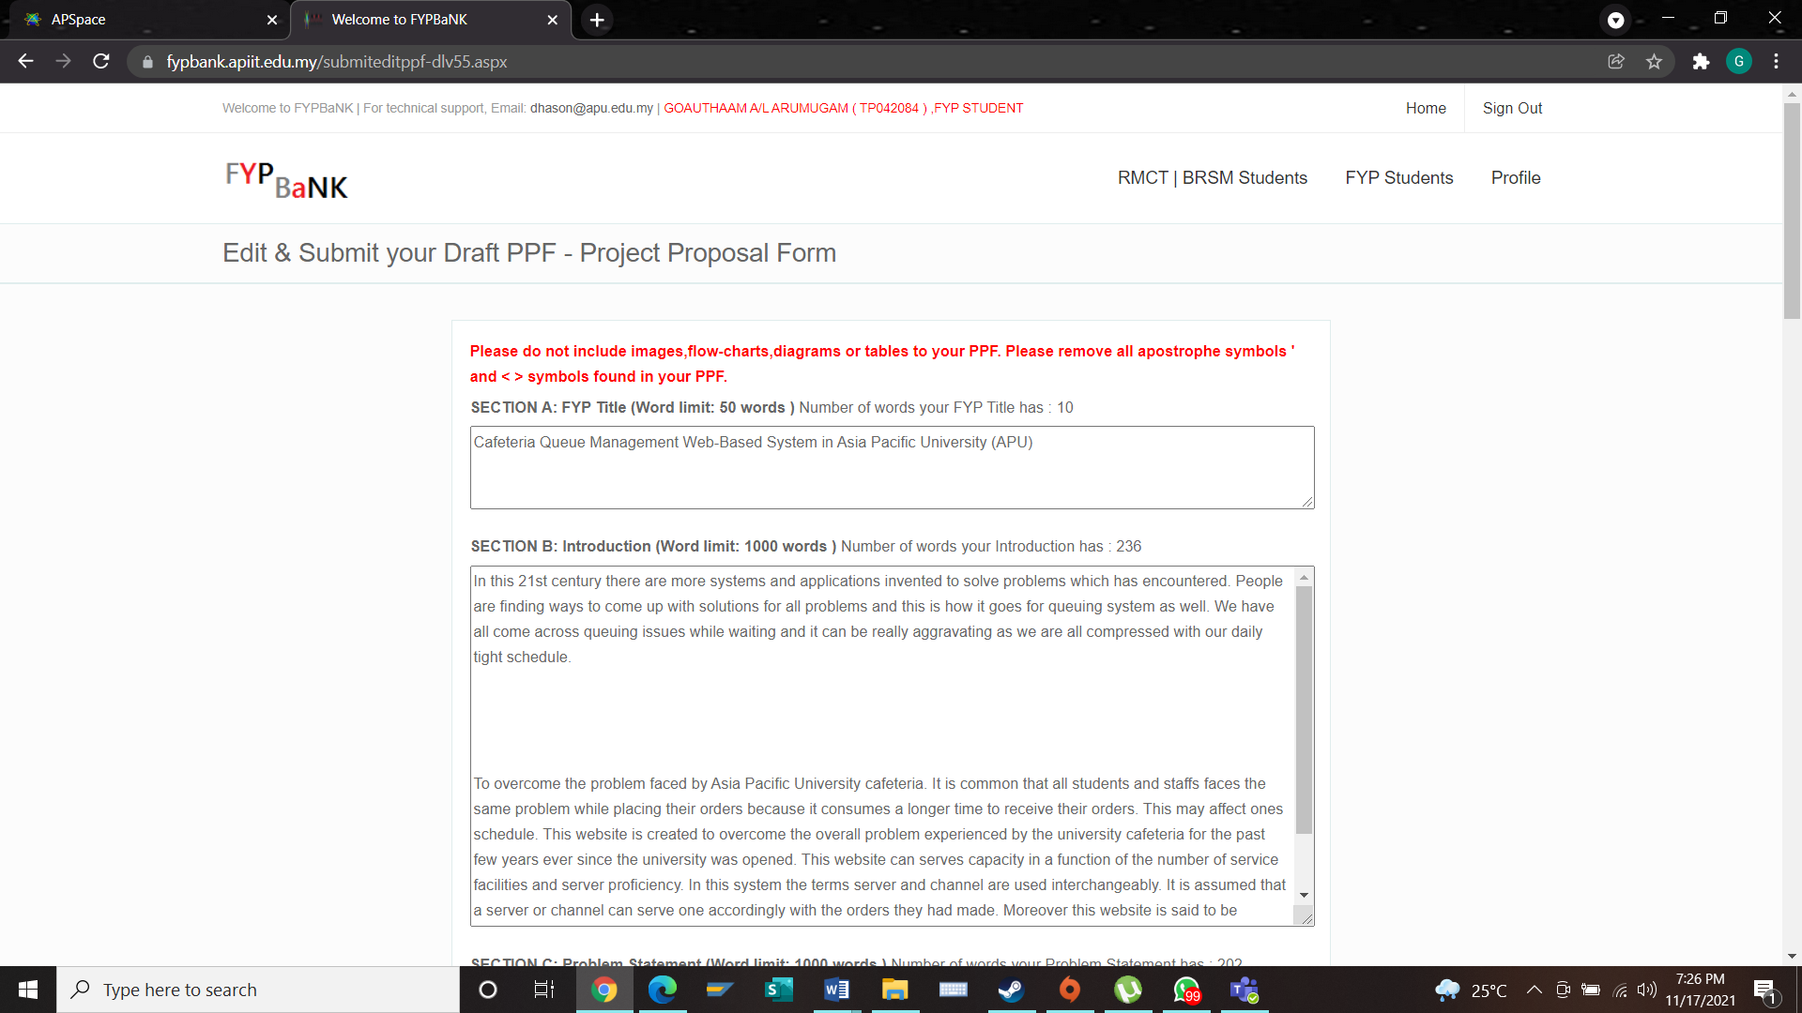

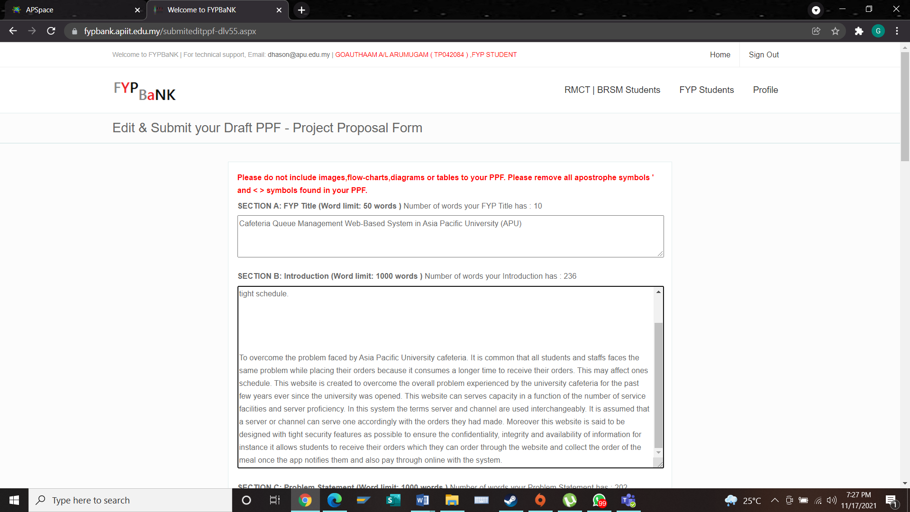

**Section C**

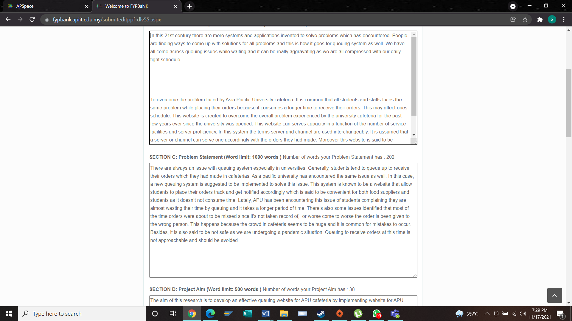

**Section D**

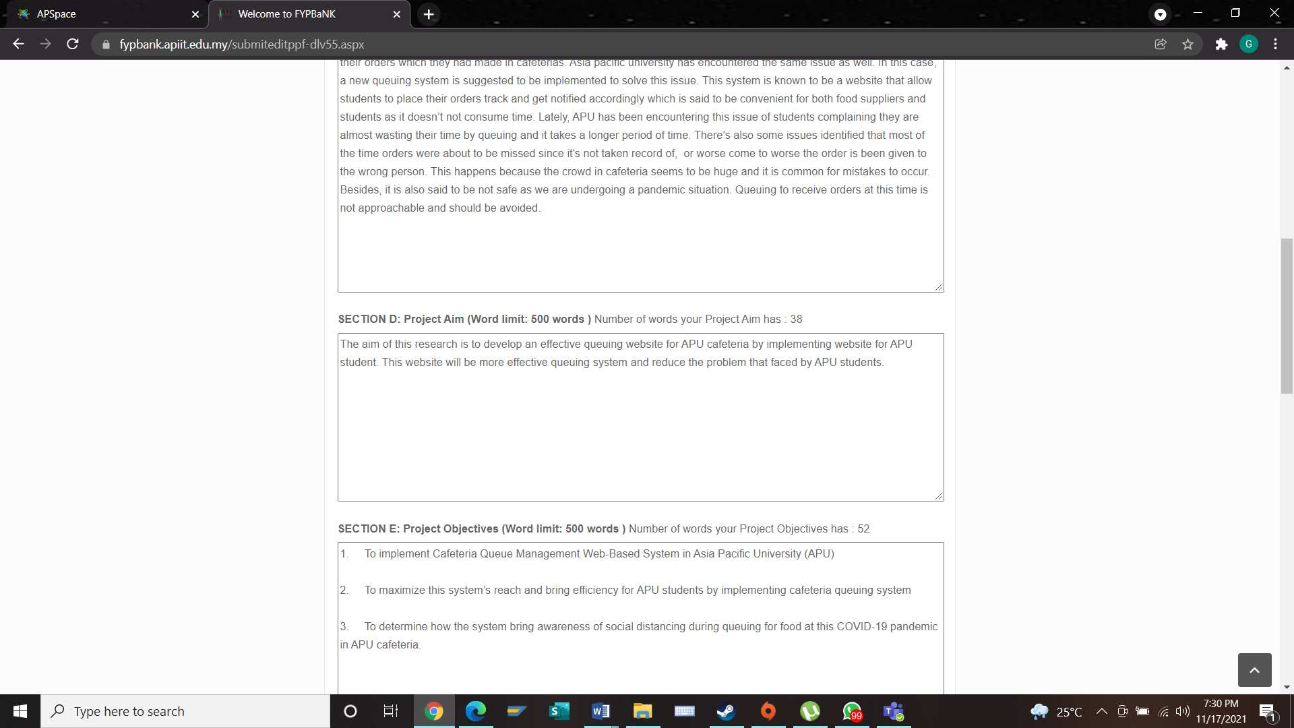

**Section E**

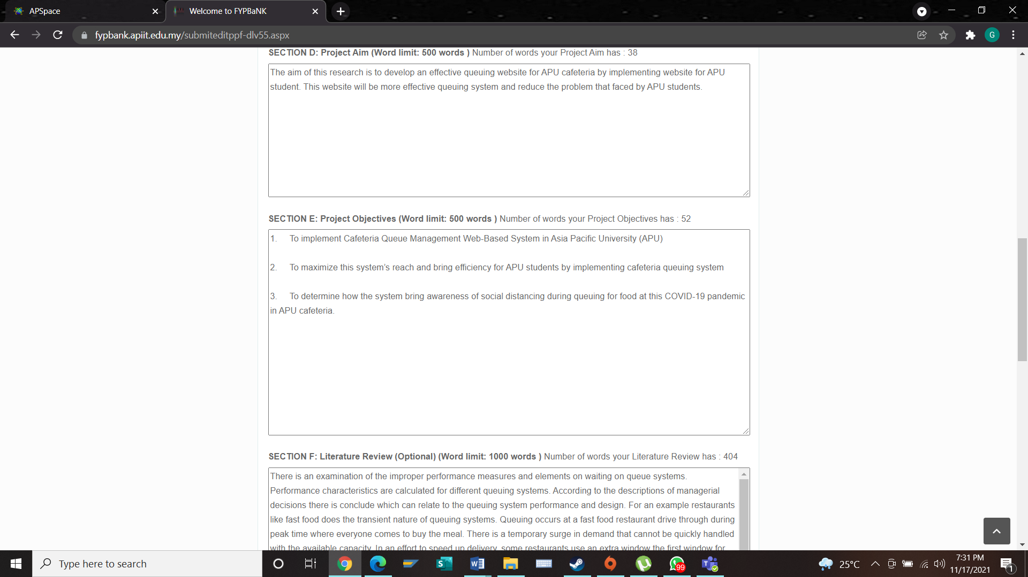

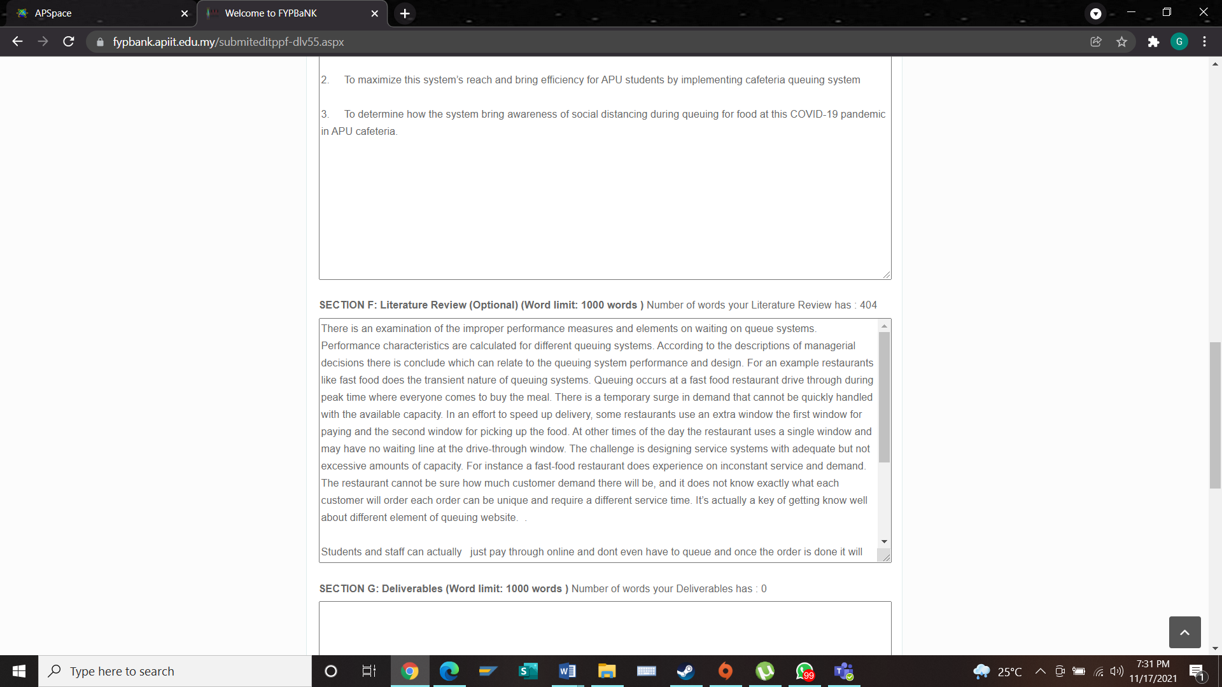**Section F**

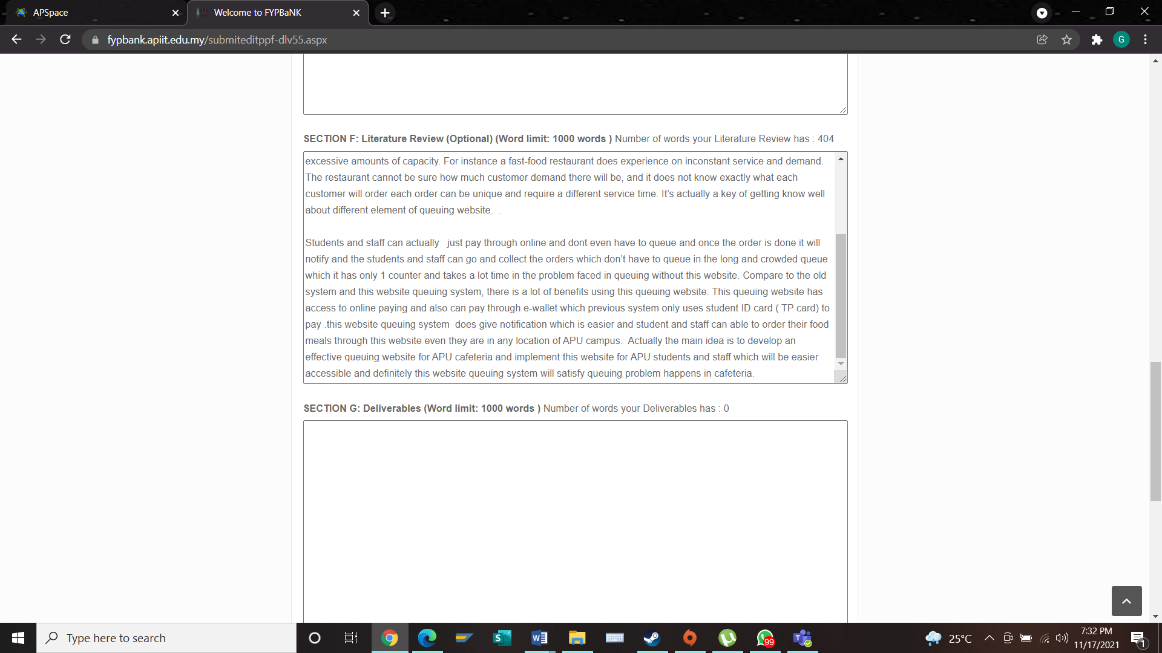

**Section G**

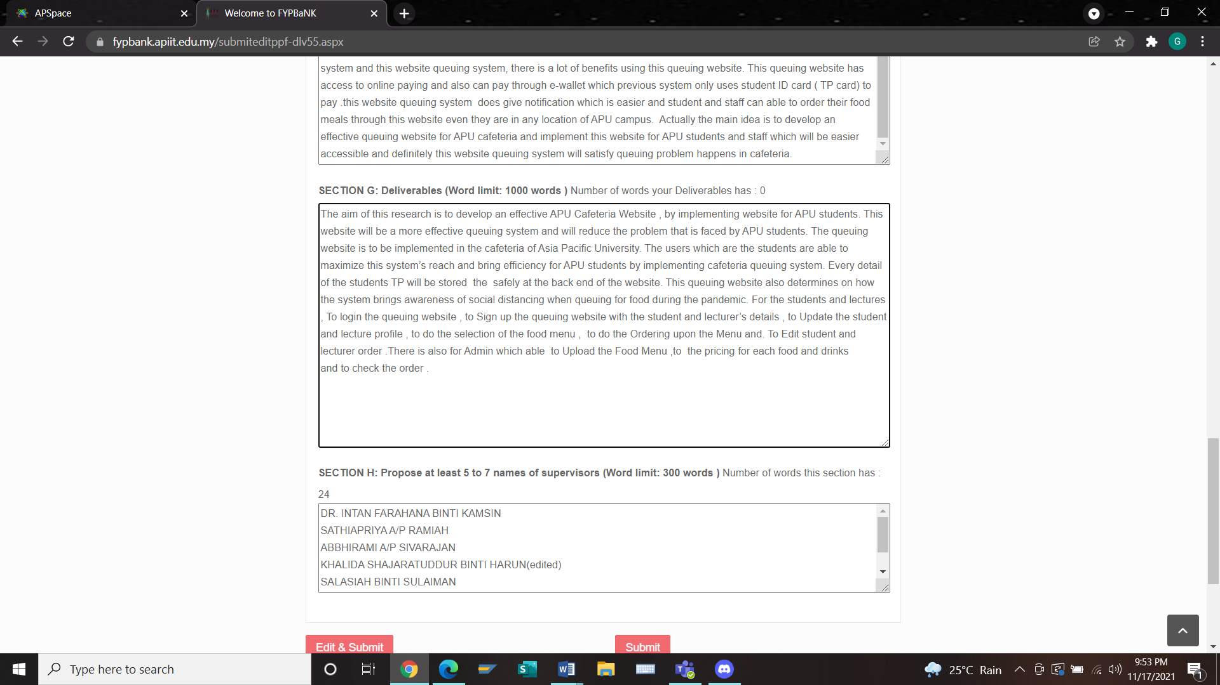

**Section H**

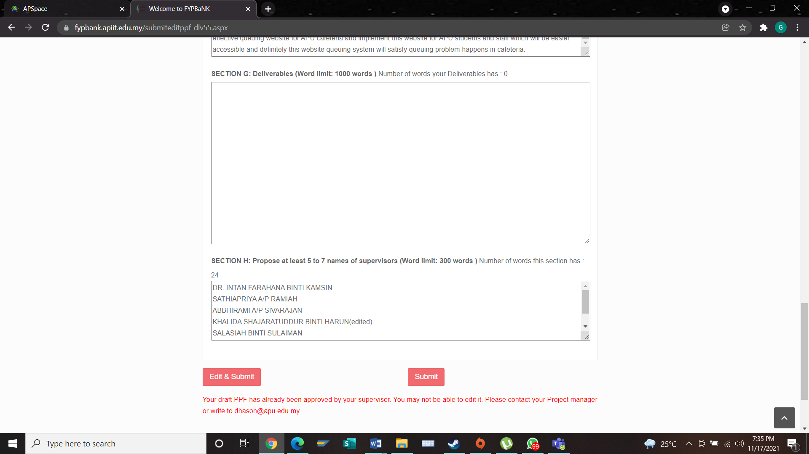

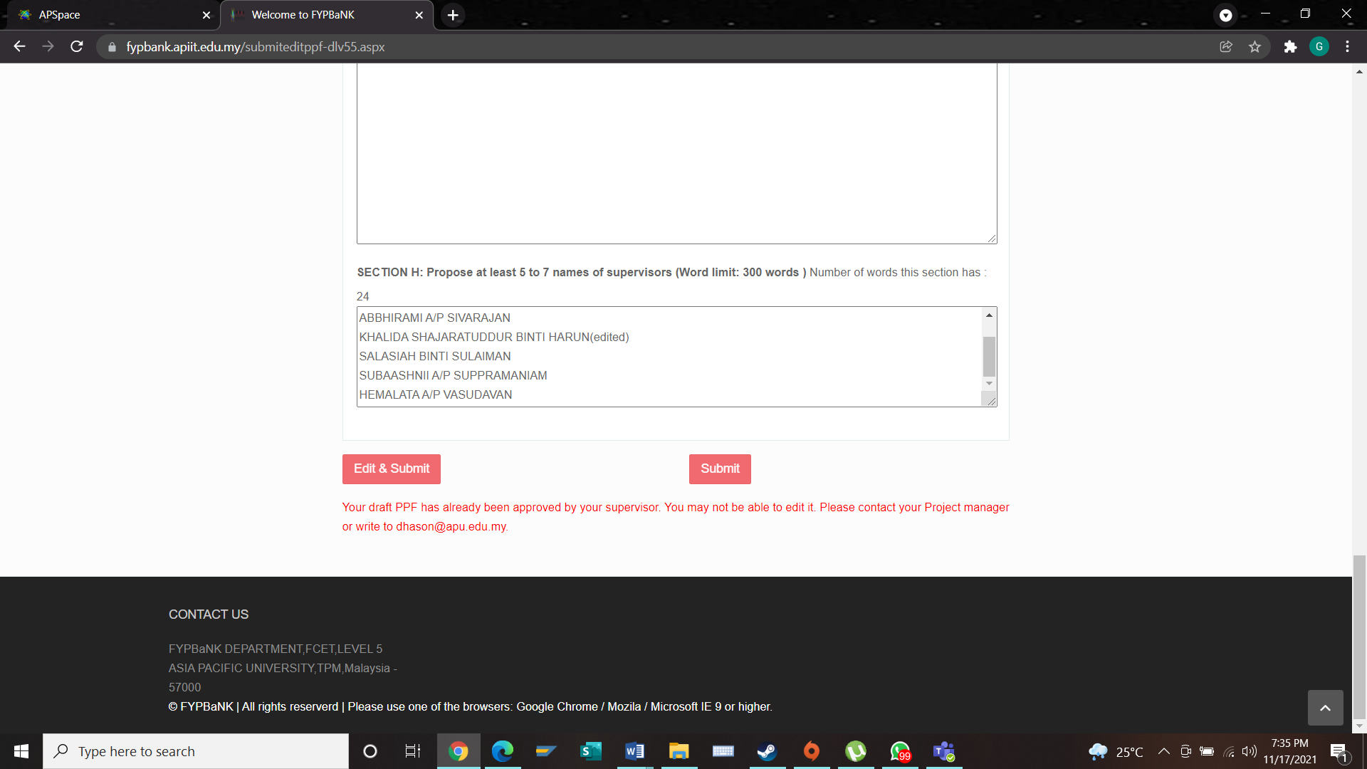

PSF

**Section A**

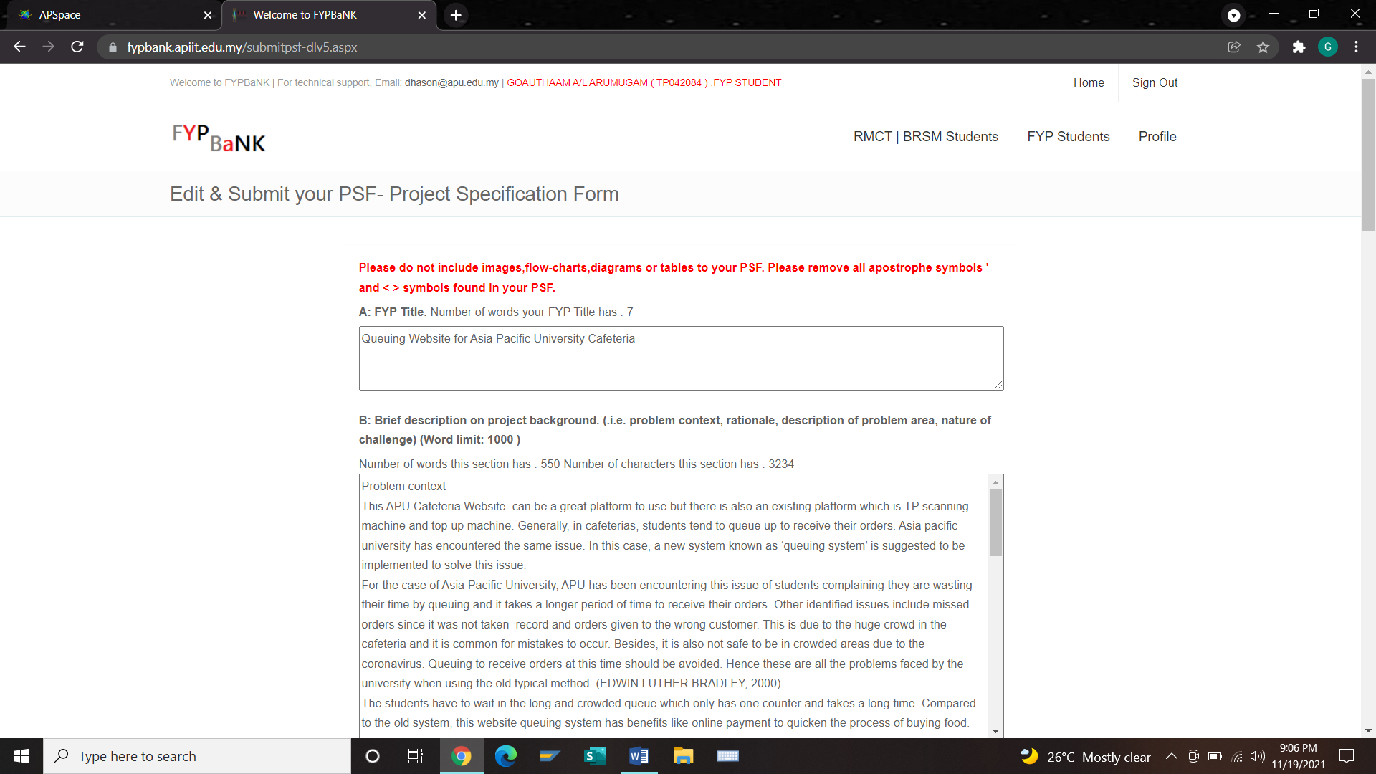

**Section B**

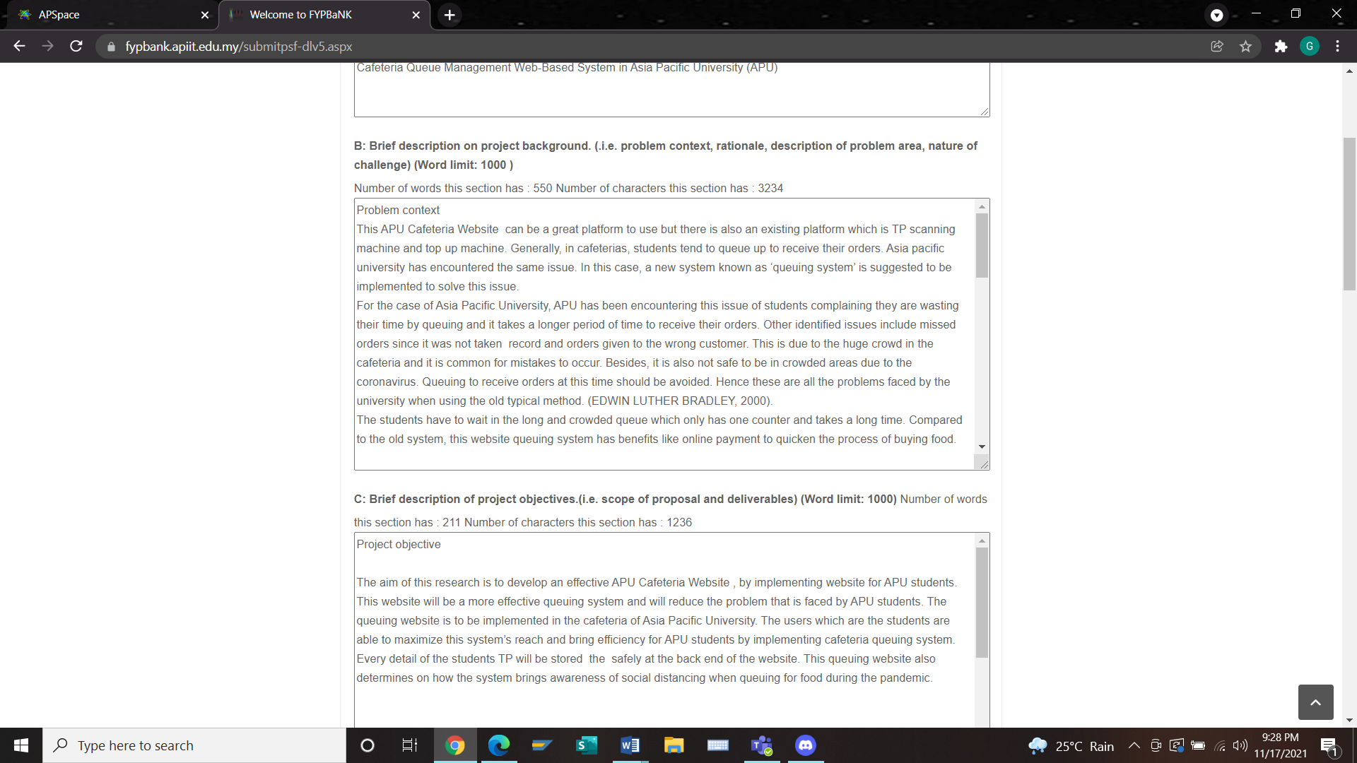

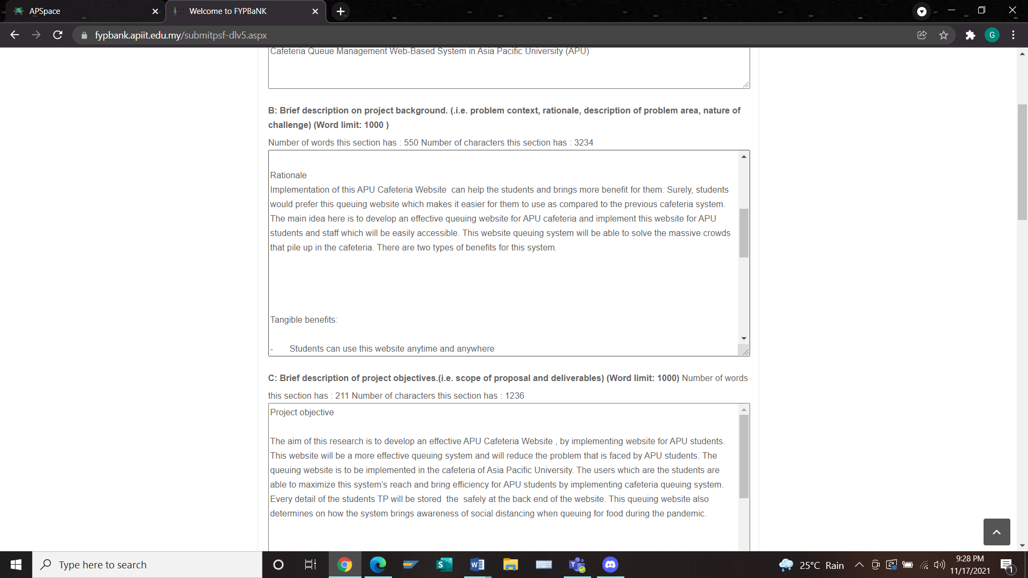

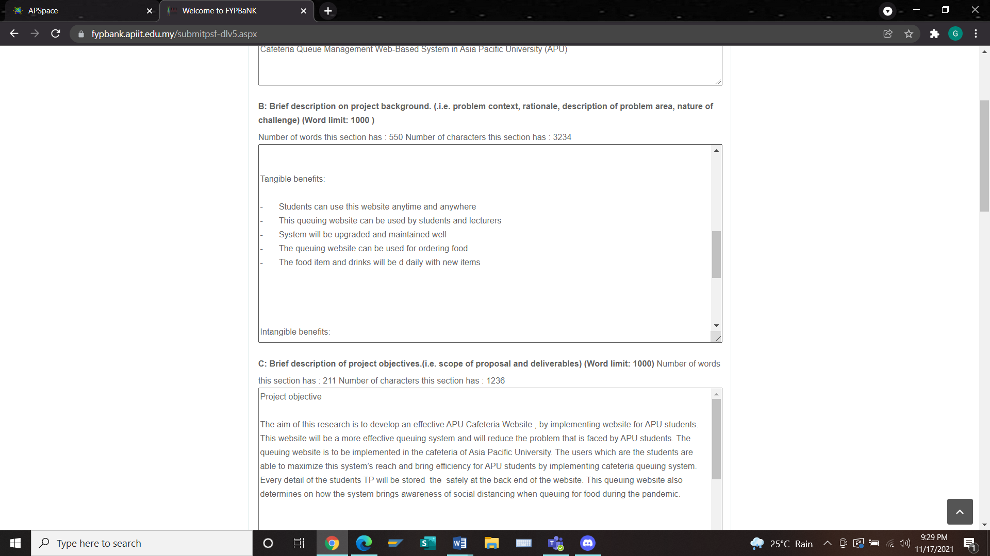

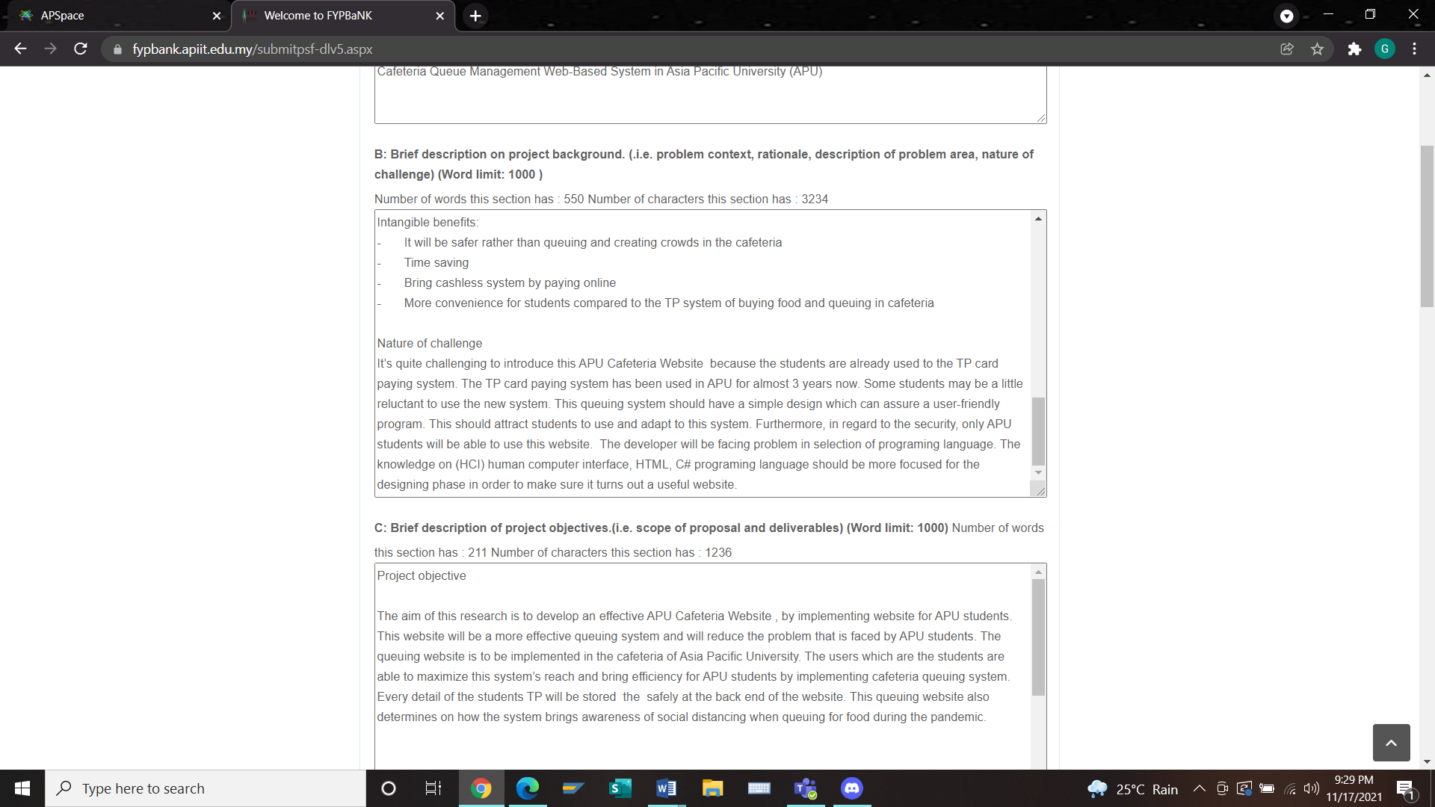

**Section C**

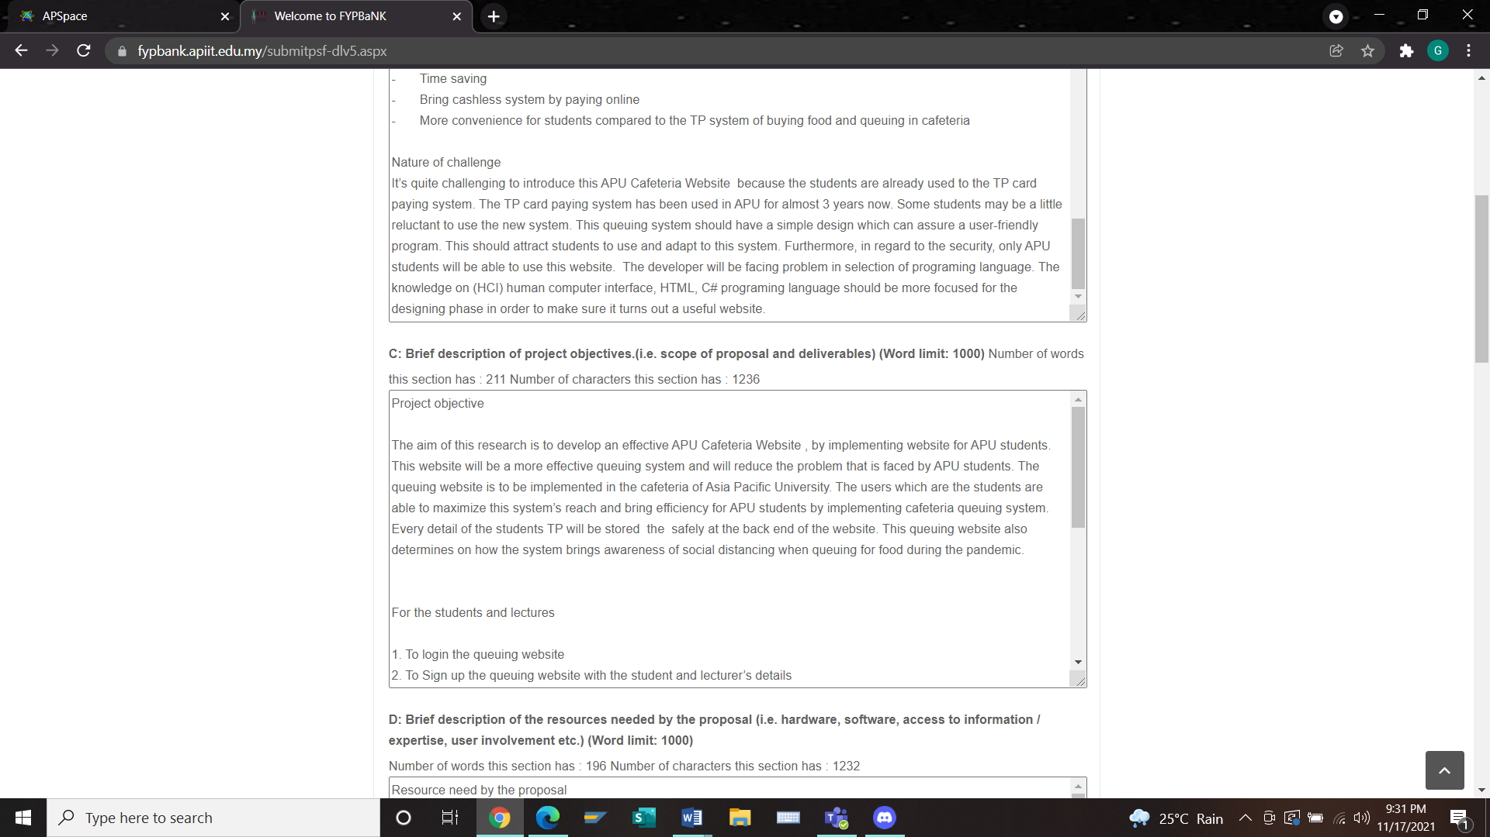

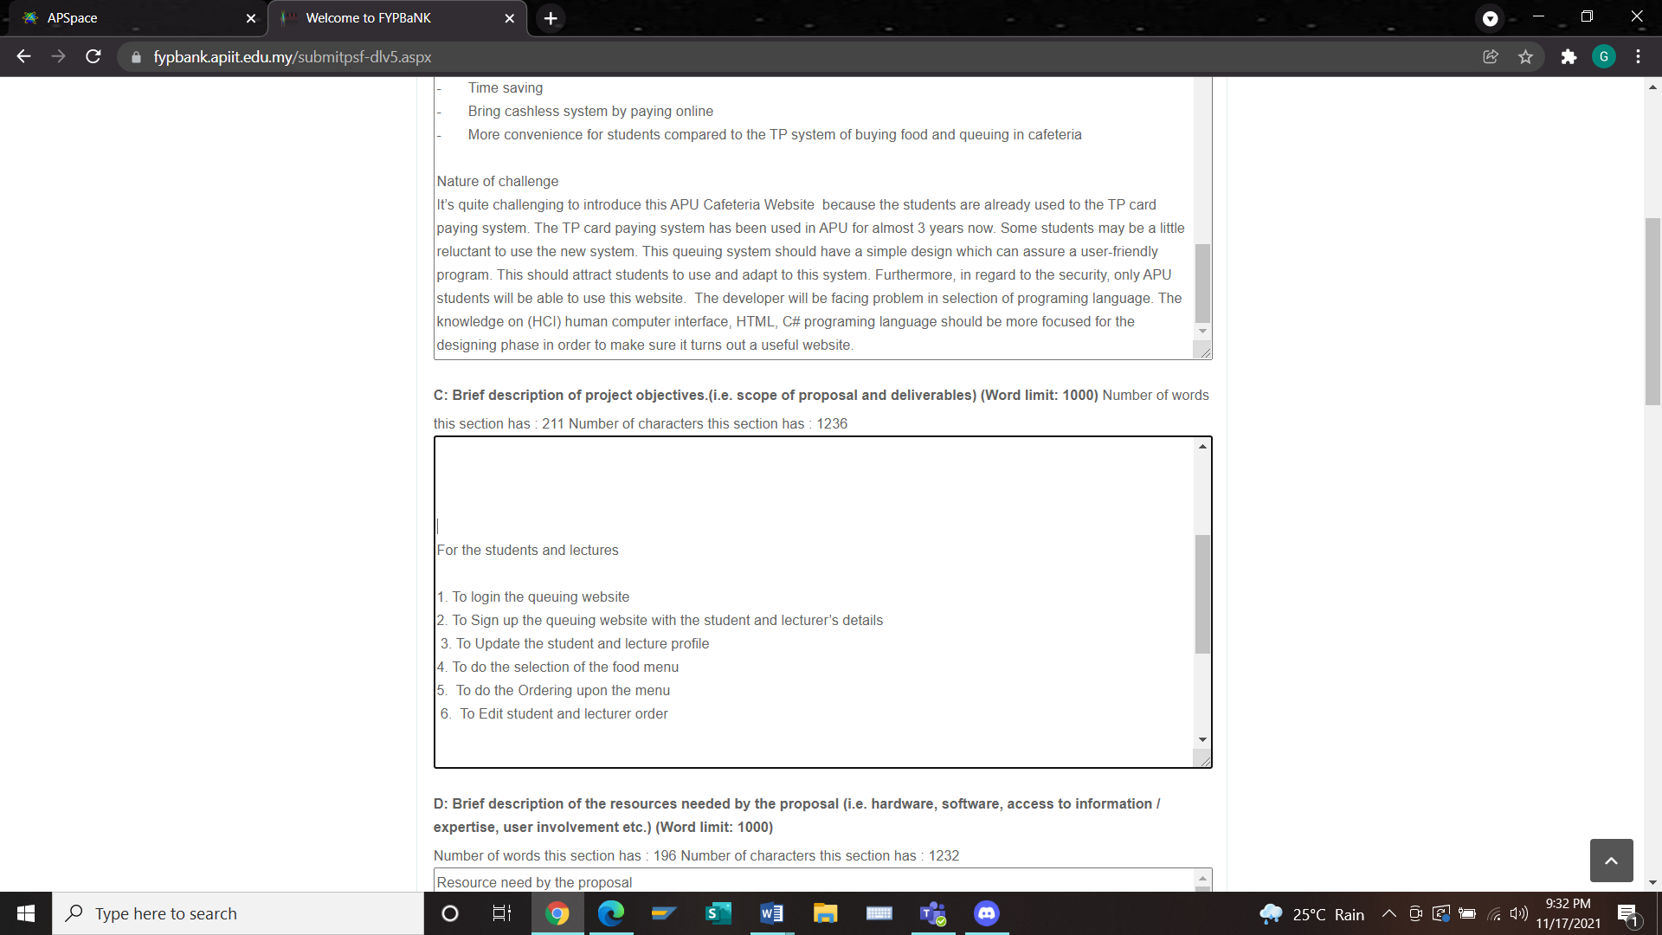

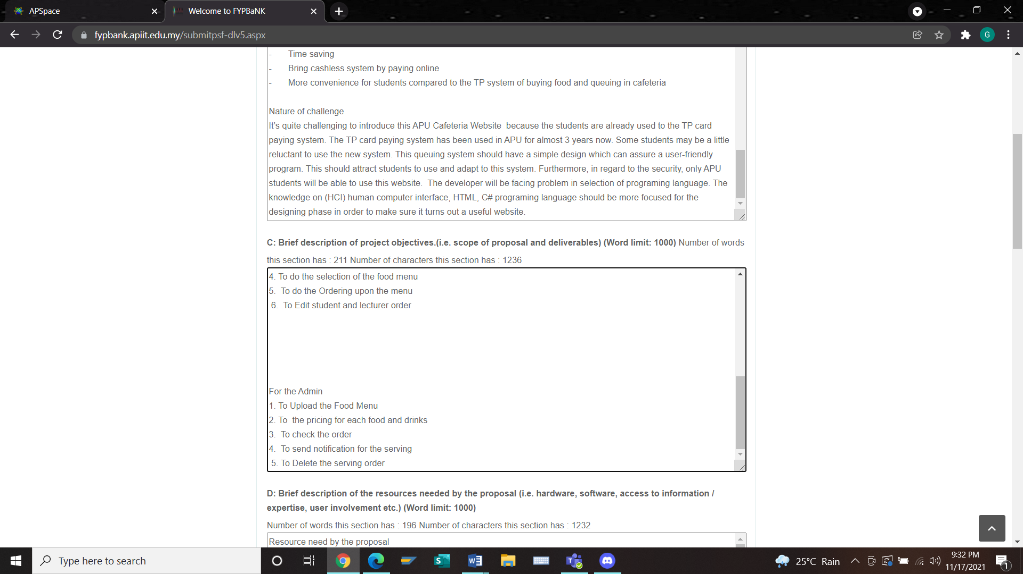

Section D

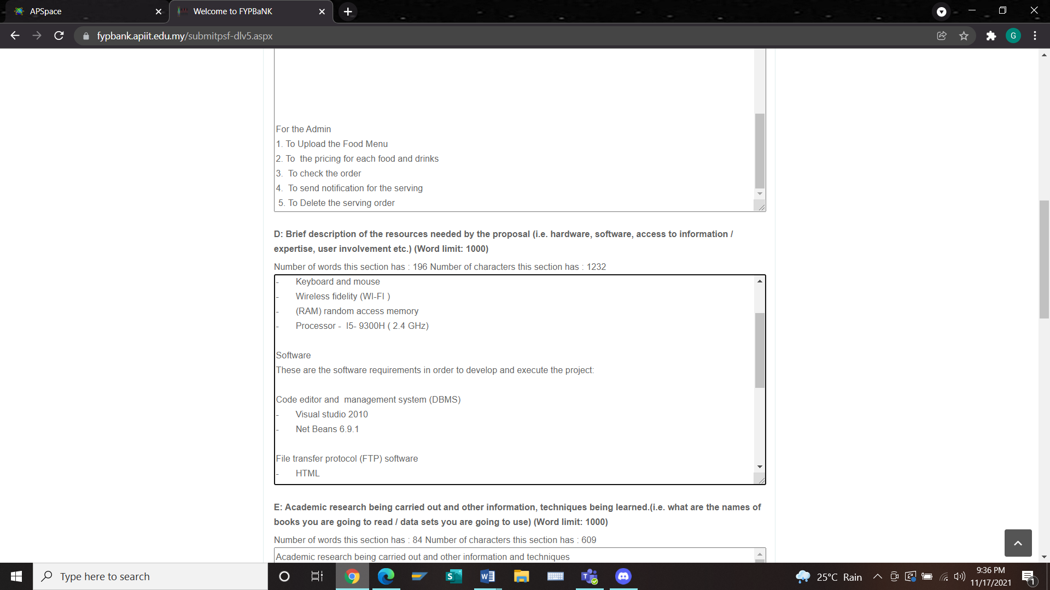

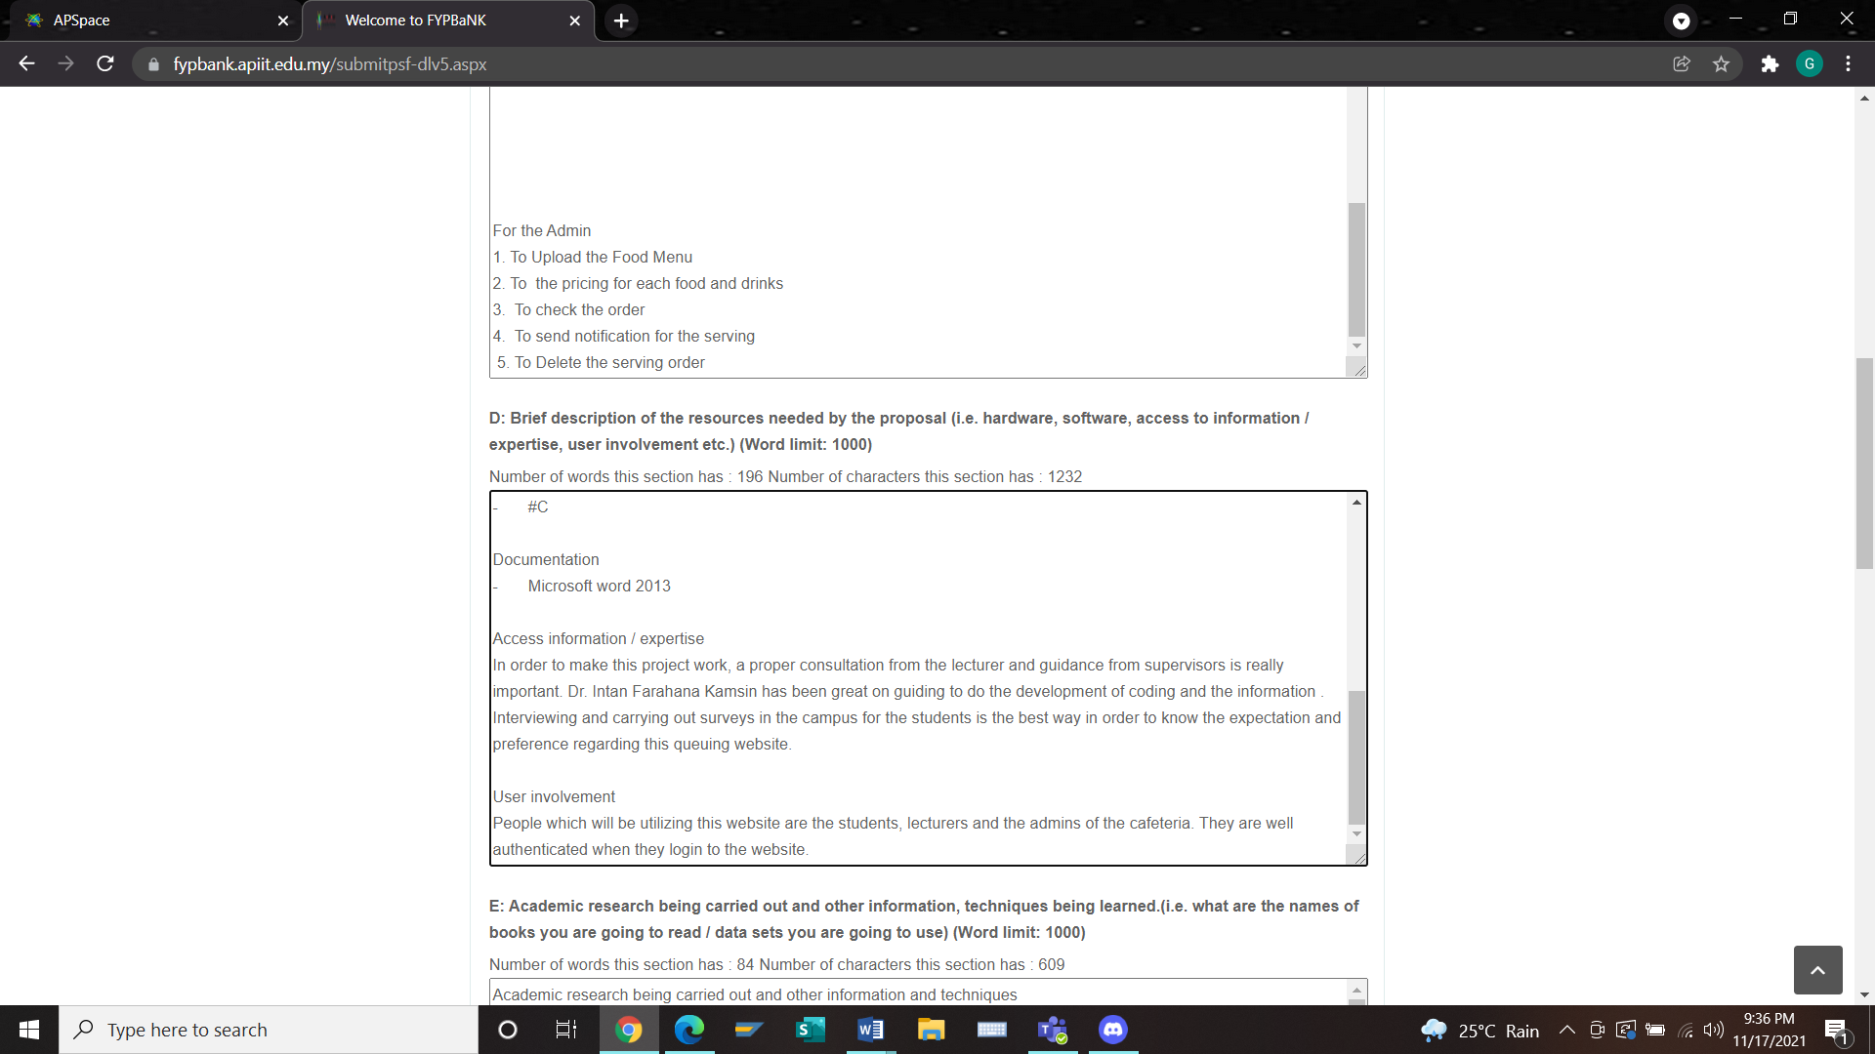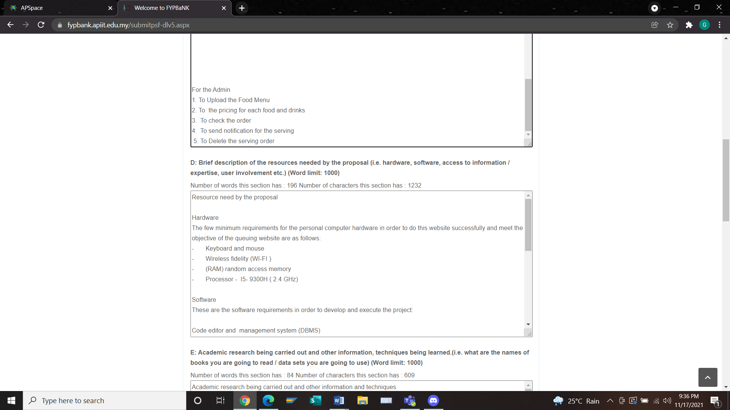

Section E

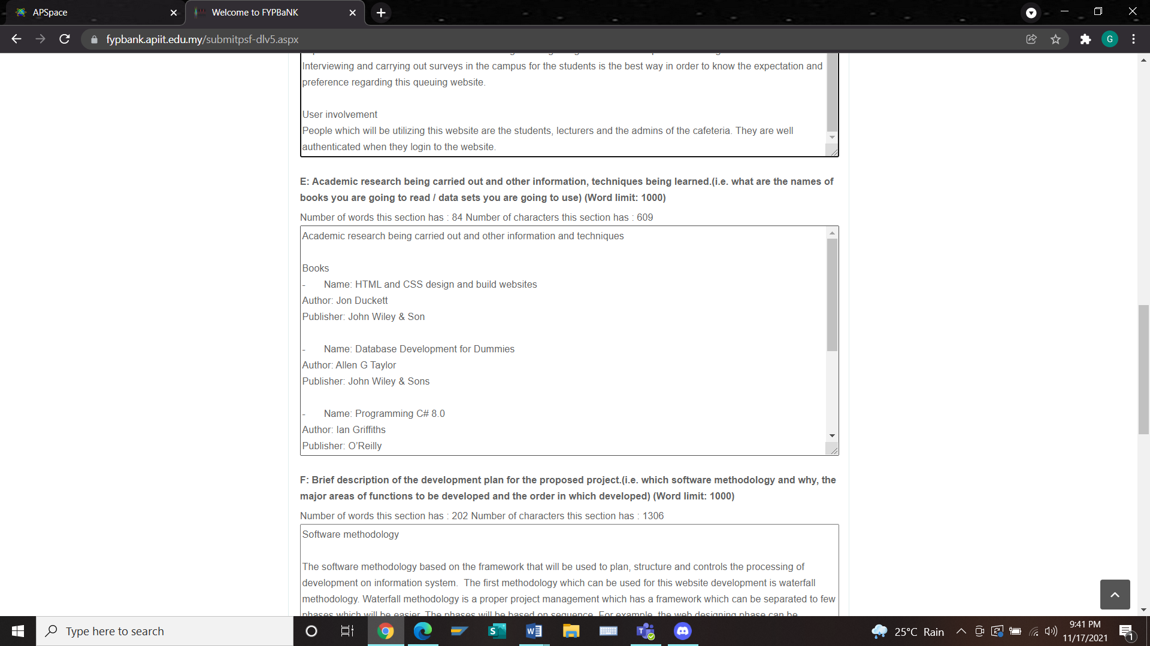

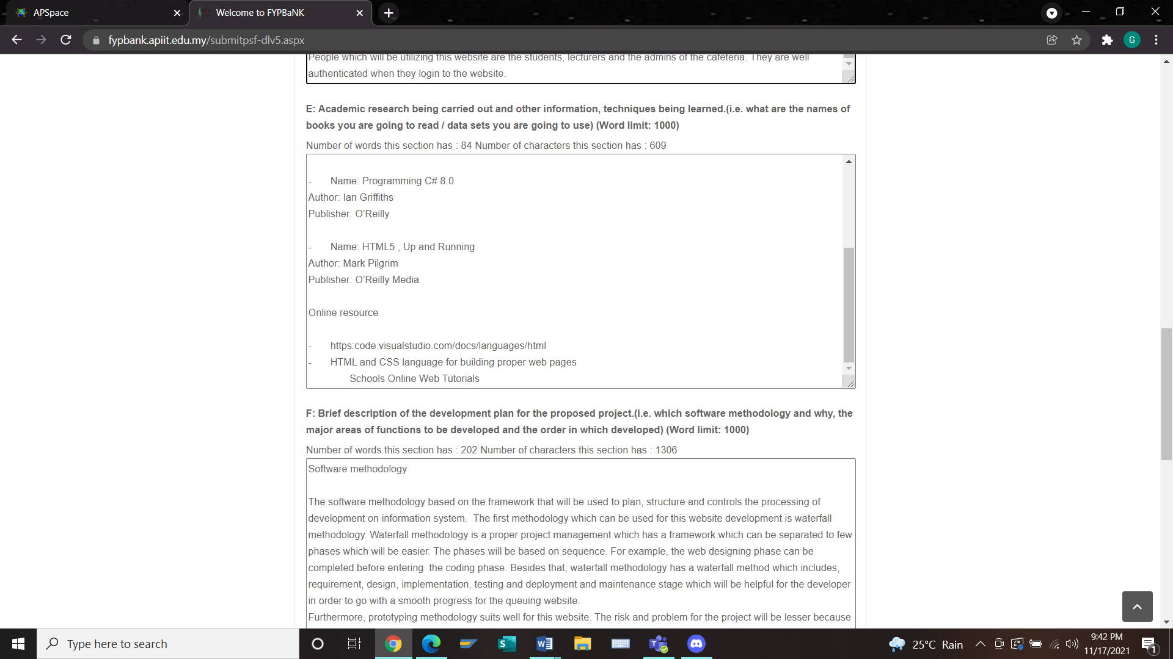

Section F

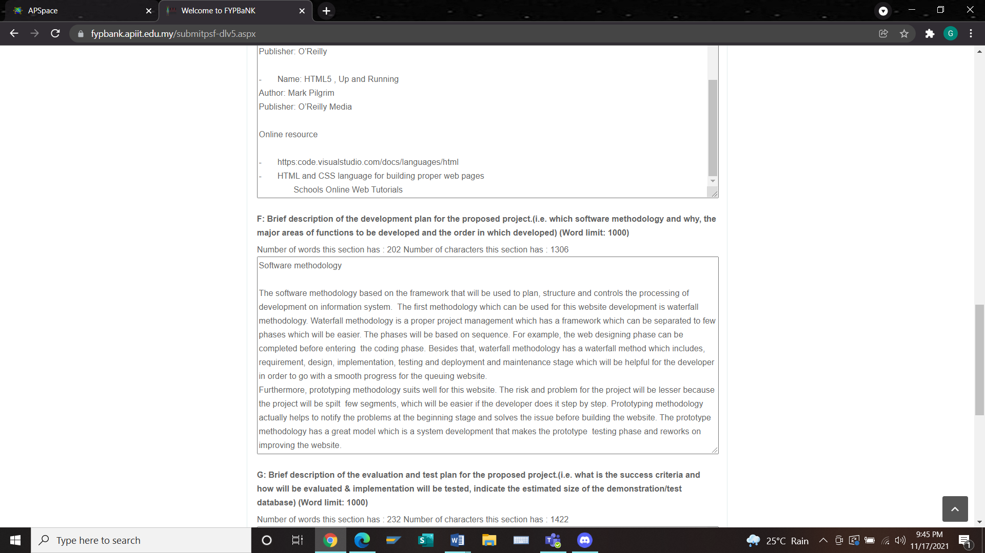

Section G

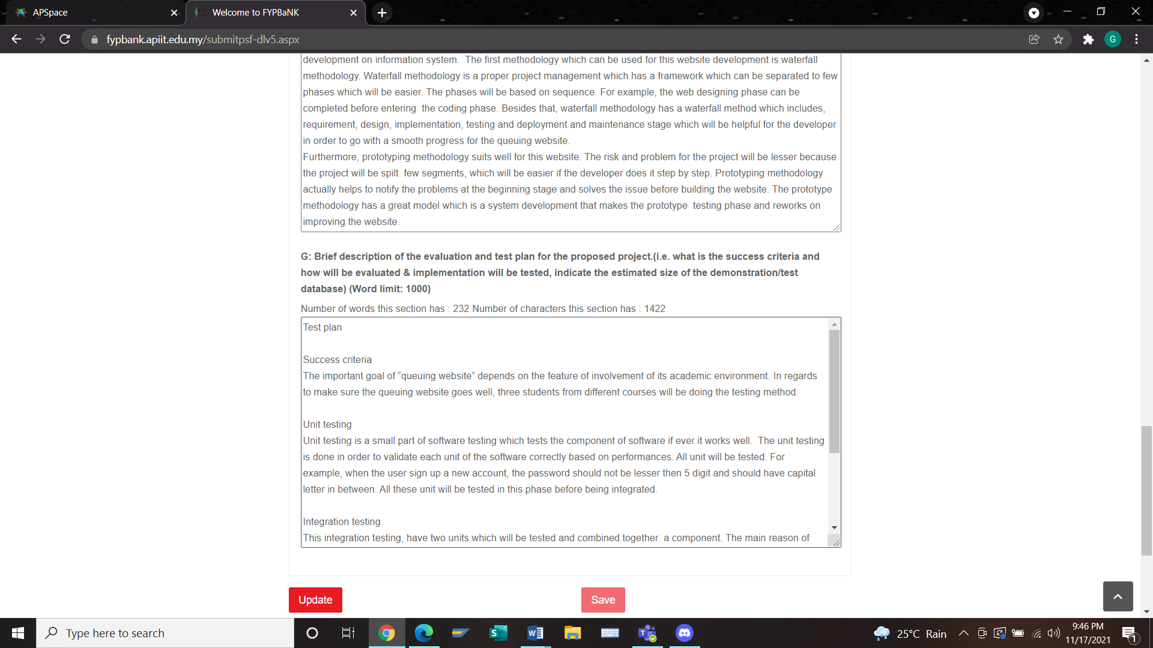

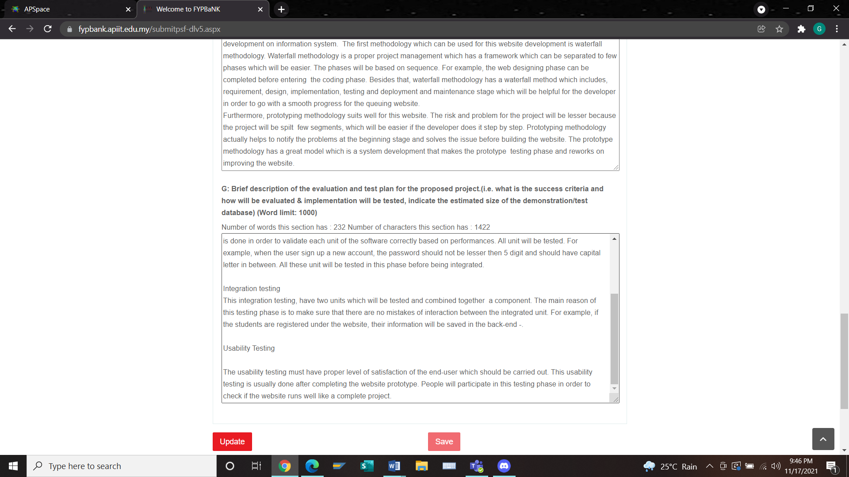

Project Log Sheet

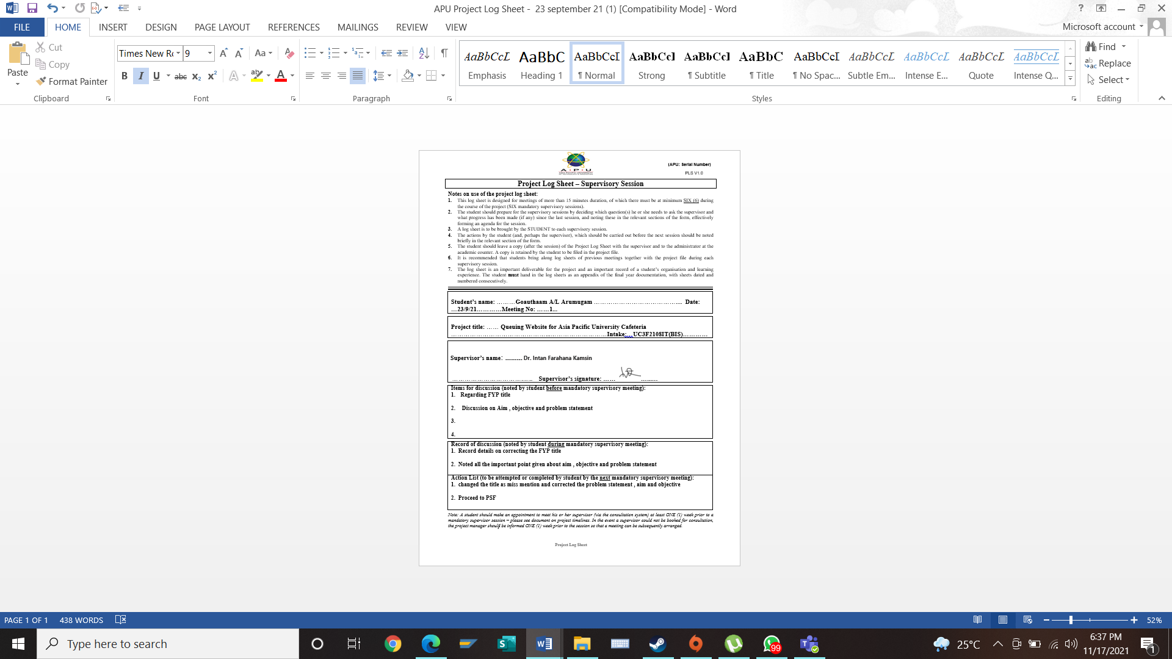

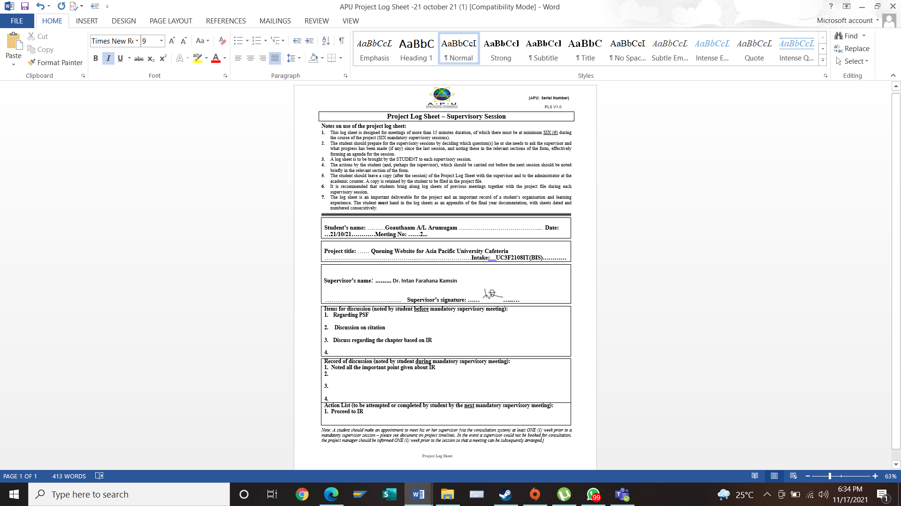

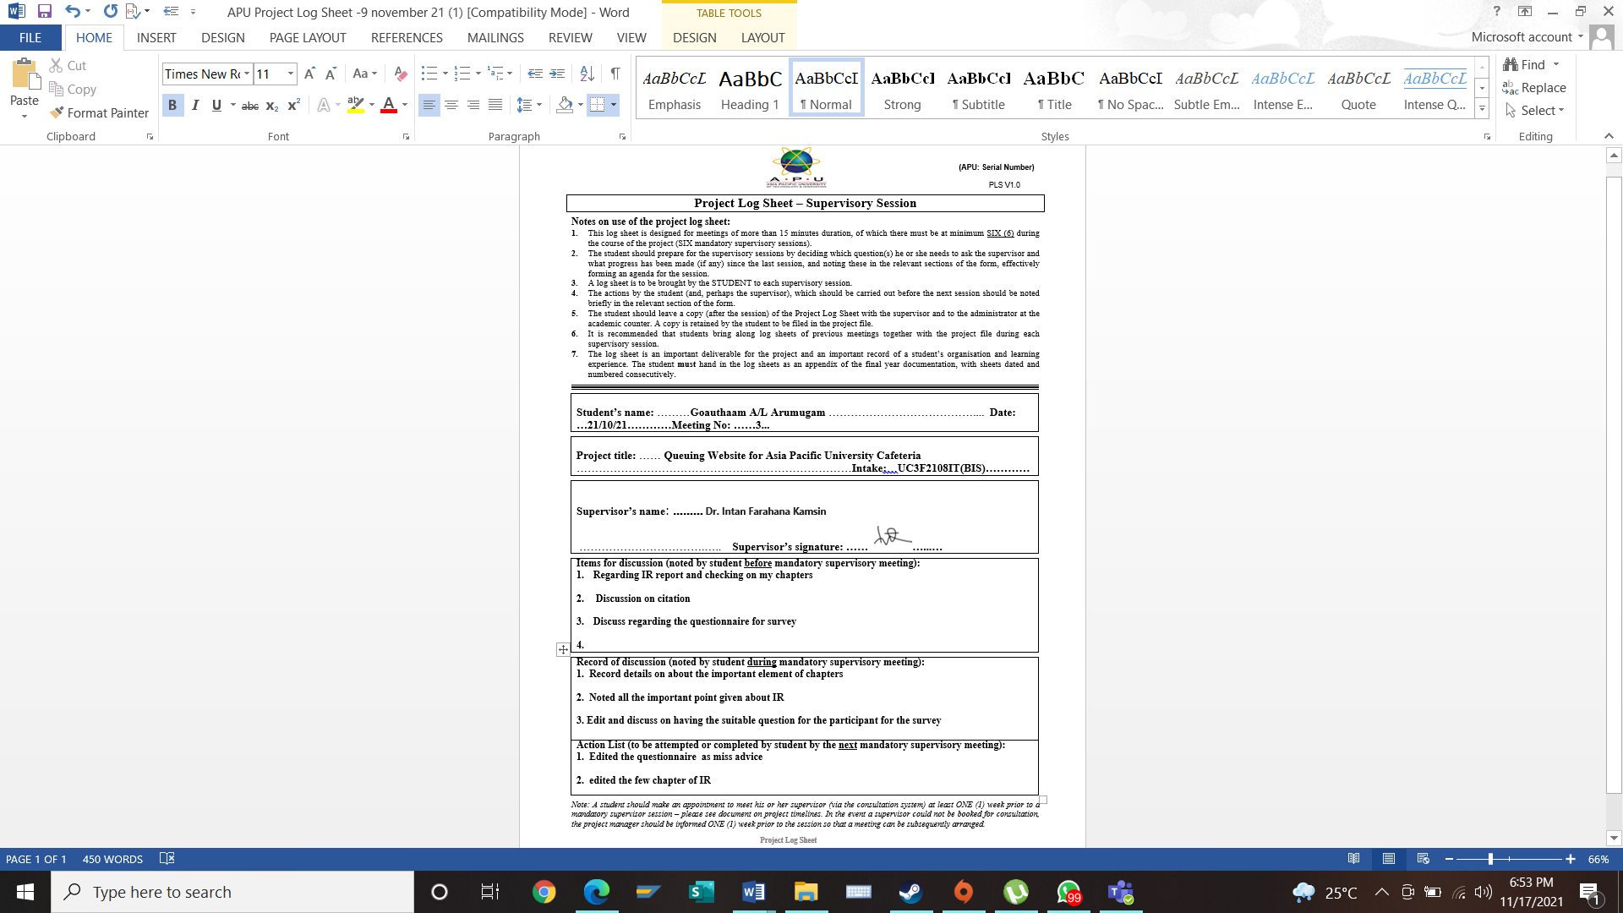

Ethics Form

